“The Legend of Chamusca”
Narrator: Welcome to Chamusca “Terra Branca e de Gente Fusca” (White land but with dark people).
There are different legends about the way Chamusca was formed. Some people say that some people passing by settled here. Others mention that some people built their houses here, and every night they would start a bonfire to warn people passing by that there was a small village here where they could rest and spend the night. There is even an older one which dates back to the time of the Romans.
During the time of the Great Roman Empire, a centurion and his legion had been walking for several days without food and water.
(a centurion shows up with his legion)
Soldier 1 - My centurion, I can´t stand it anymore.
Soldier 2 - We have been walking for more than a week without stopping. We are tired and we have no water and no food.
Soldier 1- Last time I ate something was in Badajoz (a city in Spain).
Centurion - Shut up! I’m fed up with your complaints.
Soldier 1- But Sir….
Soldier 2 - I’m starving and…
Centurion - Alright then! So, “Chã busca!”
Soldier 2 - What?!
Centurion - “Chã busca!”! It’s an order.
Soldier 1 - “Chã busca!”! What’s that?
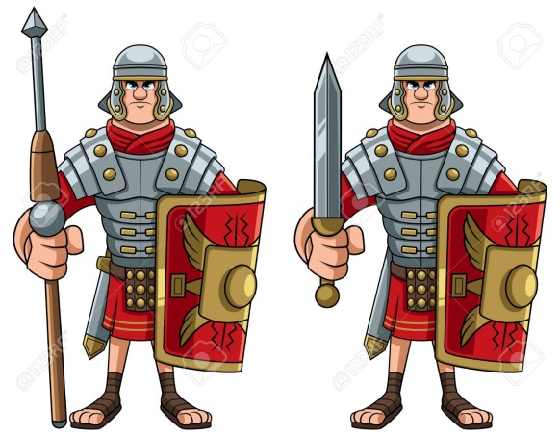
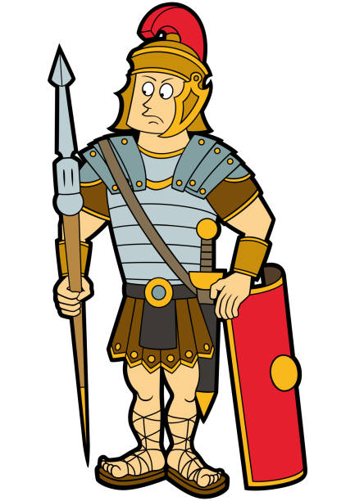
Soldier 2- You are really stupid? So, don’t you know what “Chã… busca!” means?
Soldier 1 - No, I don’t. Do you?
Soldier 2 – Of course I do!
Soldier 1 – So, what is it?
Soldier 2 – It’s a dog.
Soldier 1 – It’s what?
Soldier 2 – It’s the centurion’s dog.
Soldier 1 – Ah!!!
(They both start searching for the dog. Some time later, the Centurion returns. The soldiers become afraid)
Centurion - So? (He looks at the river Tagus) Very well! You found it! It’s not really a “Chã” but it’s a river, even better. We will camp here. Well done, men!
Soldier 1 – Did you understand anything?
Soldier 2– I think “Chã” means “water”.
Soldier 1 – Ah…(both soldiers leave) THE END

