Account on the trip to Spain

From Sunday 6th to the Friday 11th of March, I traveled to Spain in Valencia.

What I did :

• On Monday morning, we played games to meet other people and become friends. Next, we ate a delicious paella and we went to a honey's museum.
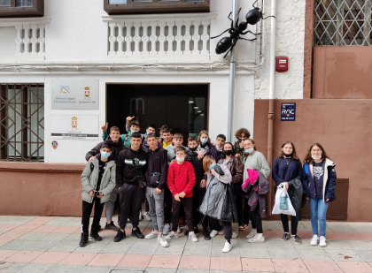
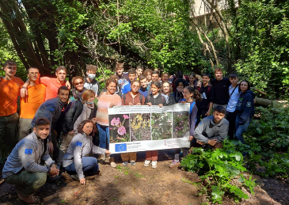
• On Tuesday, we visited a garden with mediterranean herbs and a museum with stuffed animals.

• On Wednesday, we did a hike in a natural park, then we planted plants Ruscus hypophyllum

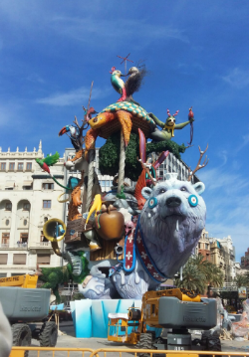
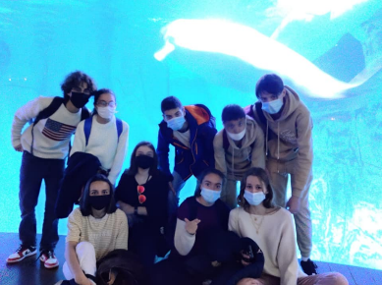
• On Thursday, we wisited a botanic garden in Valencia. After this, every pupils did a presentation related to plants. Then, we saw a show of firecracker « Mascleta » in relation to « Las Fayas ». And finally we visited an amazingly big aquarium.

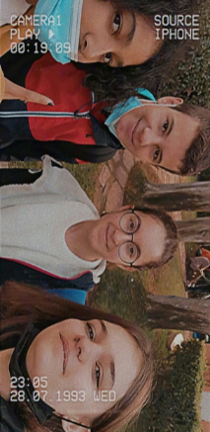
What I liked :

During my stay in Spain, I liked a lot of things and actions : I liked meeting new people and making new friends.
I loved foods (paella, sandwich, churro…).
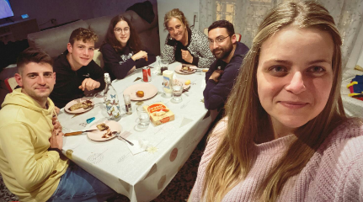
I loved visiting the Oceanographic aquarium.
I loved my host family (they were so kind with me !)

What I learnt :

I learnt new words in Spanish and in English.
I learnt from the Spanish culture like « Las Fayas » which is a festival (it’s interesting).
I learnt about the lifestyle of Spanish people (mealtimes).
I learnt new things about plants.

