ACTIVITY REPORT ERASMUS + VAN PROJECT

TÍTLE

Happiness
SCHOOL:
St Angela’s Castlebar
OBJETIVES:

Posting our Santa Letter’s
PARTICIPANTS:

Senior Infants

TEMPORALIZATION (date of realization):
10/12/18

RESOURCES:

Post Office and Letters

DESCRIPTION OF THE ACTIVITY:

We had been talking about happiness and what makes us happy.
The Children decided that they felt very happy when posting their letter to Santa.
After writing our letters to Father Christmas we went to our lacal Post Office and they allowed the children post their letters with their own special stamps.

EVALUATION CRITERIA:

The children were all very happy after the postman promised to deliver their letter’s to Father Christmas

EVALUATION: (Proposals for improvement , agreements, tasks)

RELATED FILES:

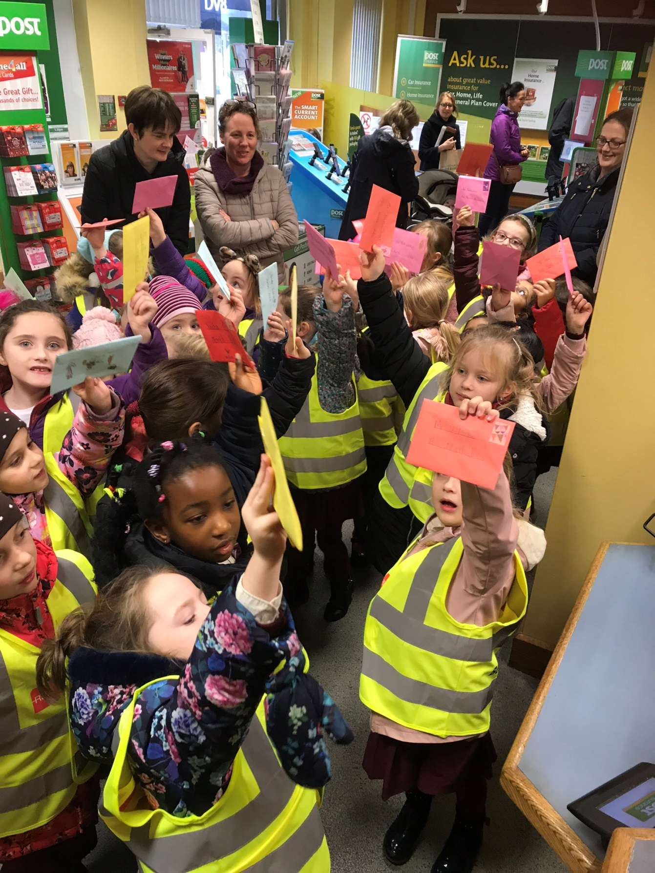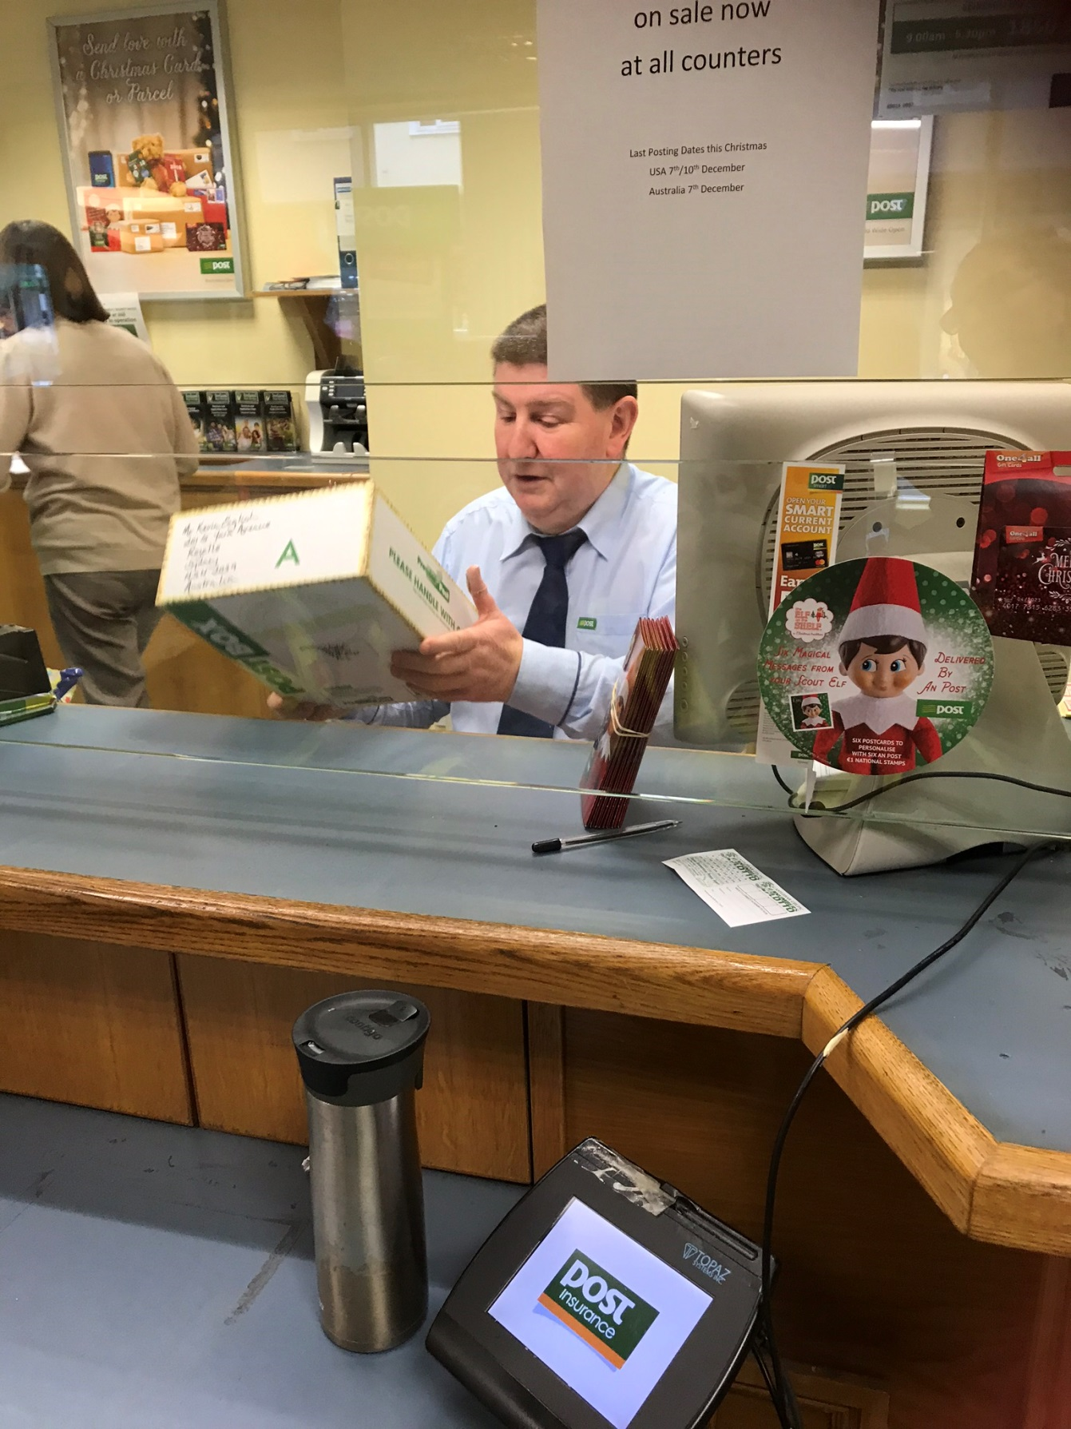
FICHA PARA RECOGER DATOS SOBRE LAS ACTIVIDADES A REALIZAR EN EL PROYECTO ERASMUS

TÍTULO:

CENTRO:
CEIP Seis de Diciembre de Alcobendas
OBJETIVOS:

PARTICIPANTES:

TEMPORALIZACIÓN (Fecha de realización):

RECURSOS:

DESCRIPCIÓN DE LA ACTIVIDAD:

CRITERIOS DE EVALUACIÓN:

EVALUACIÓN: (Propuestas de mejora, acuerdos, tareas, )

ARCHIVOS RELACIONADOS:

