ACTIVITY REPORT ERASMUS + VAN PROJECT

TÍTLE

Logo Competition
SCHOOL:
St. Angela’s N.S. Castlebar
OBJETIVES:

To introduce the Project and its meaning to the children and créate a logo for our school.
PARTICIPANTS:

Senior Infant Classes
TEMPORALIZATION (date of realization):

12/11/18
RESOURCES:

White Board
information on Logo’s
Paper and Oil Pastels

DESCRIPTION OF THE ACTIVITY:

I described the Van Project to the children and explained what a logo was.
After lots of discussion we designed a class logo and felt that it described our school perfectly.

EVALUATION CRITERIA:

This lesson was very successful and the children were very excited to think that their logo had a chance of winning a competition.

EVALUATION: (Proposals for improvement , agreements, tasks)

It would be better if the logo had been decided after we had made some of the connections as then the children would have had a greater understanding.
They were a little disappointed when their logo was not chosen.

RELATED FILES:

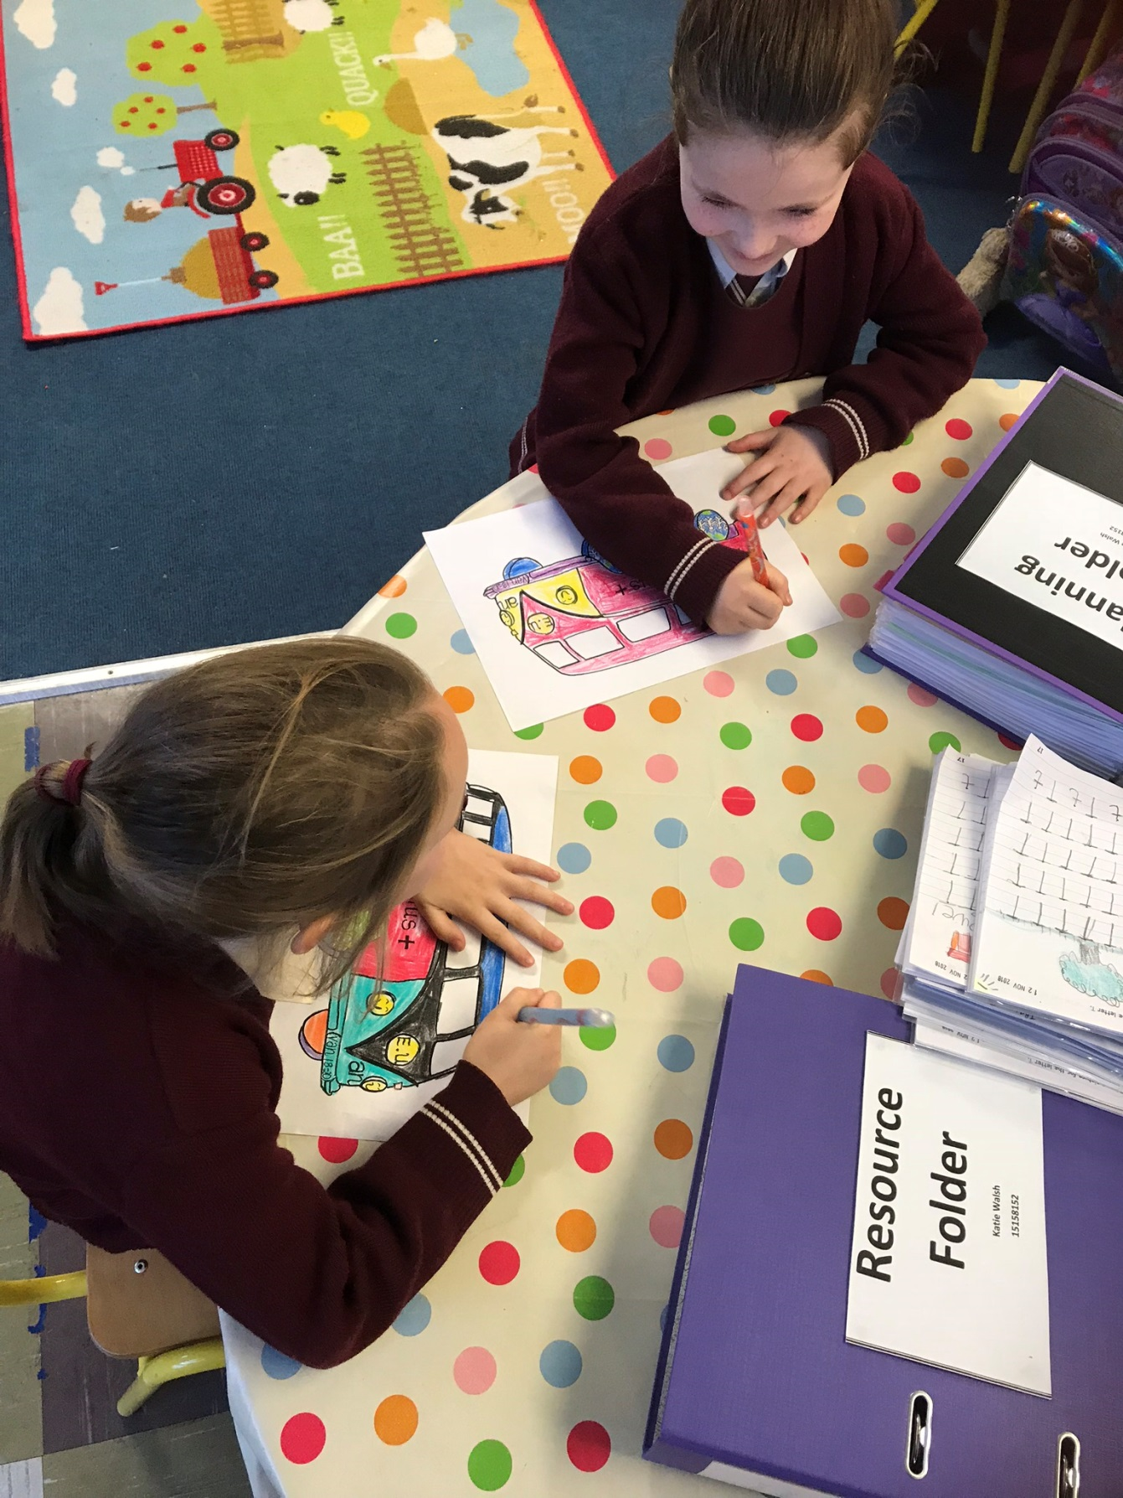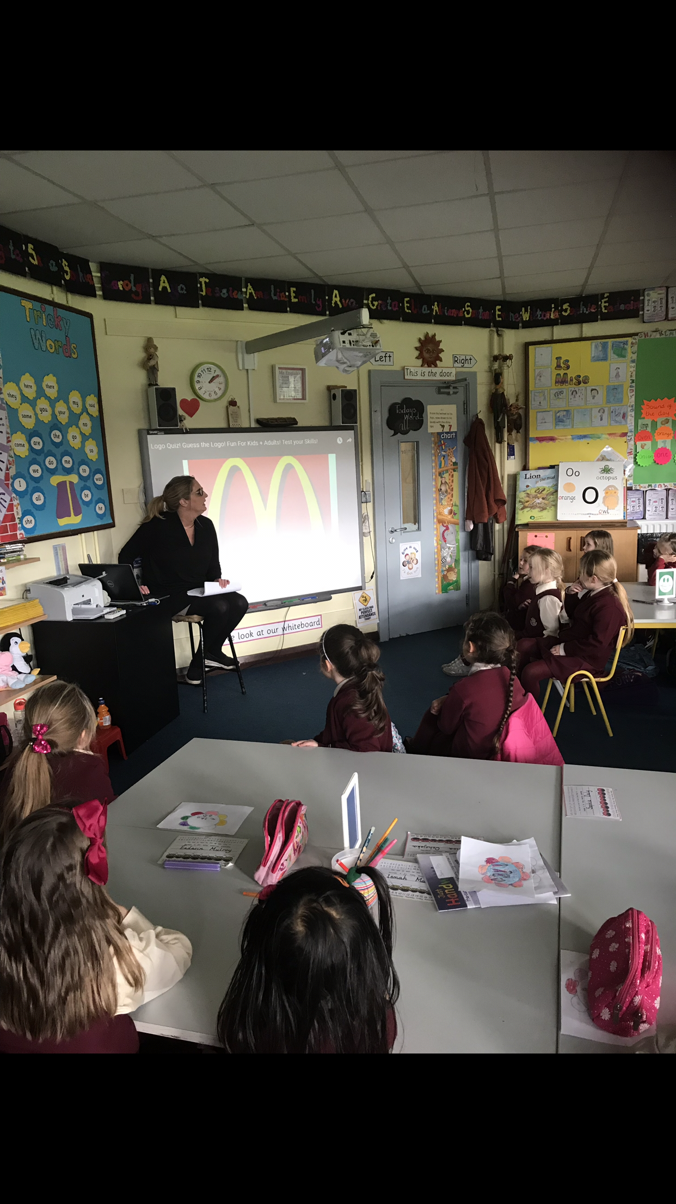
FICHA PARA RECOGER DATOS SOBRE LAS ACTIVIDADES A REALIZAR EN EL PROYECTO ERASMUS

TÍTULO:

CENTRO:
CEIP Seis de Diciembre de Alcobendas
OBJETIVOS:

PARTICIPANTES:

TEMPORALIZACIÓN (Fecha de realización):

RECURSOS:

DESCRIPCIÓN DE LA ACTIVIDAD:

CRITERIOS DE EVALUACIÓN:

EVALUACIÓN: (Propuestas de mejora, acuerdos, tareas, )

ARCHIVOS RELACIONADOS:

