ACTIVITY REPORT ERASMUS + VAN PROJECT

TÍTLE
Connection with St Angela’s and Italy

SCHOOL:
St Anglea’s
OBJETIVES:

To connect with another of our countries via Google Hangouts.
To expose the children to one of the countries that we have been learning about.
To allow the choldren recite some poems.
To allow the children to ask questions.

PARTICIPANTS:

St Angela’s NS

TEMPORALIZATION (date of realization):
25/1/19

RESOURCES:

Google Hangouts

DESCRIPTION OF THE ACTIVITY:

We made the connection using Google Hangouts and the children met with the children in Italy.
The Children heard the Italian language and were very excited.
We then sang a song and discussed what types of things made us sad.

EVALUATION CRITERIA:

This was a very successful hangout and the children are getting more used to talking to children in other countries.

EVALUATION: (Proposals for improvement , agreements, tasks)

RELATED FILES:

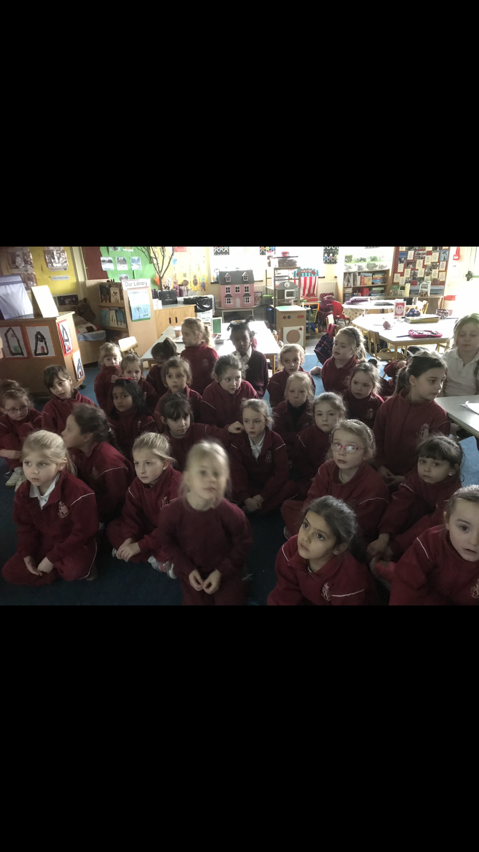
FICHA PARA RECOGER DATOS SOBRE LAS ACTIVIDADES A REALIZAR EN EL PROYECTO ERASMUS

TÍTULO:

CENTRO:
CEIP Seis de Diciembre de Alcobendas
OBJETIVOS:

PARTICIPANTES:

TEMPORALIZACIÓN (Fecha de realización):

RECURSOS:

DESCRIPCIÓN DE LA ACTIVIDAD:

CRITERIOS DE EVALUACIÓN:

EVALUACIÓN: (Propuestas de mejora, acuerdos, tareas, )

ARCHIVOS RELACIONADOS:

