ACTIVITY REPORT ERASMUS + VAN PROJECT

TÍTLE
Exploring Sadness through Art

SCHOOL:
St Angela’s
OBJETIVES:
To discuss the emotion of Sadness.
To look and respond to the Works of Picasso.
To examine the life of Picasso.
To discuss our feelings of Sadness and our use of colours.
PARTICIPANTS:

St Angela’s Ns

TEMPORALIZATION (date of realization):

7/2/19
RESOURCES:

Exploring Sadness Powerpoint
Picasso Powerpoint
Paintings from Picasso
Paints
Paper

DESCRIPTION OF THE ACTIVITY:

We discussed sadness and how it makes us feel
We also discussed what makes us sad.
The children also explored som eof Picasso Works and the colours he used during his blue period.
We mixed different shades of blue and began to Paint.

EVALUATION CRITERIA:

The children learned to identify the emotion of Sadness an the fact that everyone feels sad at times. We talked about how we can help someone feel better and also the fact that it is good to feel sad at times.

EVALUATION: (Proposals for improvement , agreements, tasks)

RELATED FILES:

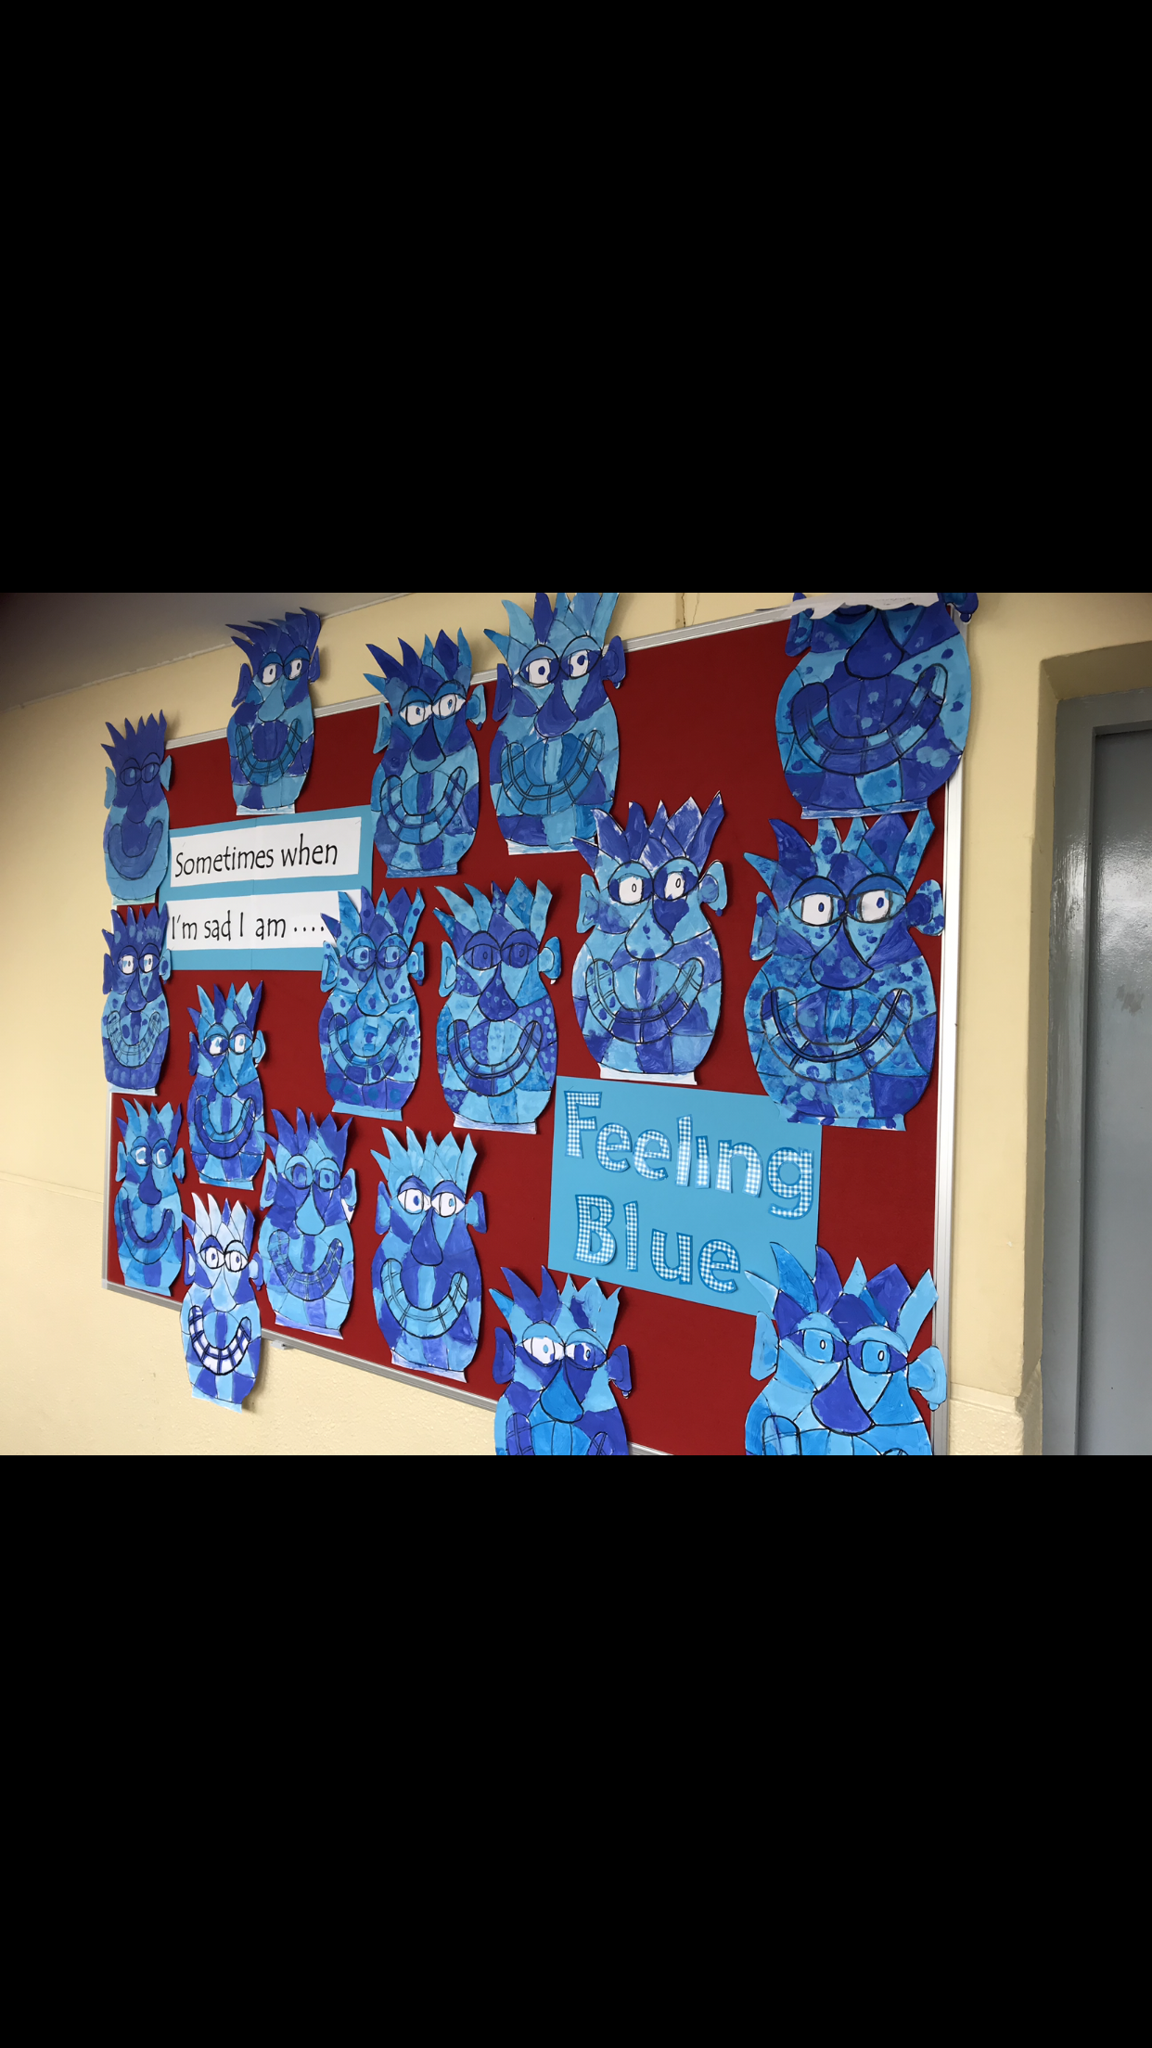
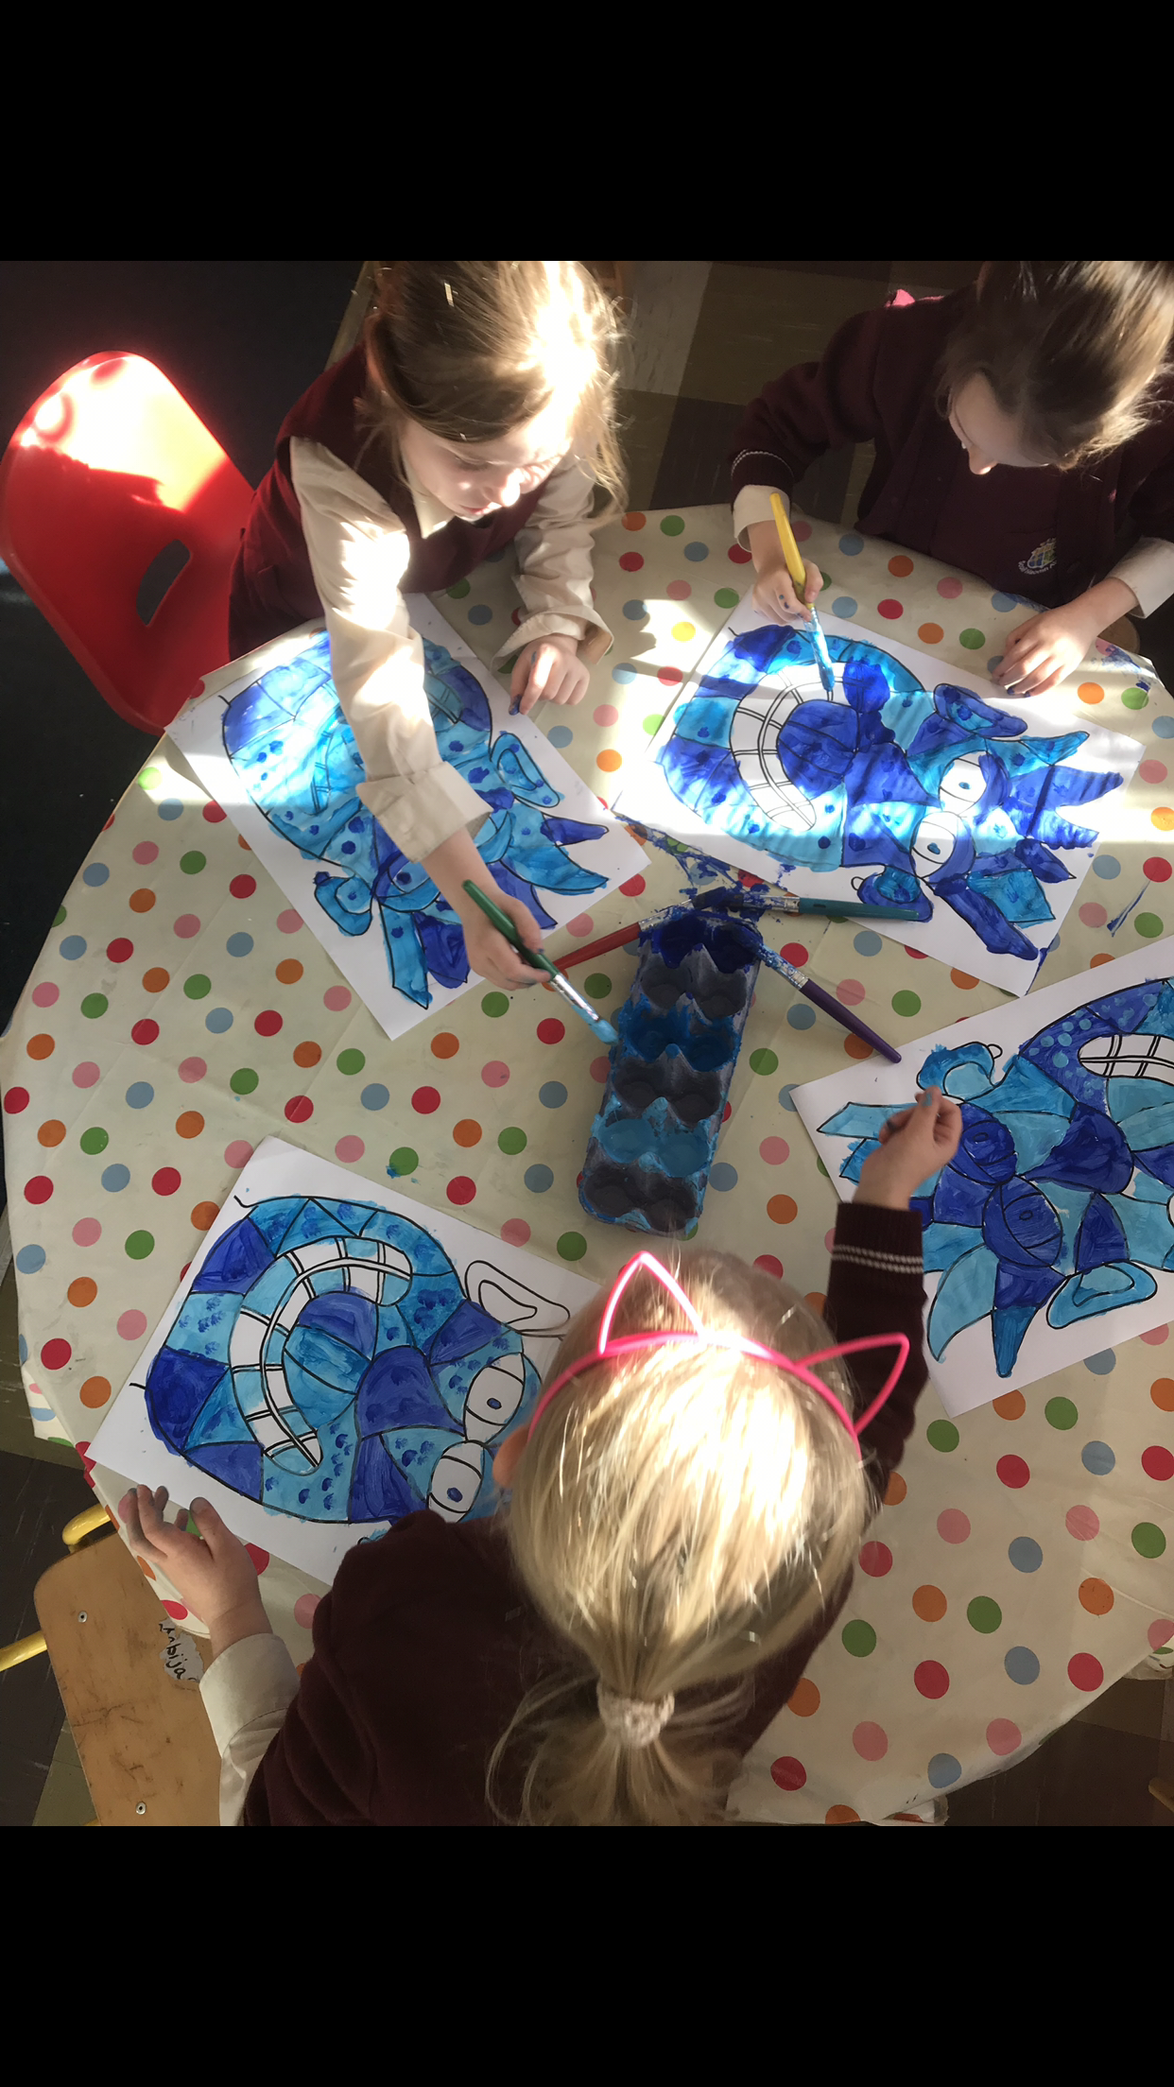
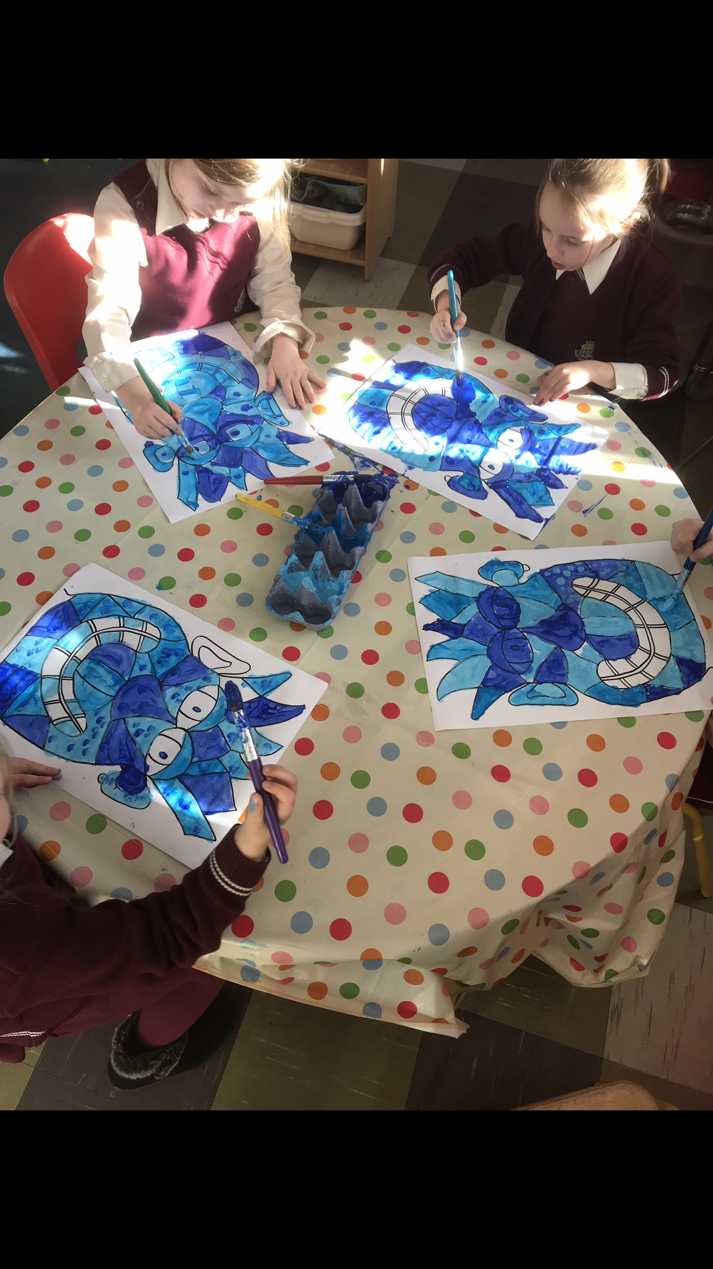
FICHA PARA RECOGER DATOS SOBRE LAS ACTIVIDADES A REALIZAR EN EL PROYECTO ERASMUS

TÍTULO:

CENTRO:
CEIP Seis de Diciembre de Alcobendas
OBJETIVOS:

PARTICIPANTES:

TEMPORALIZACIÓN (Fecha de realización):

RECURSOS:

DESCRIPCIÓN DE LA ACTIVIDAD:

CRITERIOS DE EVALUACIÓN:

EVALUACIÓN: (Propuestas de mejora, acuerdos, tareas, )

ARCHIVOS RELACIONADOS:

