ACTIVITY REPORT ERASMUS + VAN PROJECT

TÍTLE
Connection with Spain

SCHOOL:
St Anglea’s
OBJETIVES:
To see some Spanish christmas traditions

PARTICIPANTS:

St Angela’s

TEMPORALIZATION (date of realization):

21/12/18
RESOURCES:

Whiteboard
Google Hangouts
Father Christmas

DESCRIPTION OF THE ACTIVITY:

Google hangout with Spanish students and a surprise visit from Father Christmas

EVALUATION CRITERIA:

The children were very excited to meet children from another country and again went home and told their parents all about it.
The Word is spreading fast that we are connecting with all these different countries and parents are very excited.

EVALUATION: (Proposals for improvement , agreements, tasks)

RELATED FILES:

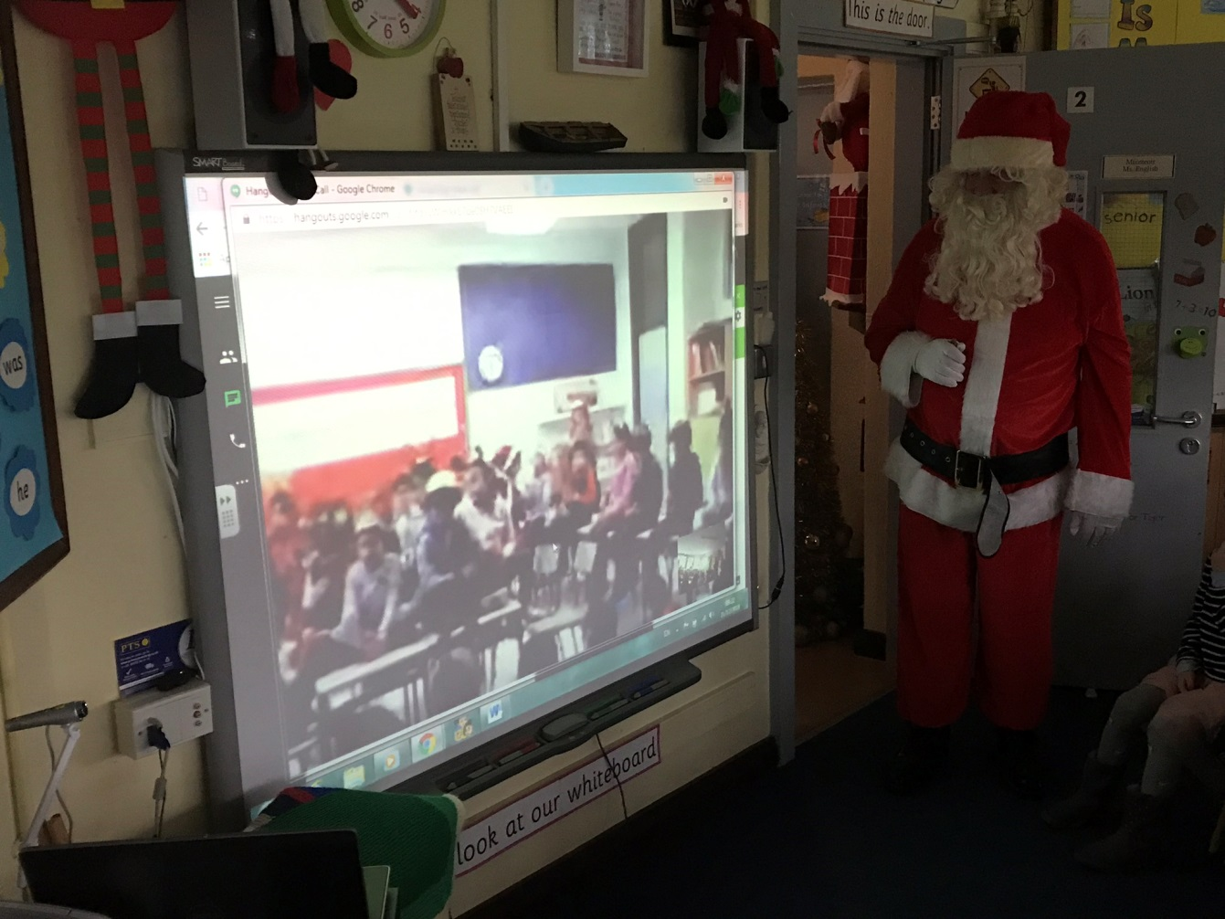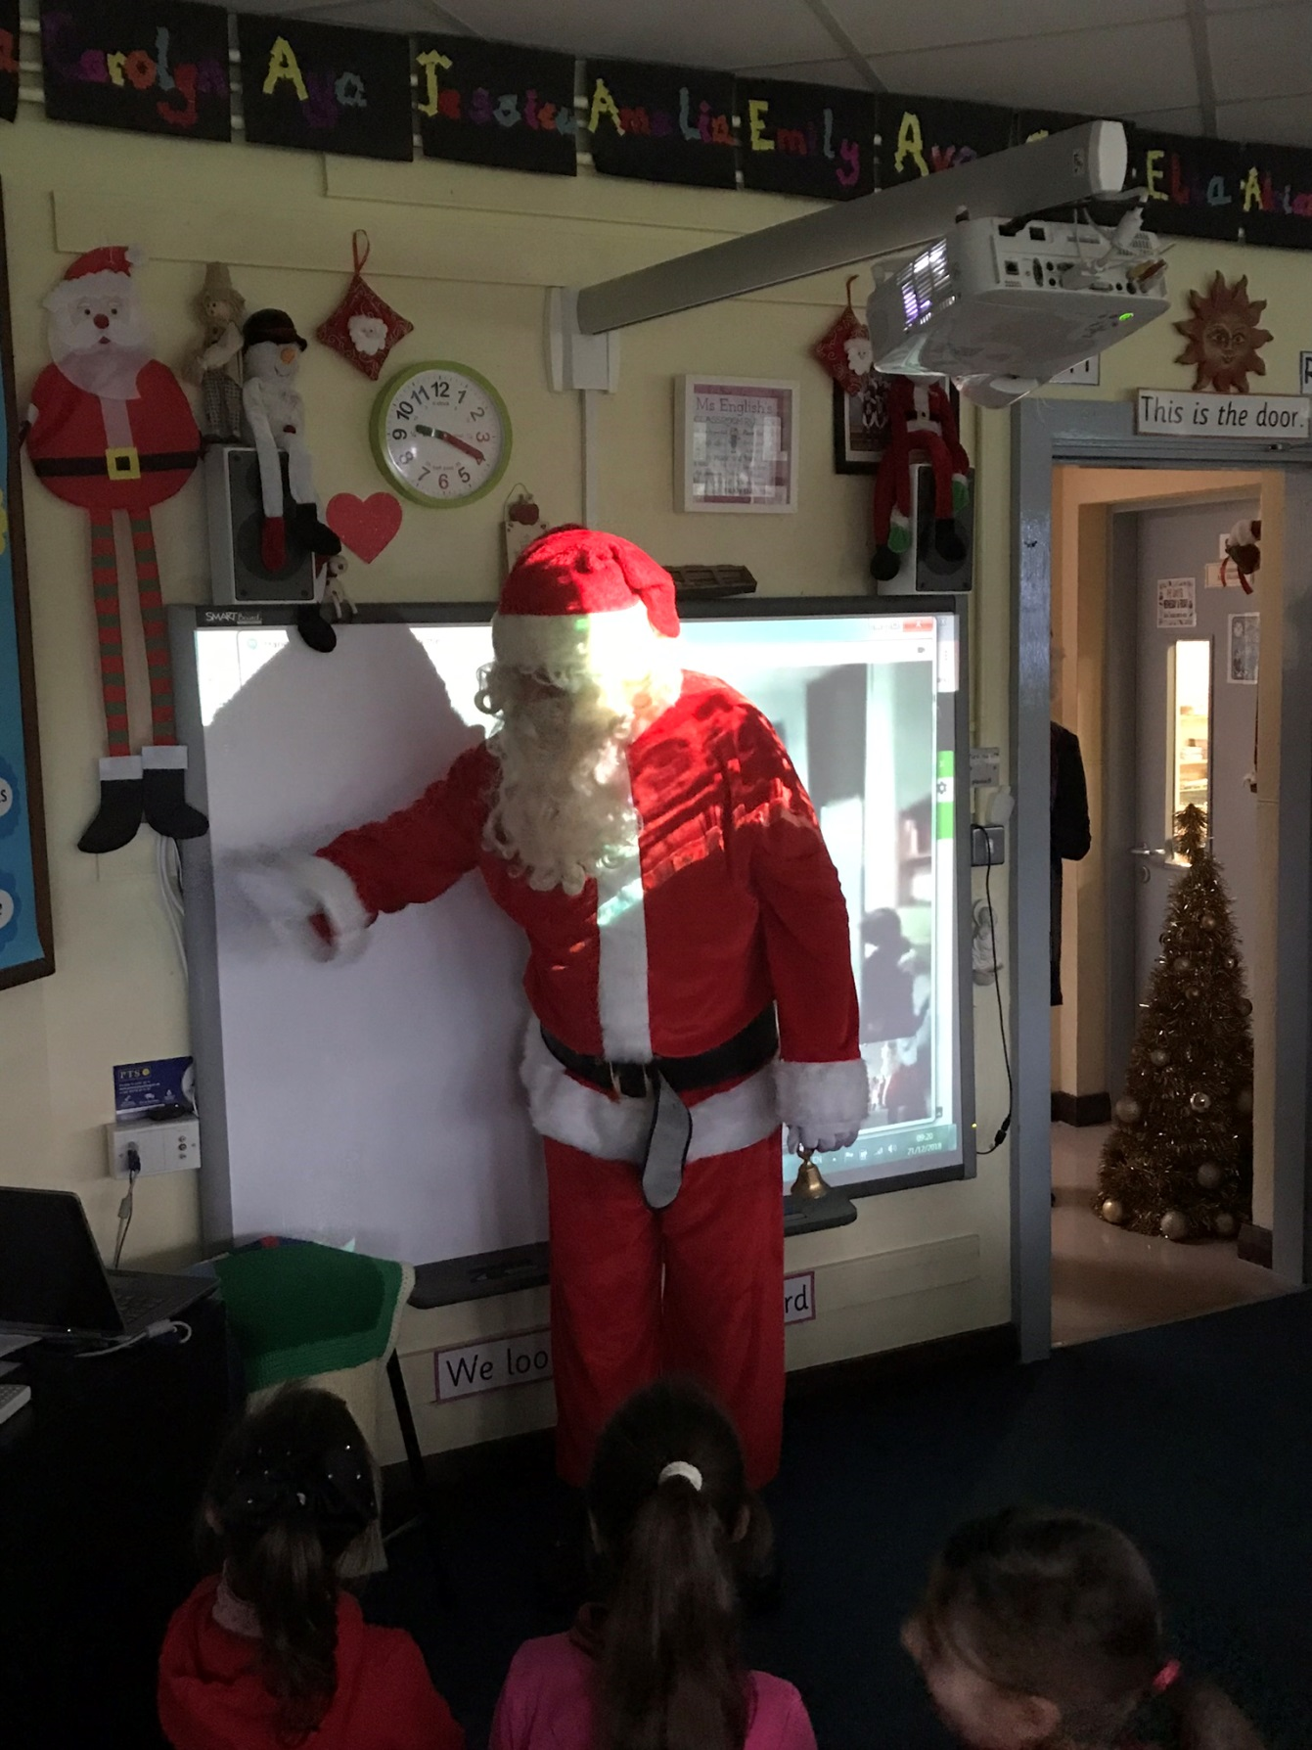
FICHA PARA RECOGER DATOS SOBRE LAS ACTIVIDADES A REALIZAR EN EL PROYECTO ERASMUS

TÍTULO:

CENTRO:
CEIP Seis de Diciembre de Alcobendas
OBJETIVOS:

PARTICIPANTES:

TEMPORALIZACIÓN (Fecha de realización):

RECURSOS:

DESCRIPCIÓN DE LA ACTIVIDAD:

CRITERIOS DE EVALUACIÓN:

EVALUACIÓN: (Propuestas de mejora, acuerdos, tareas, )

ARCHIVOS RELACIONADOS:

