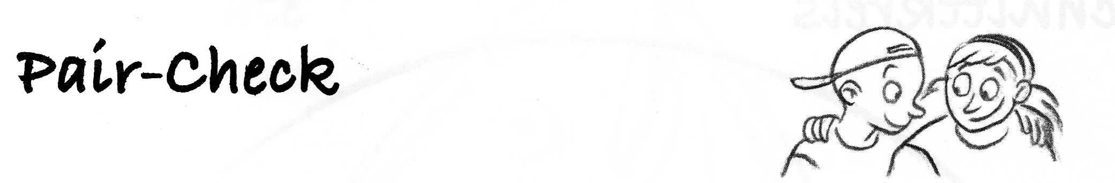

|  |  |
| --- | --- |
| Name 1: | Name 2: |
|  |  |
|  |  |
|  |  |
|  |  |
|  |  |
|  |  |

**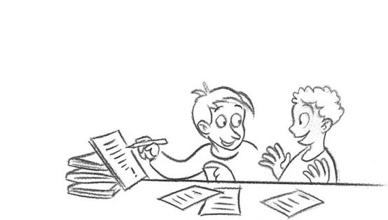**

Check Point

**Date- calendar of the class:**

|  |  |  |  |  |
| --- | --- | --- | --- | --- |
|  | http://file1.npage.de/006424/19/bilder/hund_www-clipart-kiste-de_270.gif | http://www.clipart-kiste.de/archiv/Tiere/Elefanten/elefant_u_05.gif | http://www.clipart-kiste.de/archiv/Tiere/Schildkroeten/schildkroete_15.gif | http://www.austriasites.com/animal-cliparts/cliparts/fische/fisch25.gif |
|  |  |  |  |  |
|  |  |  |  |  |
|  |  |  |  |  |
|  |  |  |  |  |
|  |  |  |  |  |
|  |  |  |  |  |
|  |  |  |  |  |
|  |  |  |  |  |
|  |  |  |  |  |
|  |  |  |  |  |
|  |  |  |  |  |
|  |  |  |  |  |
|  |  |  |  |  |
|  |  |  |  |  |
|  |  |  |  |  |
|  |  |  |  |  |
|  |  |  |  |  |
|  |  |  |  |  |

**Date- calendar of:\_\_\_\_\_\_\_\_\_\_\_\_\_**

|  |  |
| --- | --- |
| hund_www-clipart-kiste-de_270  dog |  |
| elefant_u_05 elephant |  |
| schildkroete_15  turtle |  |
| fisch25  fish |  |

**Date- calendar of:\_\_\_\_\_\_\_­­­\_\_\_\_\_\_**

|  |  |
| --- | --- |
| hund_www-clipart-kiste-de_270  dog |  |
| elefant_u_05  elephant |  |
| schildkroete_15  turtle |  |
| fisch25  fish |  |

**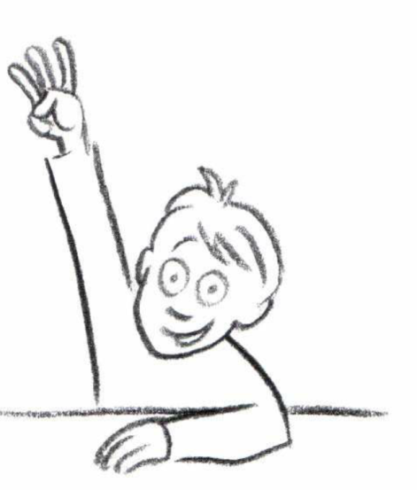Pictures of the cooperative learning methods:**

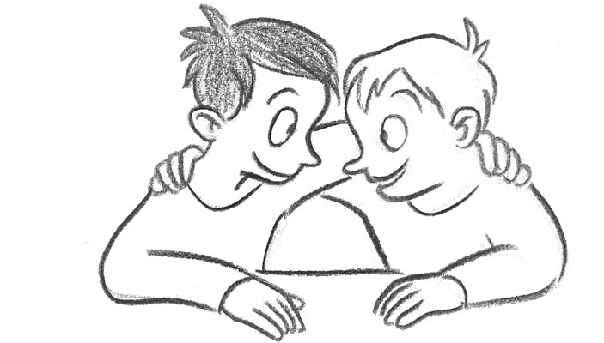

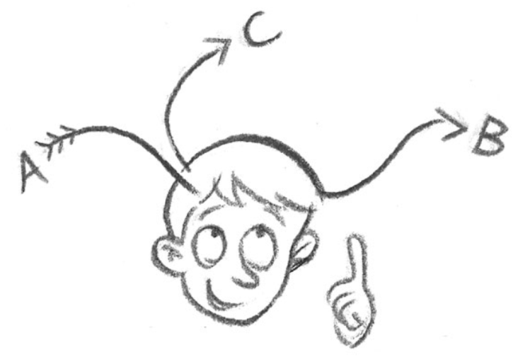

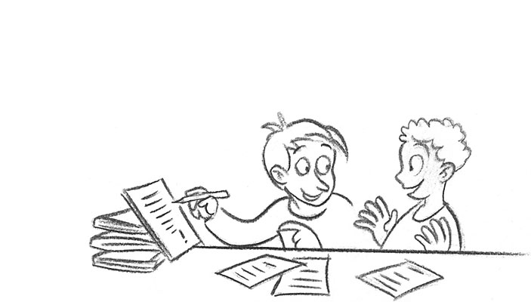

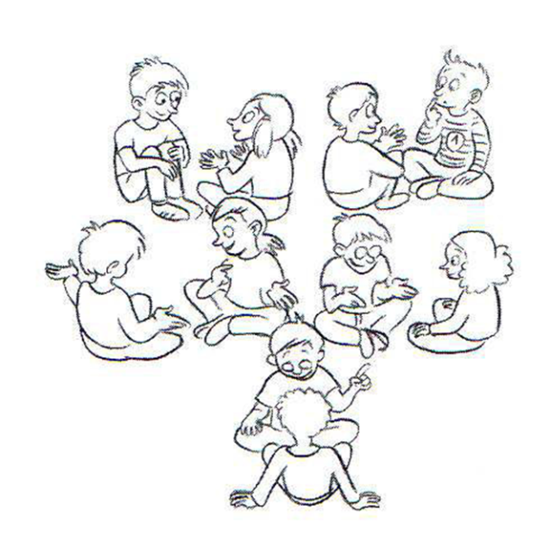

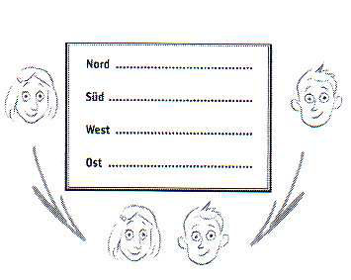



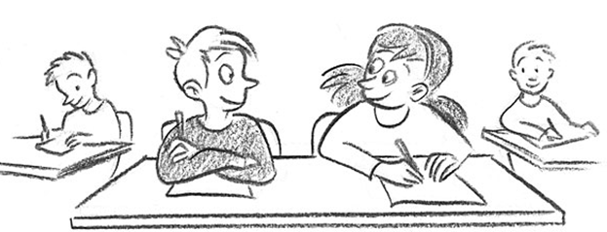

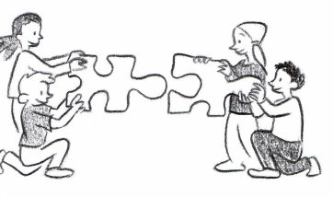

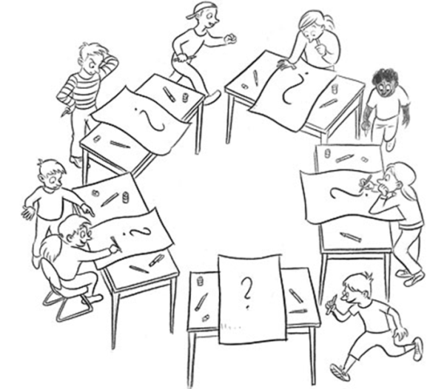

The following cooperative role cards can be used in any cooperative learning setting:

|  |  |  |
| --- | --- | --- |
| C:\Users\laptop\Downloads\Materialmanager.jpg**Material-manager** | **C:\Users\laptop\Downloads\zeit.jpgSupervisor** | nds_11**Handiman/Handiwoman** |
| C:\Users\laptop\Downloads\SChreiber.jpg**Writer** | **C:\Users\laptop\Downloads\Hilfesteller.jpgSupporter** | **C:\Users\laptop\Downloads\Ermutiger.jpgEncourager** |
| Quiet please!  C:\Users\laptop\Downloads\Flüsterstimme.jpg  **Volume- guard** | nds_37**Time- guard** | C:\Users\laptop\Downloads\Maler.jpg**Artist** |
| How are you doing?    **Harmony- guard** | C:\Users\laptop\Pictures\2014-03-22 Rollenkarten\Rollenkarten 001.jpg**Reader** | C:\Users\laptop\AppData\Local\Microsoft\Windows\Temporary Internet Files\Content.Word\Rollenkarten 001.jpg**Question- asker** |
| **C:\Users\laptop\Downloads\Paar kontrolle.jpgExpert** | It’s your turn!    **Conversation- manager** | Attention, rules!  C:\Users\laptop\Pictures\2014-03-22 Rollenkarten\Rollenkarten 001.jpg  **Rule- enforcer** |

*"The European Commission support for the production of this publication does not constitute an endorsement of the contents which reflects the views only of the authors, and the Commission cannot be held responsi­ble for any use which may be made of the information contained therein."*