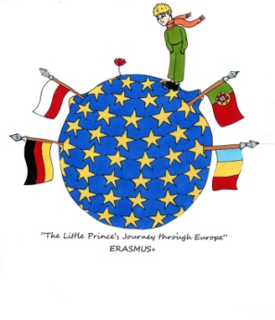

Dinstühler Str. 67 - 41836 Hückelhoven - Tel.: 02433-2771 - Fax: 02433-86280 - [info@ggs-an-der-burg.de](mailto:info@ggs-an-der-burg.de) - www.ggs-an-der-burg.de

__________________________________________________________________________________________________________________________________________________________________________________________________________________________________

**Methods of**

**Cooperative learning**

**Overview of the methods and how to use them**



* A close up of a logo

  Description automatically generated**Goal: to practise, repeat and exchange information**
* ***Pair- check (partner-check)***
* Two students work on a shared worksheet at the same time
* The students explain their approach and how they have solved

the worksheet to each other

* + for math
  + for reading
  + for tasks for which it is necessary that the students verbalize their approach
  + for tasks with multipule solutions
  + for all tasks that need to be practised and repeated with a learning partner
* ***Think - Pair- Share***
* Think alone first – exchange thoughts with a partner – present the results in a group
* ******Students are required to think about a topic/ task alone in the beginning, then share their thoughts with a partner and finally present their results in the plenum/ or to another pair of students
* to collect previous knowledge and expectations
* to repeat
* to present the work with a partner
* ***Meeting – Point / Check –Point***
* 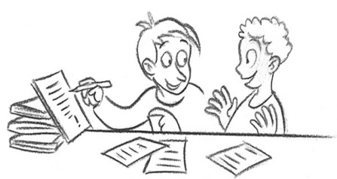A meeting point in the classroom that students can go to :
* to find a partner
* to compare and double- check their results with a partner
* to exchange and find new ideas with a partner
* **Goal: self- assessment**
* ***3-Finger- evaluation***
* A drawing of a person

  Description automatically generatedStudents show with three fingers if and to which extend they have reached the requested teaching goal
* to reflect on content- related, methodical and social goals
* if the teachers would like to have a quick overview of the students‘ assessment
* for the students to reflect on their own work
* ***Learning diary***
* Documentation of individual learning/ of exploring/ of revision/ of modifying
  + A picture containing text

    Description automatically generatedWhat new topics have I learned about?
  + New content- related knowledge?
  + Individual and social competences?
  + What will I continue to work on? When? Where? How?
  + What will I repeat, catch up on or clear up?
* **Goal: activation of previous knowledge**
* ***Mindmap***
* Graphics are used to arrange data about certain topics in an organized map
* 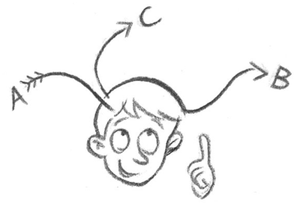activation of previous knowledge
* processing of information
* to support an oral presentation
* as a memory aid for study matters
* as a means to present information
* ***Placemat***
* In small groups each student writes into one area on the placemat, the results of the different areas are being discussed in the small group and the group decides about their common results/ about what to present in the plenum
* collection of previous knowledge
* A drawing of a person

  Description automatically generatedvoting about different contents/ facts
* agreeing on common consensus

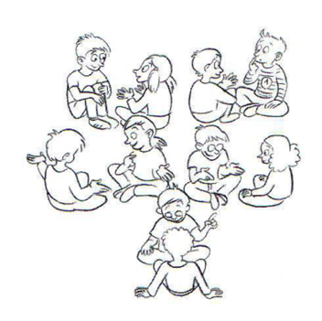

* ***Double- circle***
* Quick exchange with several partners
* exchange of previous knowledge
* communication about newly aquired knowledge
* repetition of last lessons learning objectives/ results
* 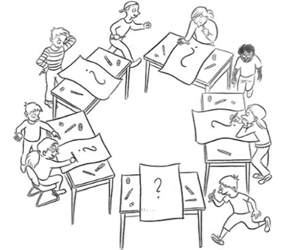interim reflection
* ***Graffiti (roation of ideas)***
* Collection of opinions/ previous knowledge/ wishes
* **Goal: processing of previous knowledge**
* ***Jigsaw/ group- puzzle***
* 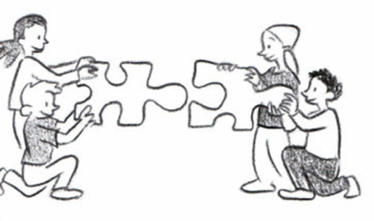The core group members split up a text, then go to work on this text in different small expert groups and finally present their results in their original core groups
* to process longer texts with individual smaller passages
* every time a topic can be broken down into smaller

sub- topics that can be divided amongst differnt small groups

* ***Mind-Map*** (see 🡪 Goal: activation of previosus knowledge)
* ***Placemat*** (see 🡪 Goal: activation of previous knowledge)
* **Goal: to find a partner**
* A close up of a logo

  Description automatically generated***Date- calendar***
* to find a partner
* meet to work together
* meet to exchange previous knowledge
* meet at the beginning or the end of a lesson
* meet for an interim reflection
* meet to present results
* A drawing of a person

  Description automatically generated***Line-Up (criteria- based lines)***
* To find partners or groups
* to collect opinions
* as an ice- breaker
* ***Meeting – Point / Check –Point*** (see 🡪 Goal: to practise/ repeat and exchange information)

**Outlook and implementation**

The methods have to be introduced one after the other. Once they have been introduced they can be applied in each school subject.

To introduce and practise the methods one could agree on certain days that are being used to work on the methods only.

*"The European Commission support for the production of this publication does not constitute an endorsement of the contents which reflects the views only of the authors, and the Commission cannot be held responsi­ble for any use which may be made of the information contained therein."*