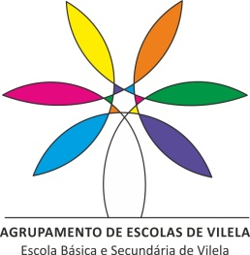
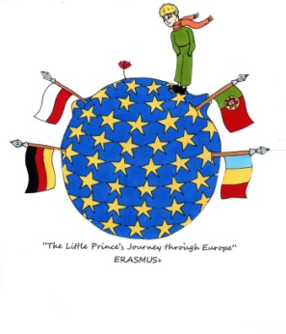

”The Little Prince’s Journey Through Europe”
24th to 26th of November 2021, Vilela, Portugal

Time | November 24th | November 25th | November 26th
09:30 – 11:00 am | - Welcome: watching a video about our school (Agrupamento de Escolas de Vilela)  - Activity: story telling: Subtitle some pictures  - Telling the story | - Watching the Portuguese play “The Little Prince visits Vilela”  - Activity: creating and telling a story using some props. | - Virtual meeting for the coordinators  - Activity: mime a story: Each country has to mime a story Students may use vocal sounds, corporal movements, musical instruments…)

Note: we will send you the pictures you will need on November 24th
We will suggest the props you will need on November 25th
We will choose de story you will need on November 26th

