Our trip to finland
It has been an amazing experience the week we have spent in Joensuu! The activities were really fun and we are counting the days to see our partners again.
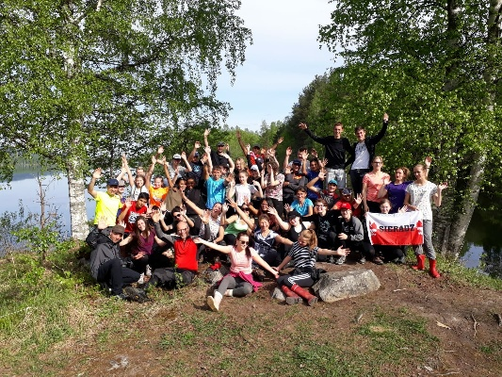
The first day we went sightseeing in Helsinki. We love it because we could go where we wanted with the tram. We were amazed about the hight prices in the main market! There were also many products on the supermarket that were really weird.
The second day in the afternoon we took a train and we went to Joensuu to meet our partners. We were really nervous! When we arrived at their houses we all thought the same. The were really big!
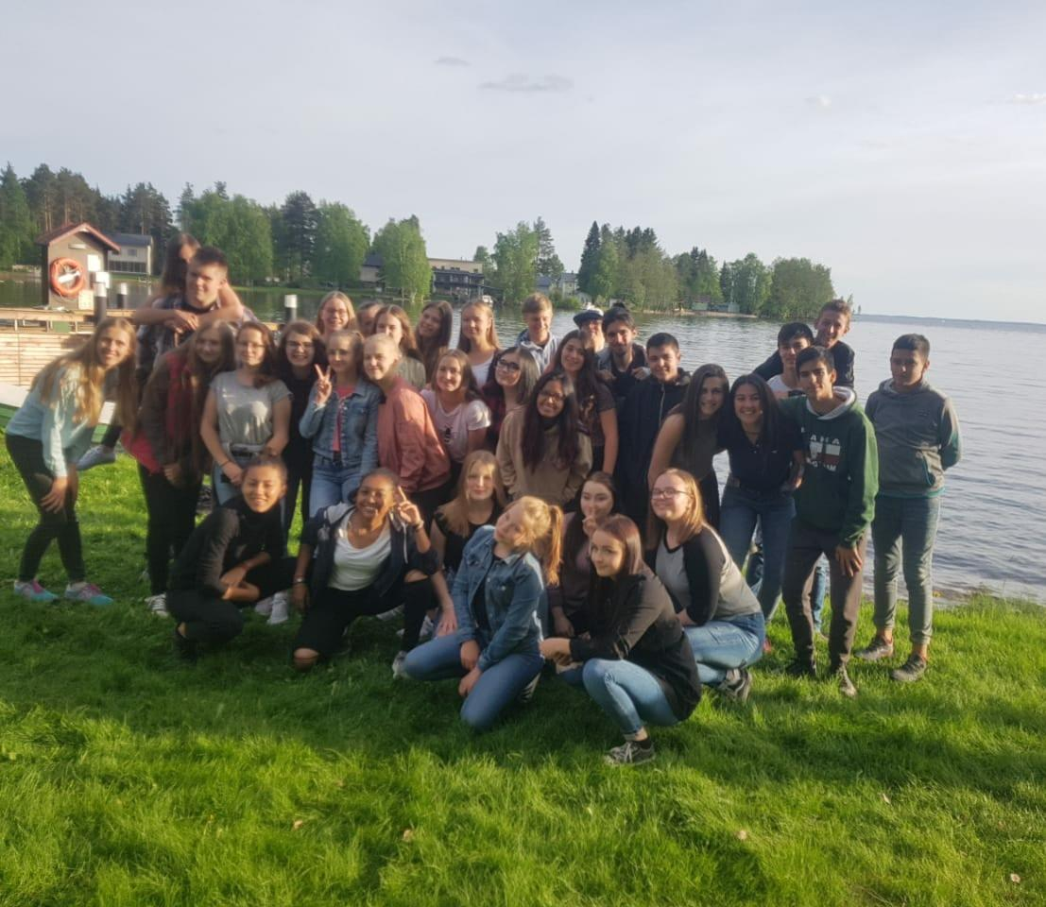
We went to a trip in Koli National park. The hiking was really hard but wothwhile because of the landscapes, they were amazing! There we camped and we stayed in a traditional finnish sauna for a long time because it was cold outside. After spending some minutes in the sauna we ran very fast to a lake next to it because we wanted to swim there. The water was absolutely cold. We also had to prepare our own foods like survivors! At night we sang while we sat next to a fire.
We did more activities like a game in Joensuu, learn traditional music or dances of each country or games in the school. It was one of our best weeks of our lifes and we met a lot of new people!!

