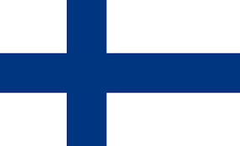
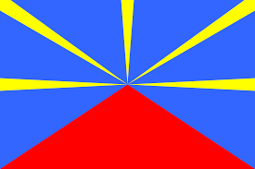

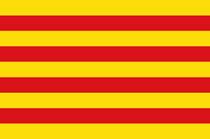

Quizz- Assessment of knowledge of the countries involved
Here’s a few question to see if you know enough about the countries involved in the project (Finland, Reunion Island, Poland and Catalonia). Let’s see who wins!

Quizz made by Joan Sales and Pol Canalda
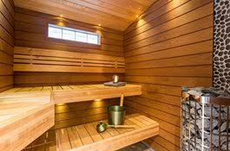
Q1:Finland: What is a typical activity in Finland?
-Bear Hunting
(This is a wrong answer)
-Sauna
(This is a correct answer)
-Go surffing
(This is a wrong answer)
-Go cycling
(This is a wrong answer)

Q2:Finland: Which of this languages is not spoken in Finland
-Swedish
(This is a wrong answer)
-Russian
(This is a wrong answer)
-Norwegian
(This is a correct answer)
-Sami
(This is a wrong answer)

Q3:Poland: One is not a polish typical dish
-Tarte Tatin
(This is a correct answer)
-Mazurek
(This is a wrong answer)
-Bigos
(This is a wrong answer)
-Gulasz
(This is a wrong answer)

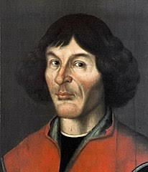
Q4:Poland: Mikolaj Kopernik was a very famous...
-Architect
(This is a wrong answer
-scientist
(This is a correct answer)
-Musician
(This is a wrong answer)
-artist
(This is a wrong answer)

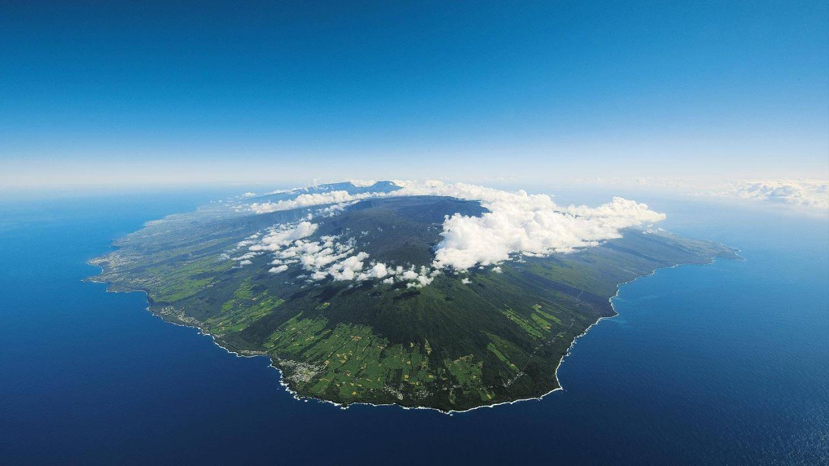
Q5:Reunion Islands: Which is the Reunion Island's capital city?
-Fontainebleau
(This is a wrong answer)
-Paris
(This is a wrong answer)
-Reunion
(This is a wrong answer)
-Saint-Denis
(This is a correct answer)

Q6:Reunion Island: How big is Reunion Island's surface?
-830,2 km2
(This is a wrong answer)
-1300 km2
(This is a wrong answer)
-2500 km2
(This is a correct answer)
-4300 km2
(This is a wrong answer)

Q7:Catalonia: How many stripes does the catalan flag have?
-2
(This is a wrong answer)
-9
(This is a correct answer)
-3
(This is a wrong answer)
-10
(This is a wrong answer)

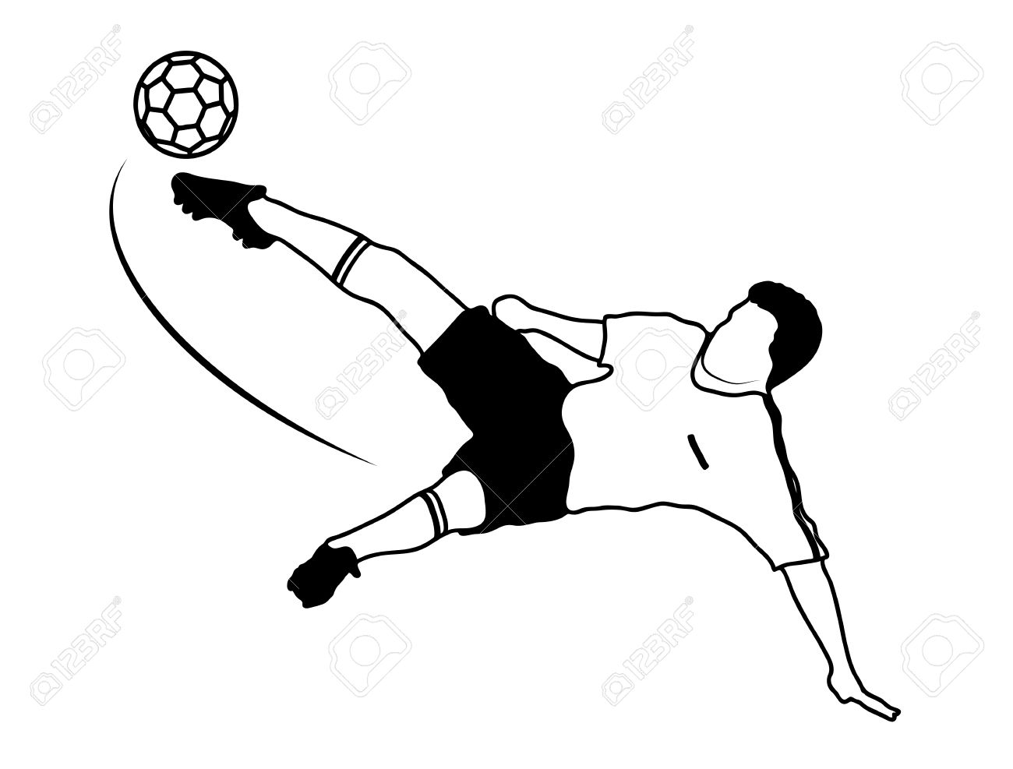
Q8:Catalonia: Which is objectively the best catalan football team?
-FCBarcelona
(This is a correct answer)
-Real Madrid
(This is a wrong answer)
-RCDEspañol
(This is a wrong answer)
-Atlético de Madrid
(This is a wrong answer)

