ISTRAŽIVAČKI ZADACI
Vučedolska golubica – istraži i zapiši!

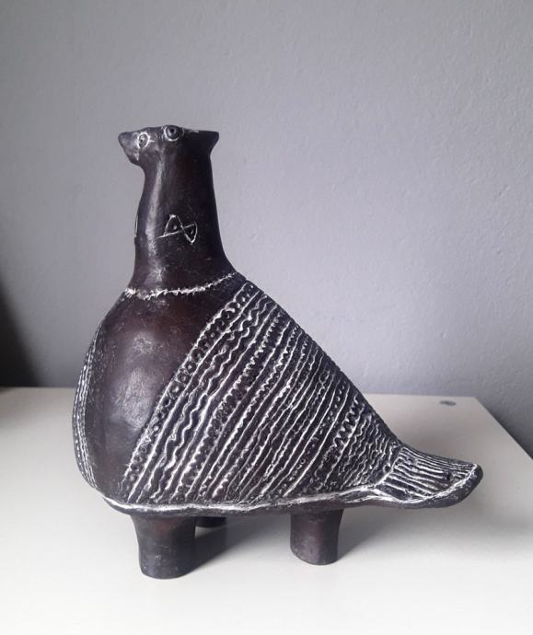
1. Koji je još naziv za Vučedolsku golubicu?
2. Kada i gdje je pronađena?
3. Opiši Vučedolsku golubicu?
4. Koja joj je bila namjena?
5. Gdje se trenutačno nalazi?
________________________________________________________________________________________________________________________________________________________________________________________________________________________________________________________________________________________________________________________________________________
________________________________________________________________________________________________________________________________________________________________________________________________________________________________________________________________________________________________________________________________________________________________________________________________________________________________________________________________________________________________________________________________________________________________________________________________________________________________________

