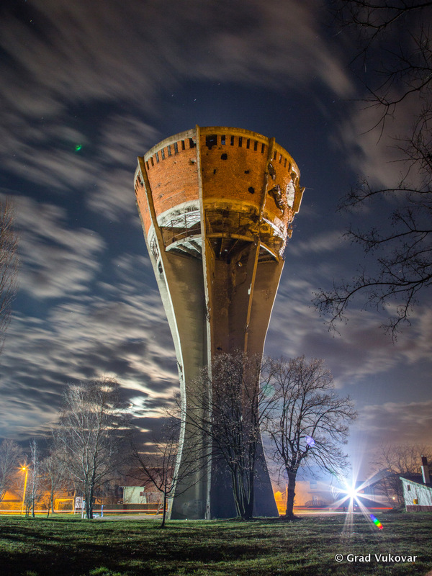
Istraži i zapiši:
- Koju obljetnicu bitke za Vukovar obilježavamo?
- Kada je 18.11. proglašen državnim praznikom?
- Kako glasi puni naziv praznika?
- Što simbolizira Vukovarski vodotoranj?

Bitka za Vukovar

_______________________________________________________________
_______________________________________________________________
_______________________________________________________________
___________________________________________________________________________________________________
___________________________________________________________________________________________________
___________________________________________________________________________________________________
___________________________________________________________________________________________________
___________________________________________________________________________________________________

