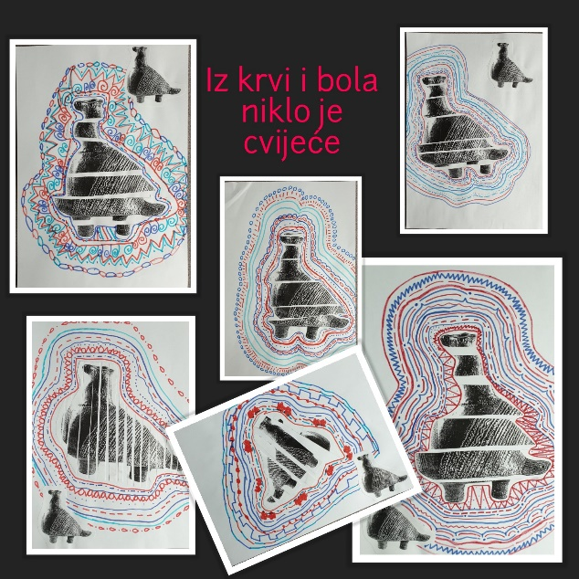
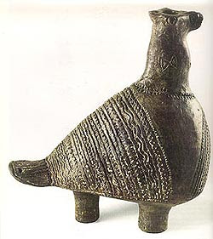
Vučedolska golubica (jarebica, grlica)
Istraži i zapiši:
- Što je vučedolska golubica?
- Gdje i kada je pronađena?
- Tko je autor djela?
- Čemu je bila namijenjena?
- Gdje se danas nalazi?

___________________________________________________________________________________
___________________________________________________________________________________
___________________________________________________________________________________
___________________________________________________________________________________
___________________________________________________________________________________
___________________________________________________________________________________
___________________________________________________________________________________

