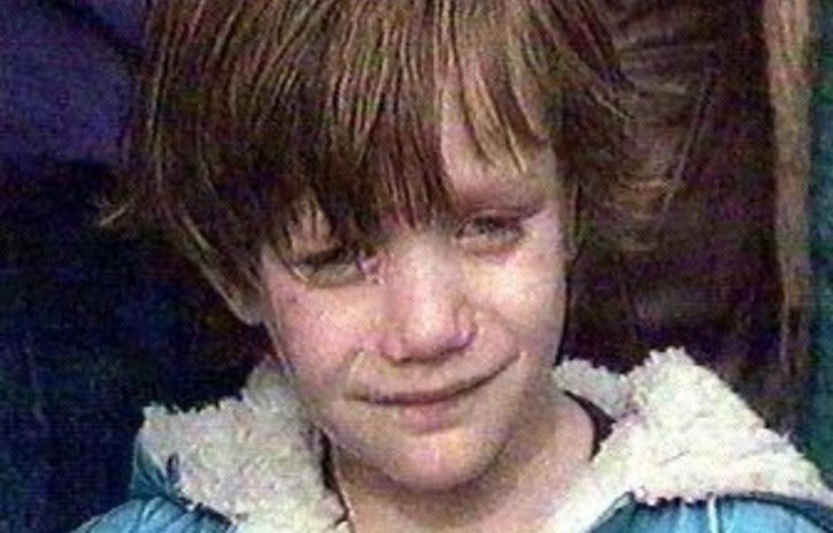
Napiši pismo djevojčici u plavom kaputiću.
Istraži i zapiši:
- Kako se zove djevojčica u plavom kaputiću?
- Koliko je imala godina kada je napustila Vukovar?
___________________________________________________
___________________________________________________

________________________________________________ ,
_____________________________________________________________________________________
_____________________________________________________________________________________
_____________________________________________________________________________________
_____________________________________________________________________________________
_____________________________________________________________________________________
_____________________________________________________________________________________
___________________________________

