(CRO)
ACTIVITIES 2 – PI ART

Martin Krzywinski is a scientist who specializes in bioinformatics, or using computer science and statistics to understand biological data. Krzywinski started publishing his pi art in 2013, beginning with this visualization.
Each digit of pi is represented by a dot of a different color: 3 is orange, 1 is red, 4 is yellow, and so on. Krzywinski then folded these colored dots, each of which represents a different digit ("1" or "4"), into a spiral.
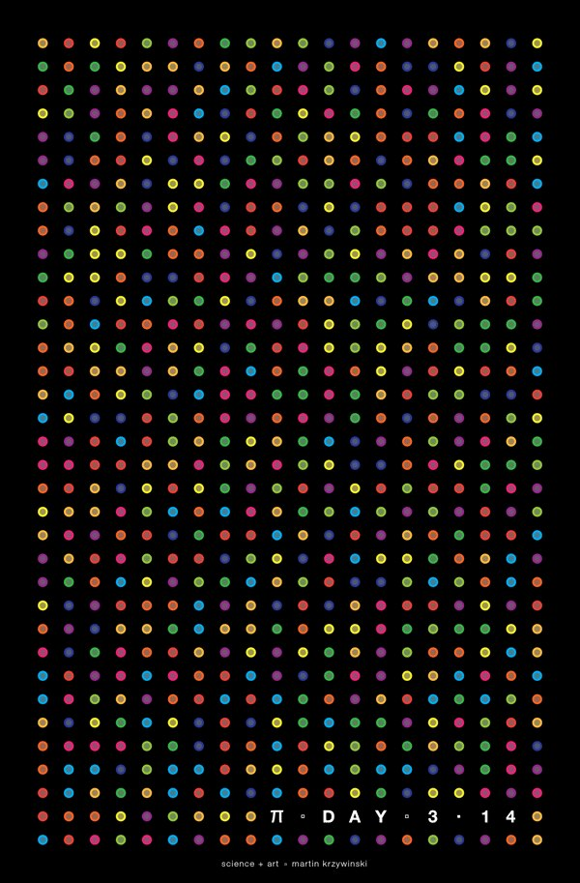
Source:
http://mkweb.bcgsc.ca/pi/

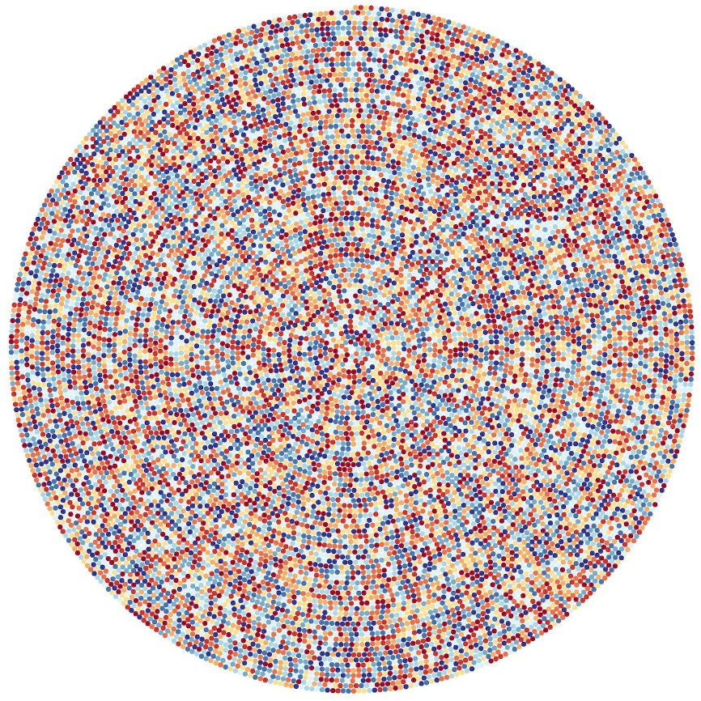
Create your own color code and create a pi-dot image in GeoGebra or on paper.

