Blocks with GeoGebra

Using an isometric coordinate system you can easily construct a "building" with several cubes (blocks).
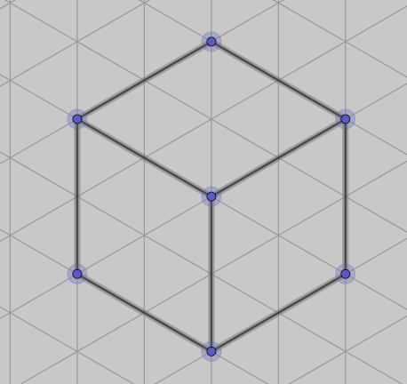
Open a file with an isometric coordinate system.Construct a 3d object, a cube. You can decide if you take 2 units or more for the length or only one. (If you need midpoints of segments an even number of units are better). By marking the whole cube and right mouse click you can hide all labels and the coordinate system.

In an easy way you can construct connected blocks, in a row or in other positions.

Task 1:
Construct a picture with 3 or 4 blocks next to each other (not necessarily in a row).
Question: How many different arrangements of blocks can you have with 3 (4) blocks?

Task 2:

Export your picture (coordinate system should be hidden)e.g. into PAINT and colour it.

Task 3:

Construct arrangements that are similar to those that you can see on the pictures.

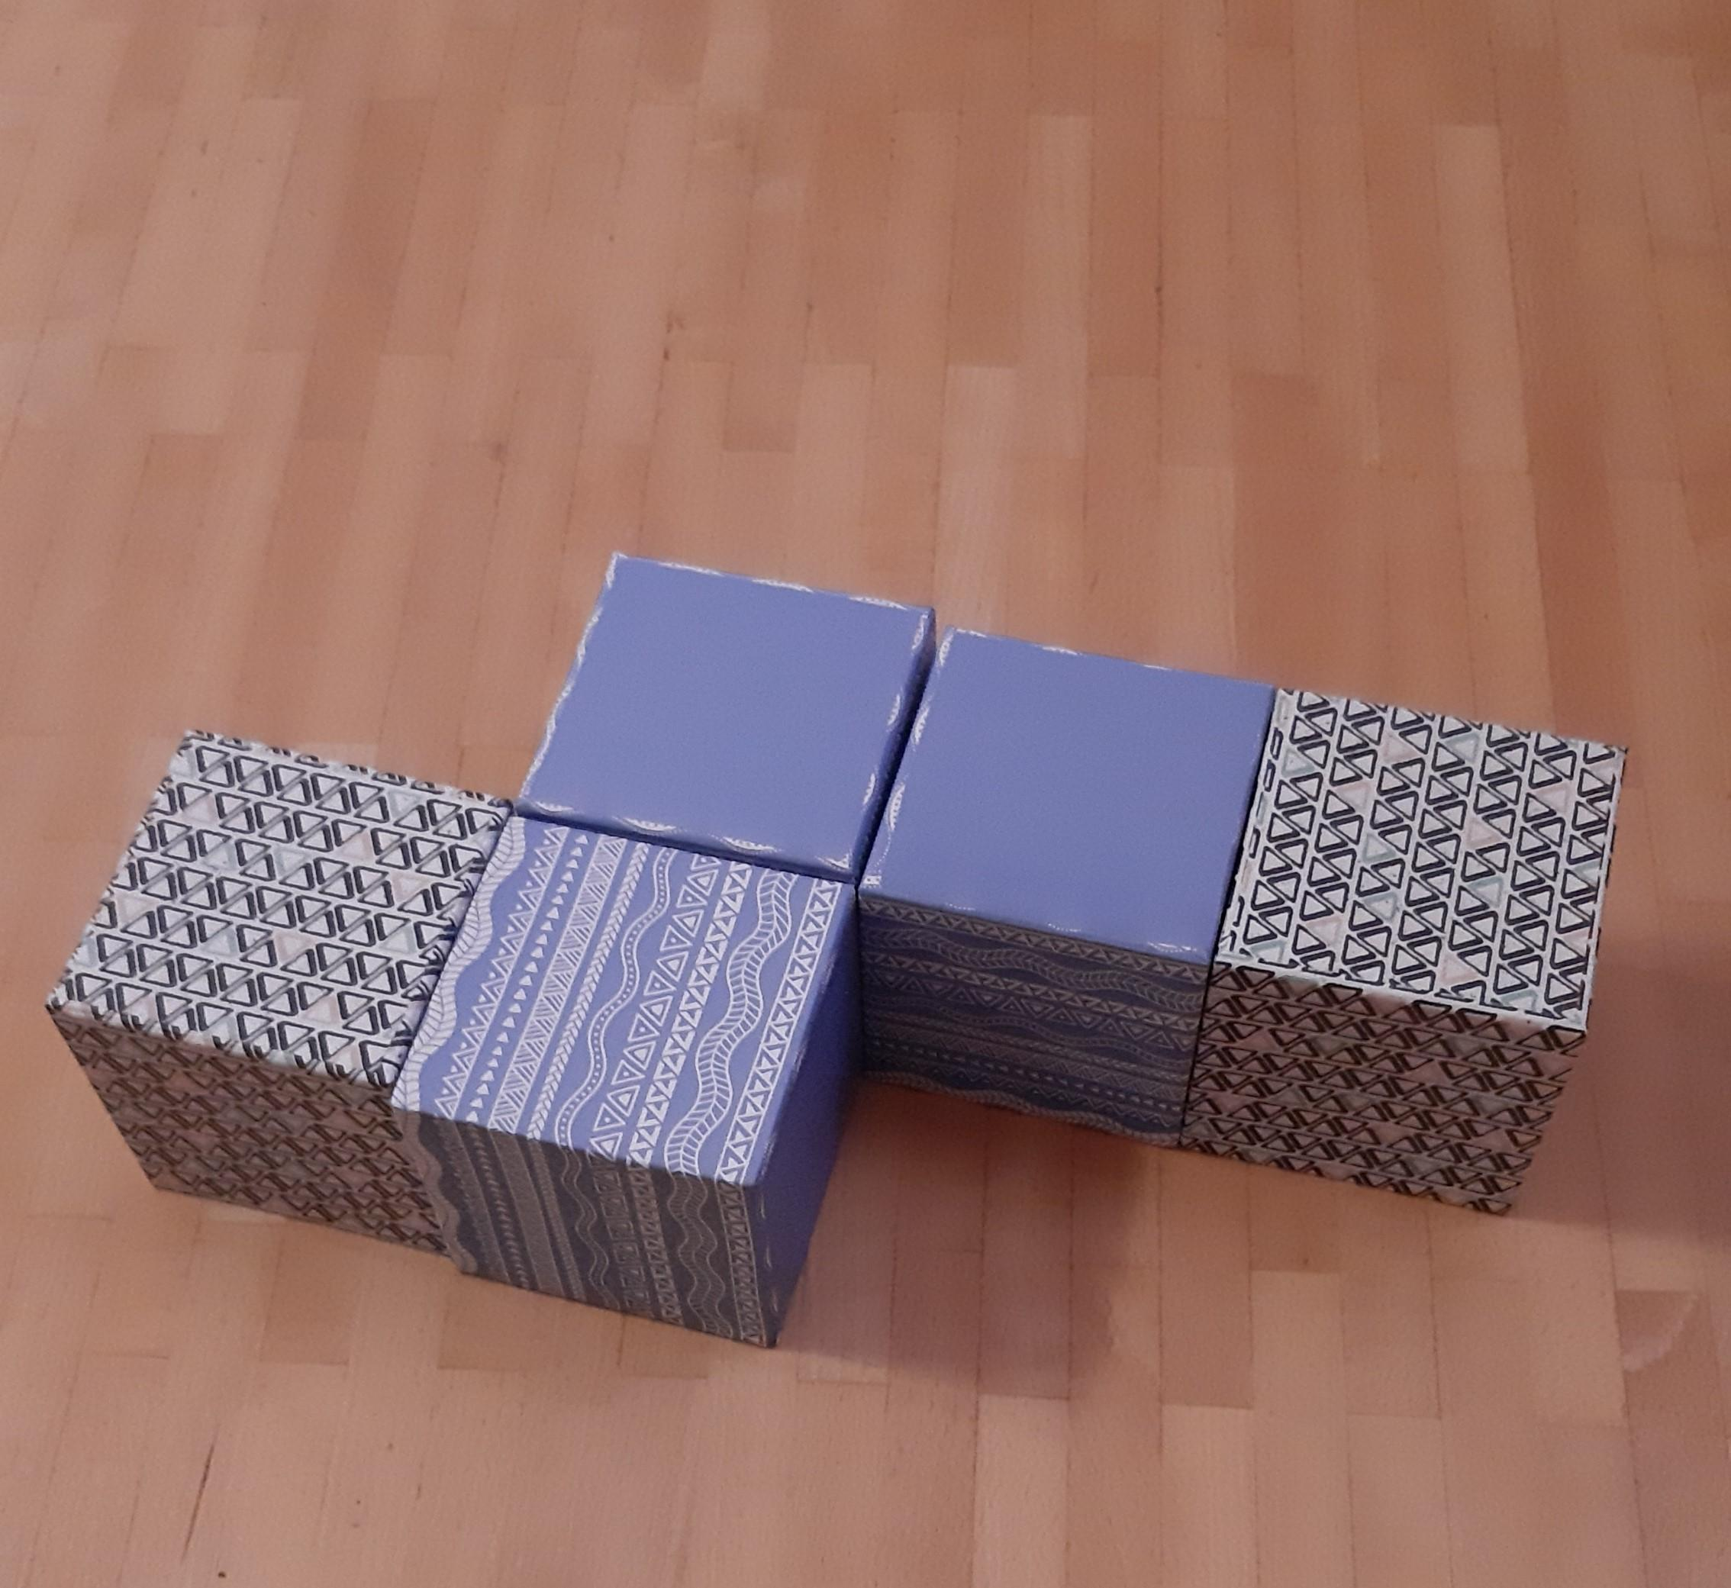
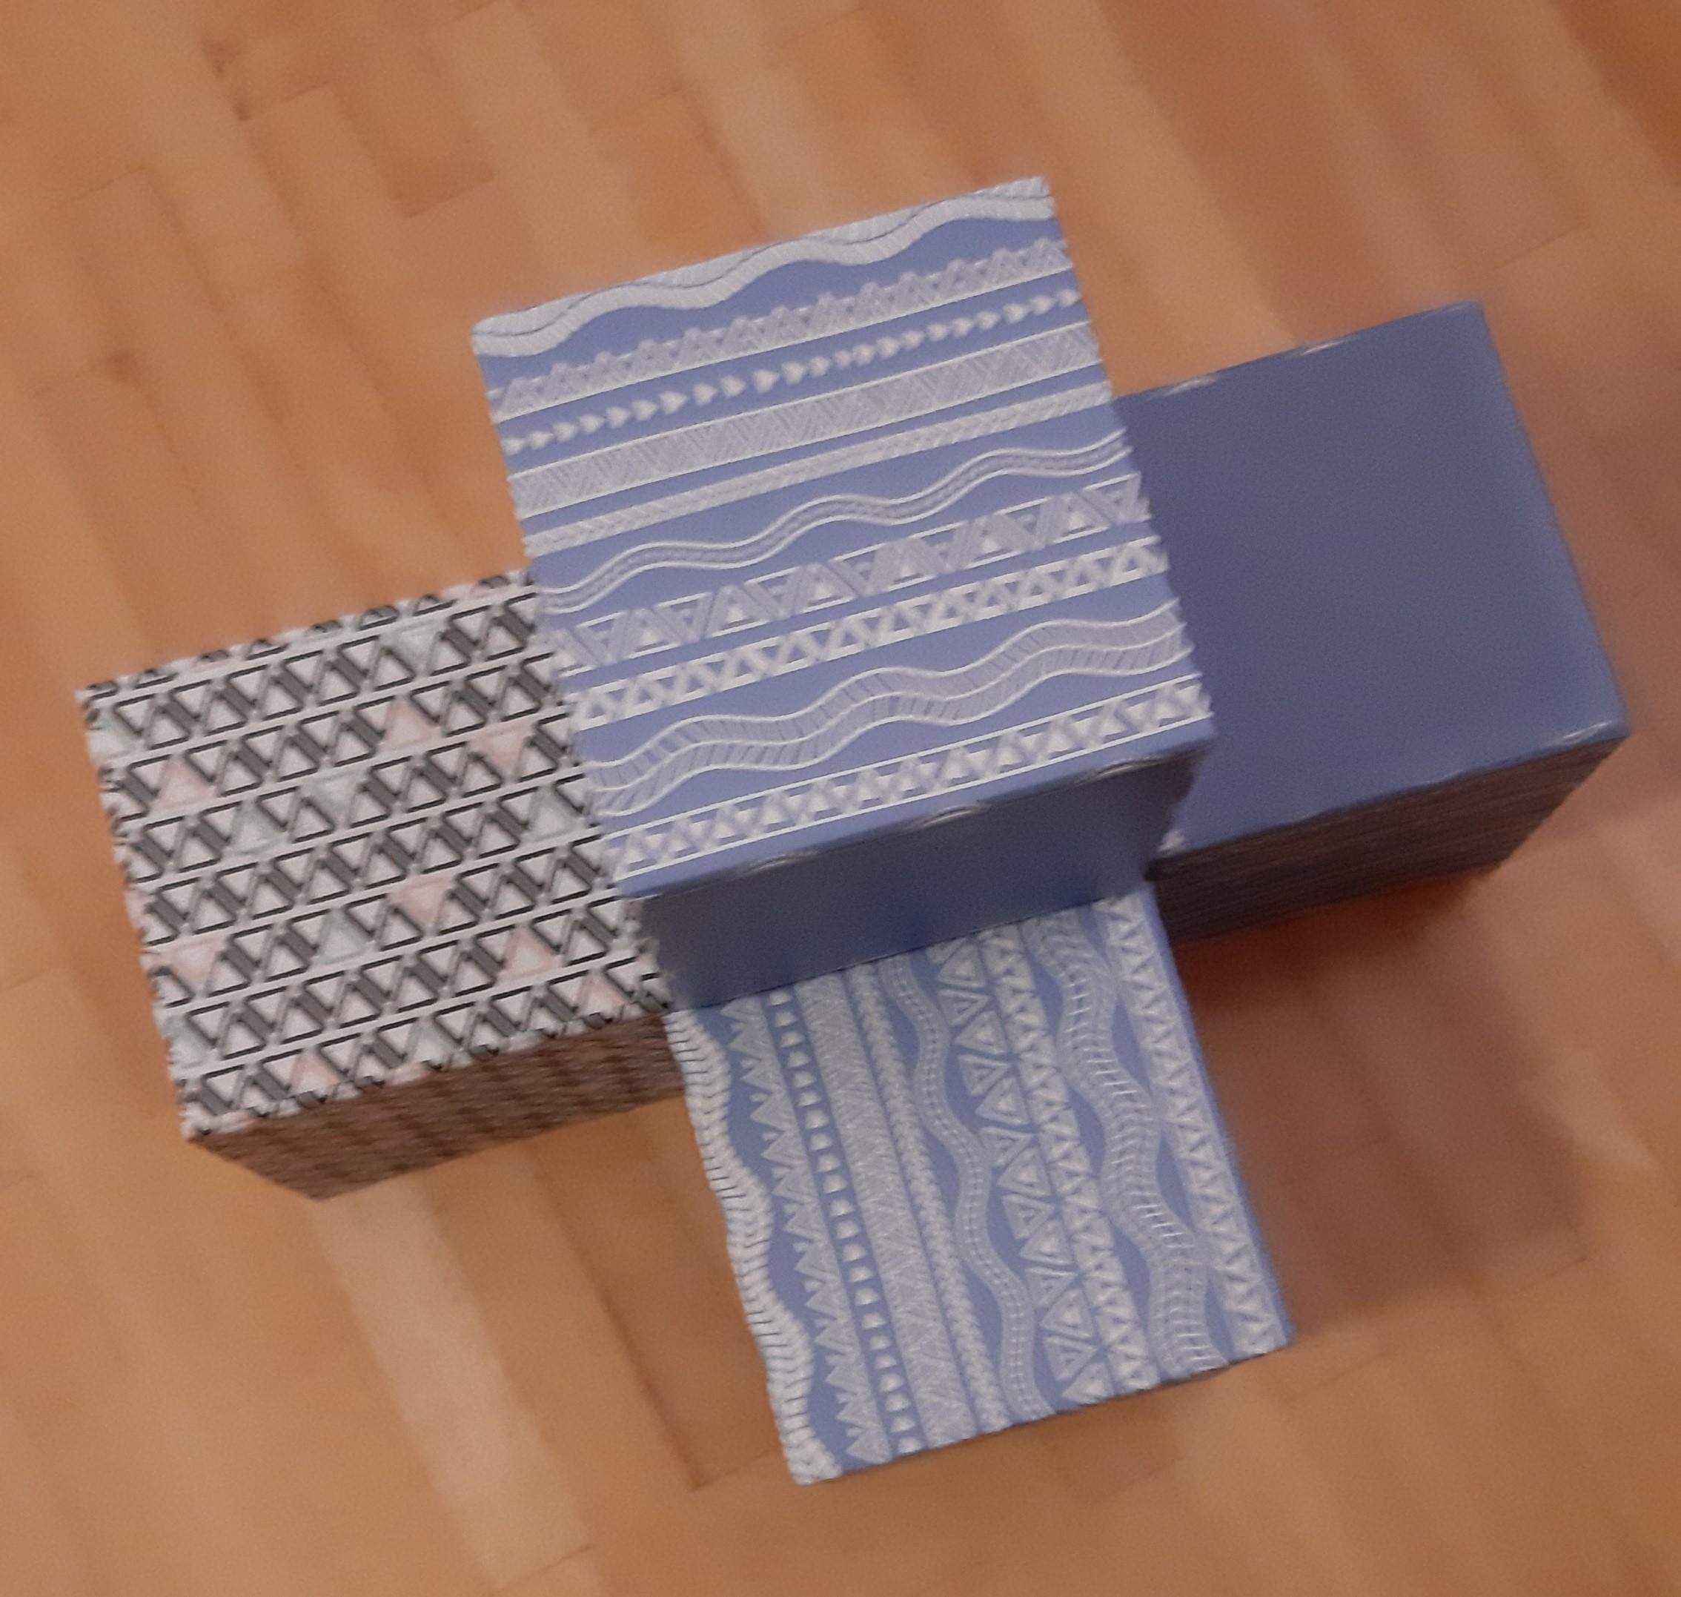
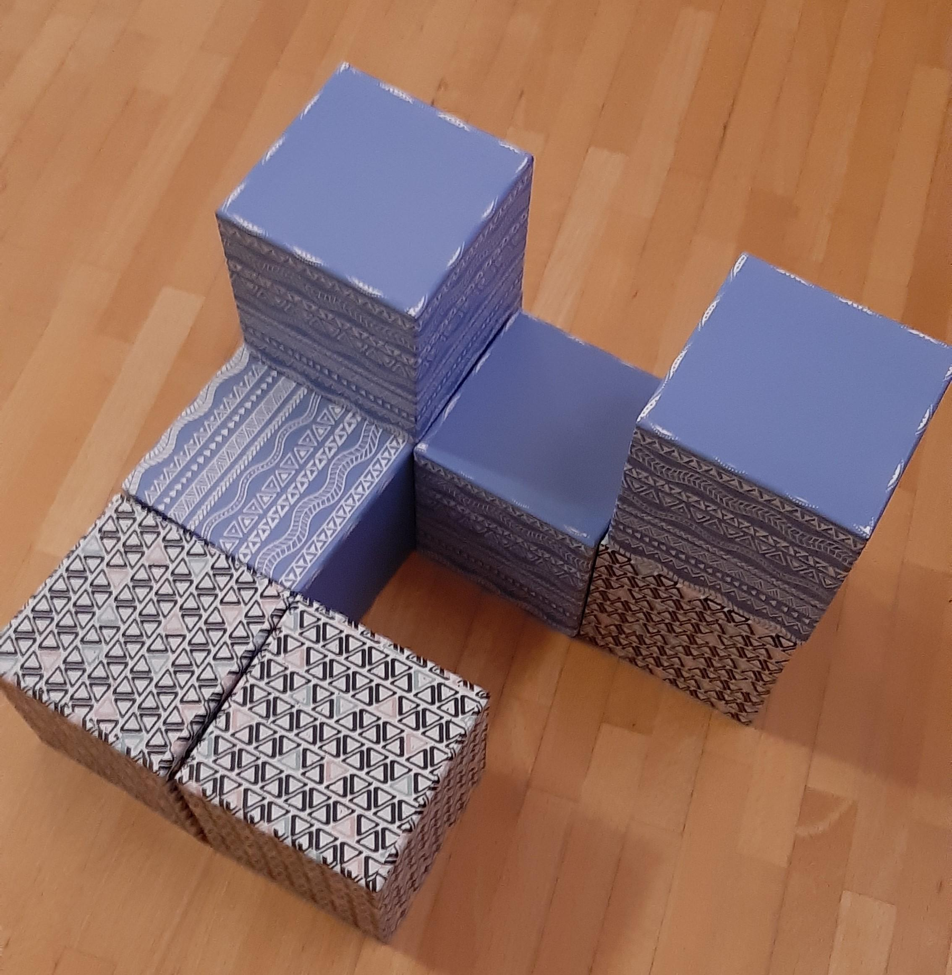

2020, Monika Schwarze, PGU Unna

