Animations with GeoGebra

I will show you how to animate objects to create wondefrul pattern
Step 1: Create with polygons (triangle, quadrilateral, ..) by using the command midpoint a so-called string art.

Schritt 2: If completed it may look like the right picture.

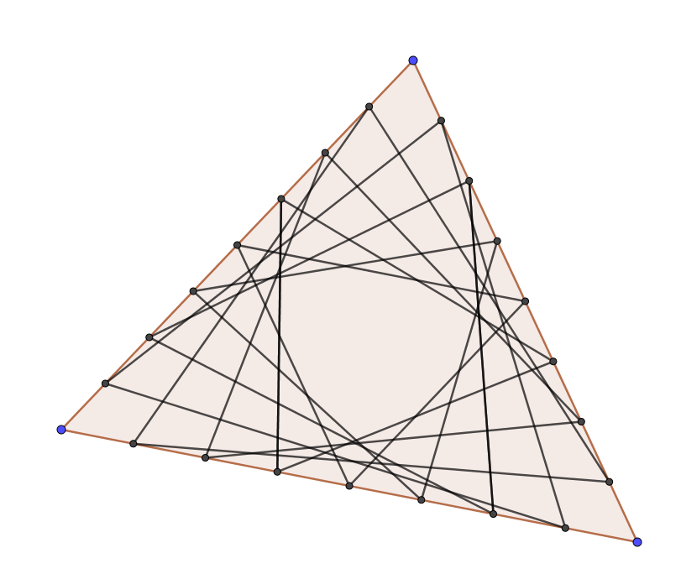
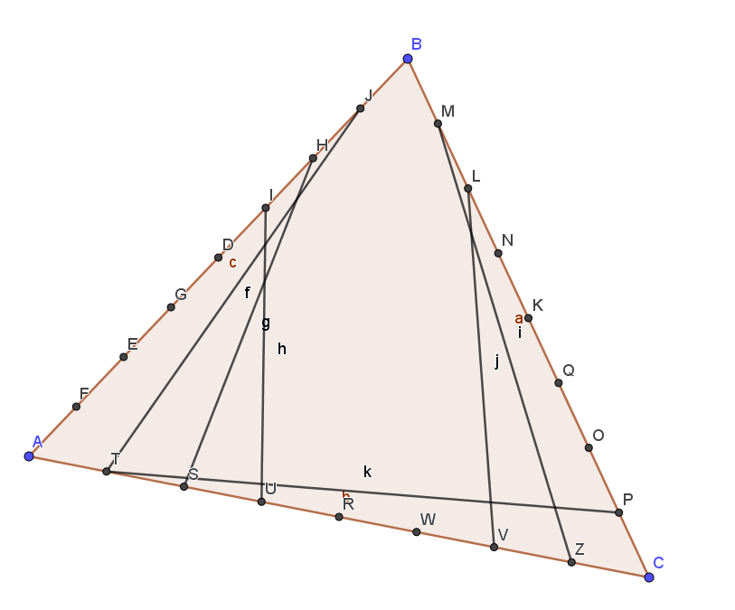

Step 3: So animation works!

Point A should move on a segment in one direction and back. Point c should move on a circle. There are two different ways of animation.
Construct a segment that is NEAR point A but not through point A and a circle with midpoint and point (this point cannot be C). Then use the command „Attach point“ by first clicking on A, then on the segment. Now point C remains and moves on the segment.
Do the same for point C. Attach it on the circle line.

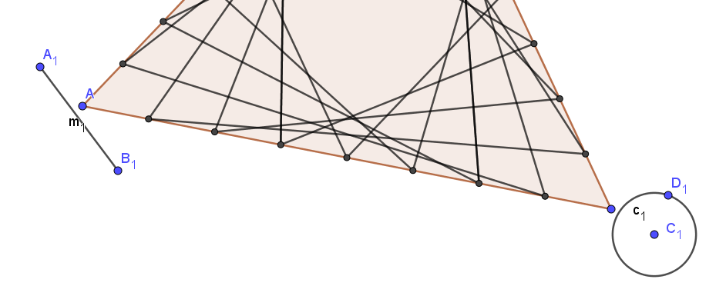

C

Right click on point A -> animation makes point C move on the segment and point C on the circle. With rightclick on the animated points and object properties -> algebra you can change speed (between 0.1 and 4 works well) steps. By object properties -> repeat you have different options. For animation on segments I prefere oscillating.

Before hiding the segement and the circle you can try out the best position for segment and circle. You can animate all basic poins (blue points). The artwork will be nicer if you colour some areas (you have to makr points of intersectoin before doing this!)
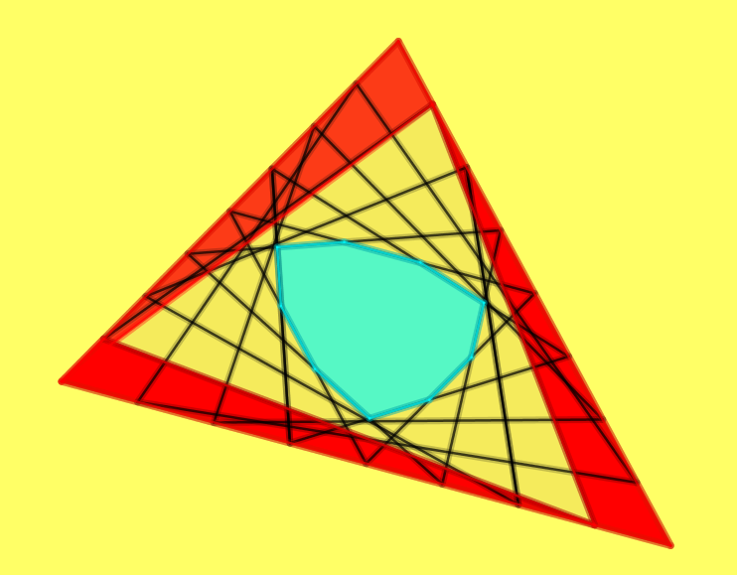
.

You may have a look at these geogebra files:
file 1: https://bit.ly/39RKEqd file 2:https://bit.ly/38MUesY

You may be inspired by these creations!
Good luck and have fun!
