House project
1. Watch the tutorial on Youtube: https://youtu.be/yGHj_tpAJ5M
2. Try to construct different forms of houses. See examples on the picture.

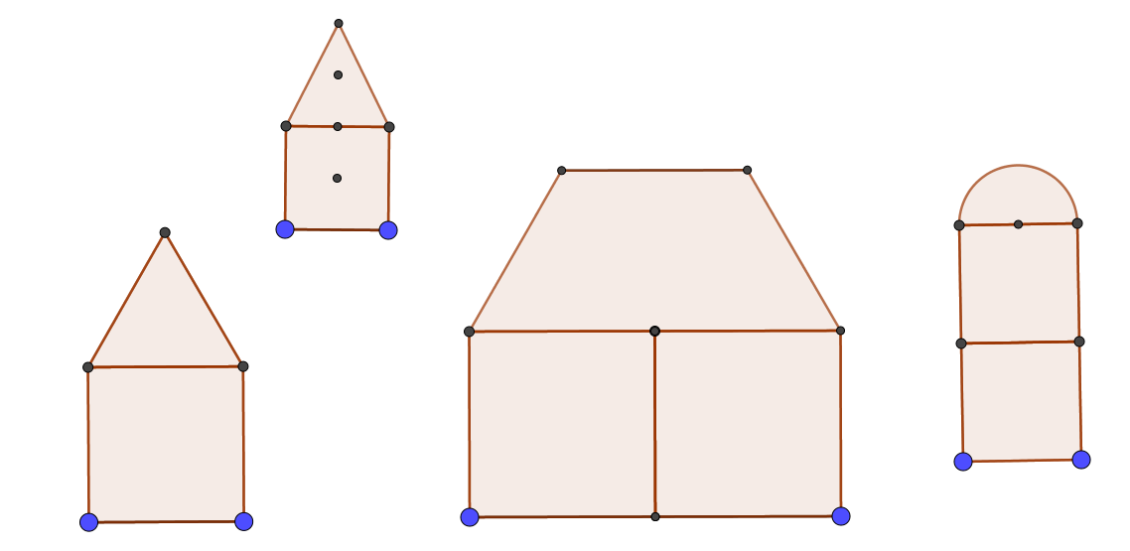
The blue points are basic objects. You may hide some points or segements when you create the tool (or remove later).

3. Test your tools! Important: all house tools should be in only one ggb-file! Name your file as e.g. all houses.ggb (this file will be your basic file) and use it for differents new files which you rename first.
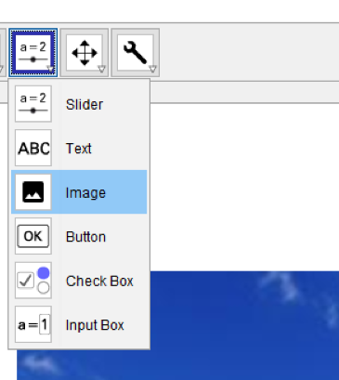
4. Import a suitable picture e.g. from www.pixabay.com and put there some houses. (See the screenshot with GeoGebra 5.0).

5. Then you can put houses by using your tool(s).

6. you can colour it in GeoGebra or import it e.g. in PAINT (or another image editing software).

This one of the results that were sent by my students.

