y=ax² +bx +c
HeadPhone
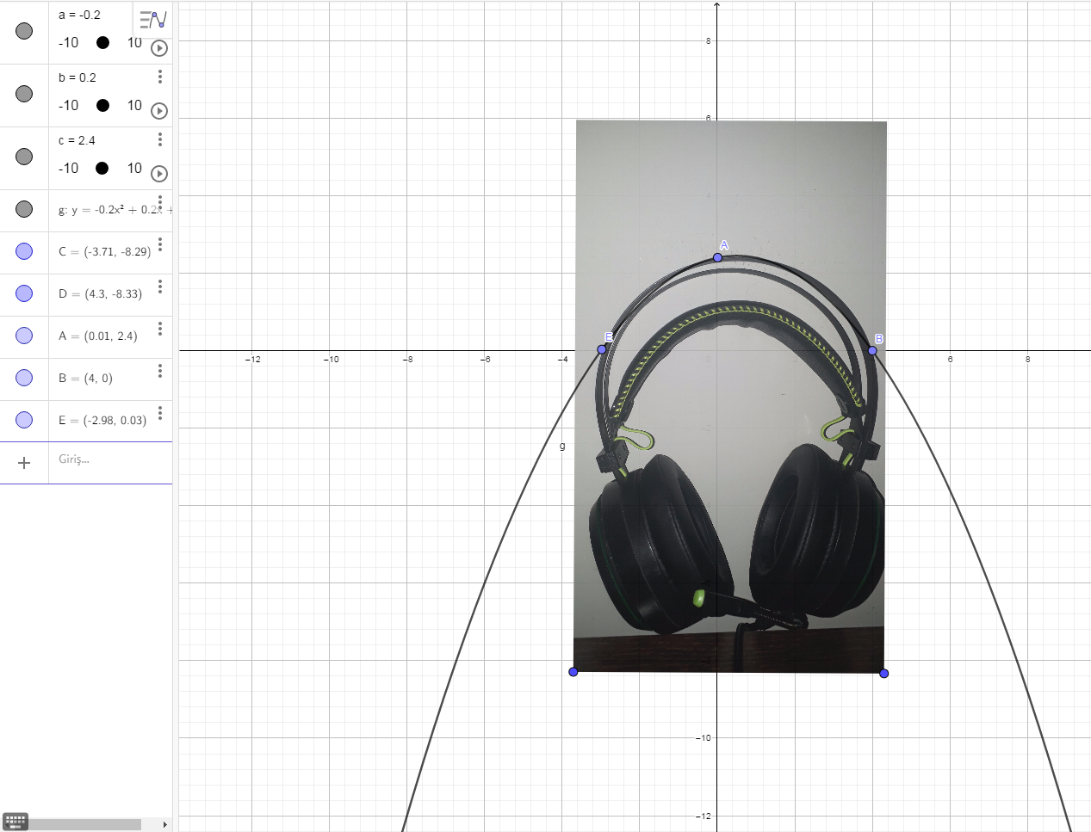

a(-0.2) b(0.2) c(2.4)
g:y=-0.2x² + 0.2x + 2.4
B(4.0)
E(-2.98 0.03)
Headphone has a shape of parabola
Samet Bayram 11/A Gorele Anatolian High School

