Özlem Topal Busenaz Eşkin 11/A-Gorele Anatolian High School
y=ax²+bx+c
a(1.0) b(-0.2) c(-0.6)
f:y=x²- 0.2x-0.6
C=(-0.69,0.01)
D=(0.88,0
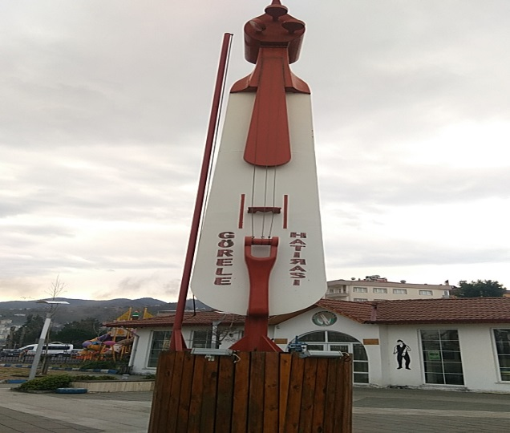
GÖRELE KEMENÇE ANITI

