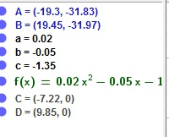
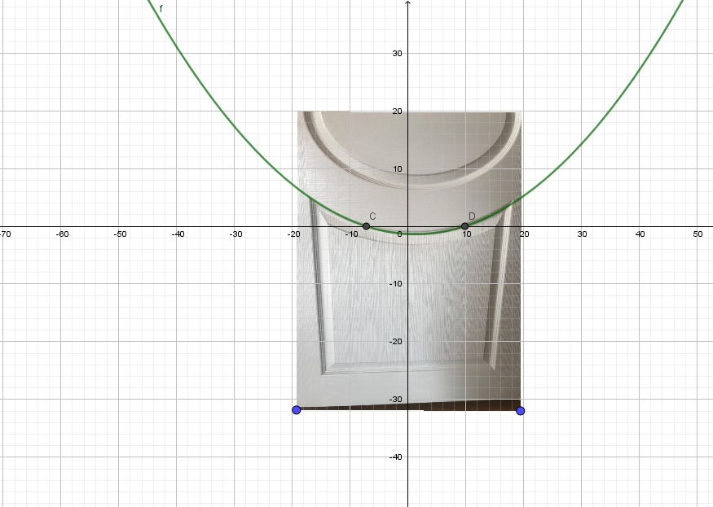
GÖRELE ANATOLIAN HIGH SCHOOL 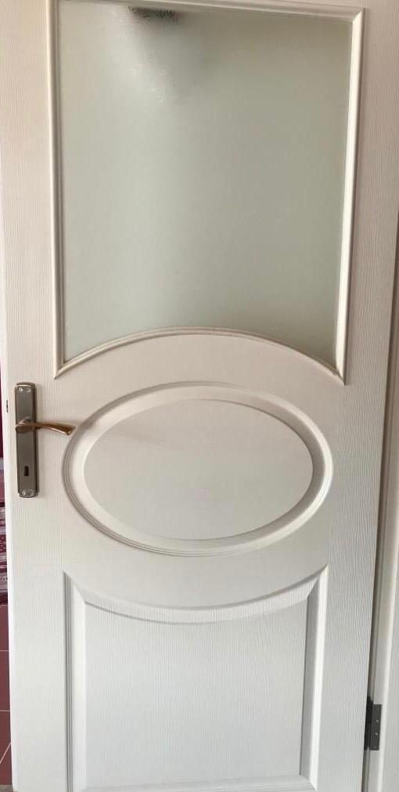

MELİKE AYDIN - 11/A

