Clock in the math classroom
Private secondary school KLASIKA, Riga, Latvia
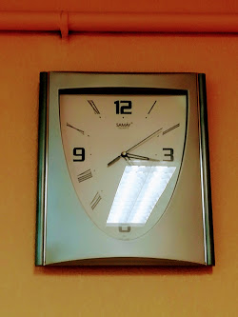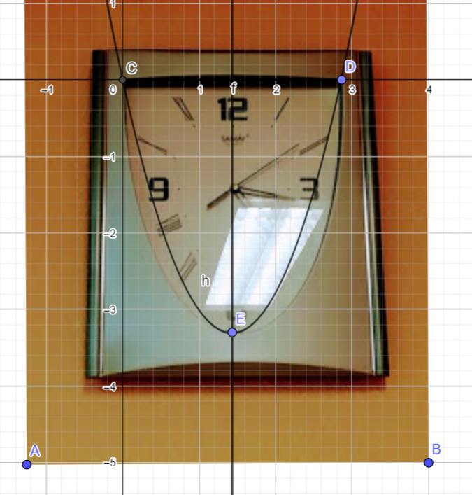

$$y=ax^{2}+bx+c$$
C (0;0) D(2,86;0) E(1,43;-3,3)
$$\left\{\begin{aligned}{2,86}^{2}a+2,86b=0 \\ {1,43}^{2}a+1,43b=-3,3\end{aligned}\right.$$
C=0 a=1,62 b=-4,63
$y={1,62x}^{2}$-4,63x – Equation of Parabola
Eugene Gofenshefer 10 Grade

