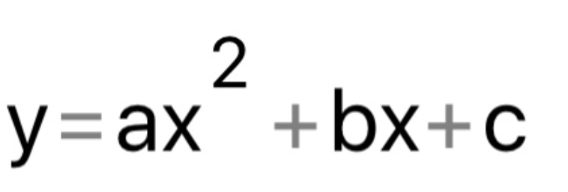
C(1,7) b(-0,12) a(-0,24)
f (-2,9231691553909,0)
e (2,4231691553909,0)
mandarin

Mandarin has a shape of parabola. Goncagül Karaman 11A –Görele Anatolian High School

