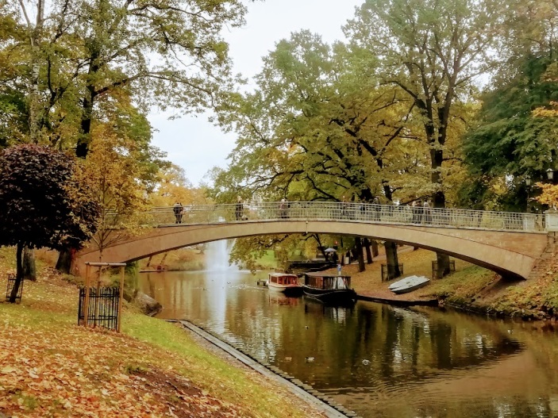
Bridge across the channel in Old Riga
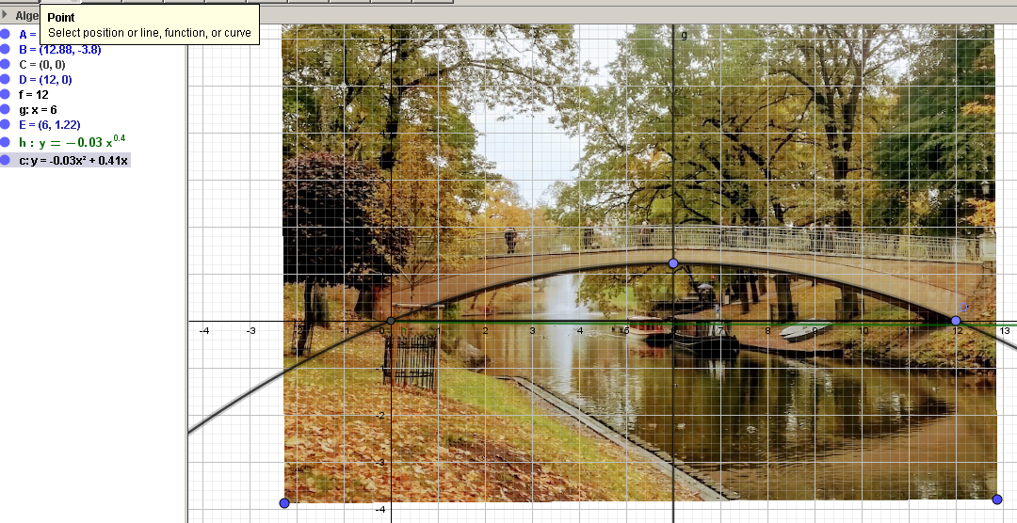
$$y=ax^{2}+bx+c$$
C(0;0) D(12;0) E(6;1,22)
$c=0$ $\left\{\begin{aligned}36a+6b=1,22 \\ 144a+12b=0\end{aligned}\right.$
$a≈-0,034 b=0,408$ $y=-0,034x^{2}+0,408x$
The bridge has a shape of parabola.

Elizaveta Titova 10 b class

