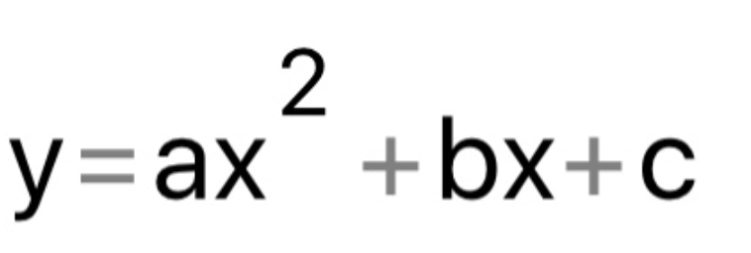

Y= -0,109x^(2)+0,022X+3,917

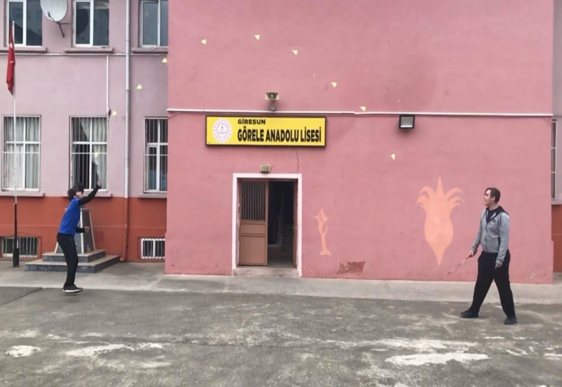
Badmington
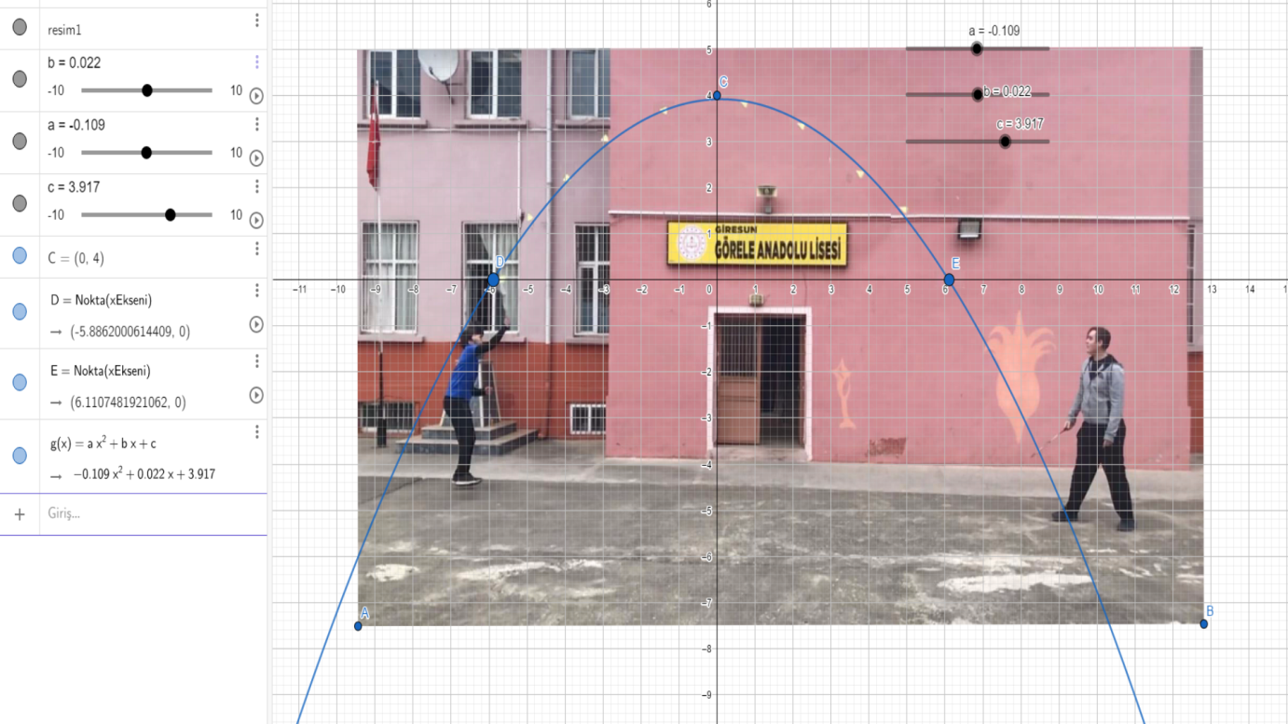

Tunahan Demirbaş And Fensur Kaplan 11/A Görele Anatolian High School

