GORELE ANATOLIAN HIGH SCHOOL/TURKEY
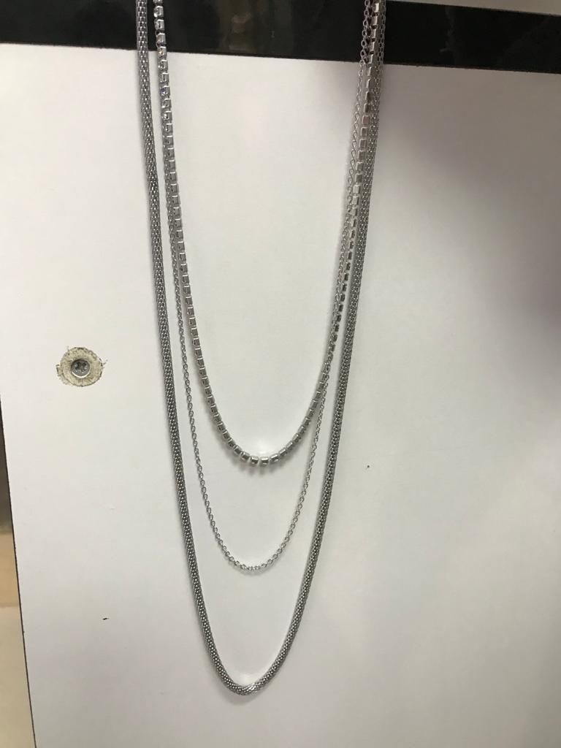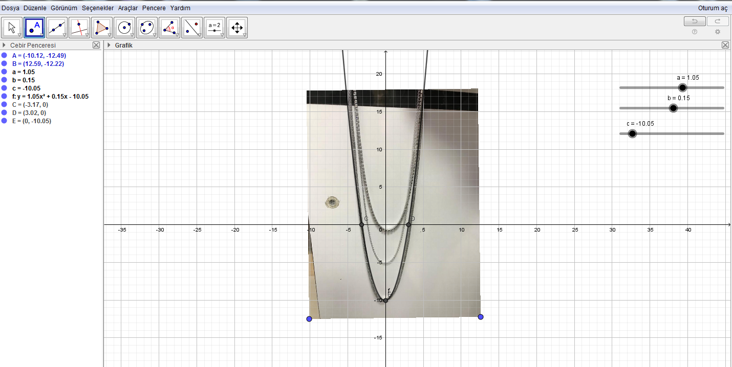
f(x)= 1.05x²+0.15x-10.05
A=(-10.12,-12.49) B=(12.59,-12.22) C=(-3.17,0) D=(3.02,0) E=(0,-10.05)
Yıldız Çoban -11/A
The necklace has a shape of parabola

