GORELE ANATOLIAN HIGH SCHOOL- Damla TOKALAK- Neslihan KÖÇEK 11A

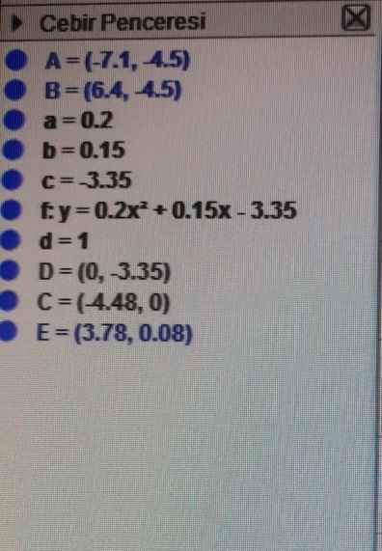

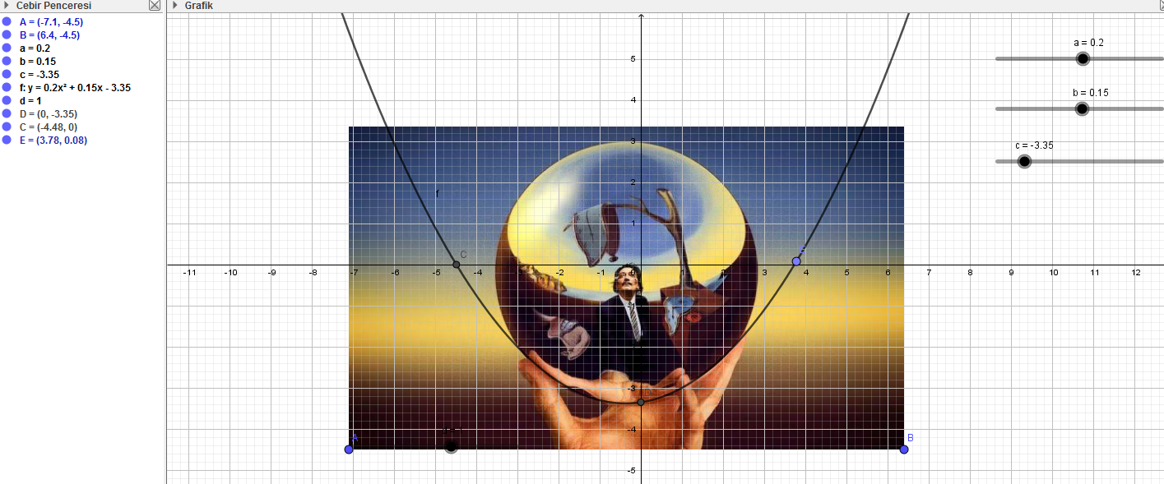

y=ax² + bx + c
y=0.2x² + 0.15x – 3.35

