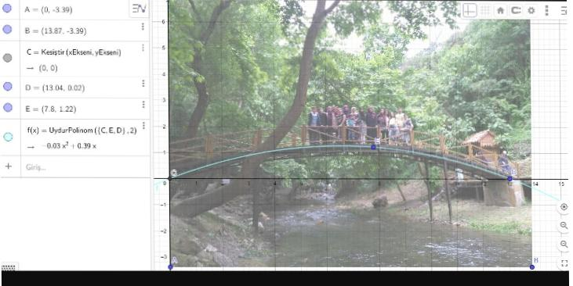
Kurşunlu waterfall bridge

Y=ax²+bx+c
C(0,0) D(13.04,0.02) E(7.8,1.22)
13.04a²+13.04b = 0.02
7.8a²+7.8b = 1.22
C=0 b=0.39 a=-0.03
y=-0.03x²+0.39x
Halime A. Şahin Şen Girl Anatolian Imam Hatip High School
10.Grade

