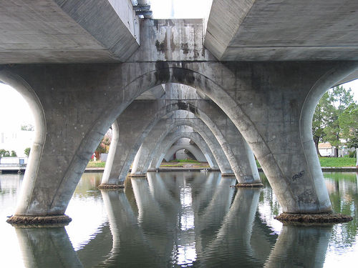
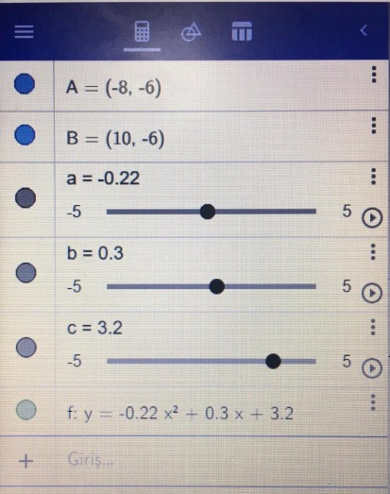

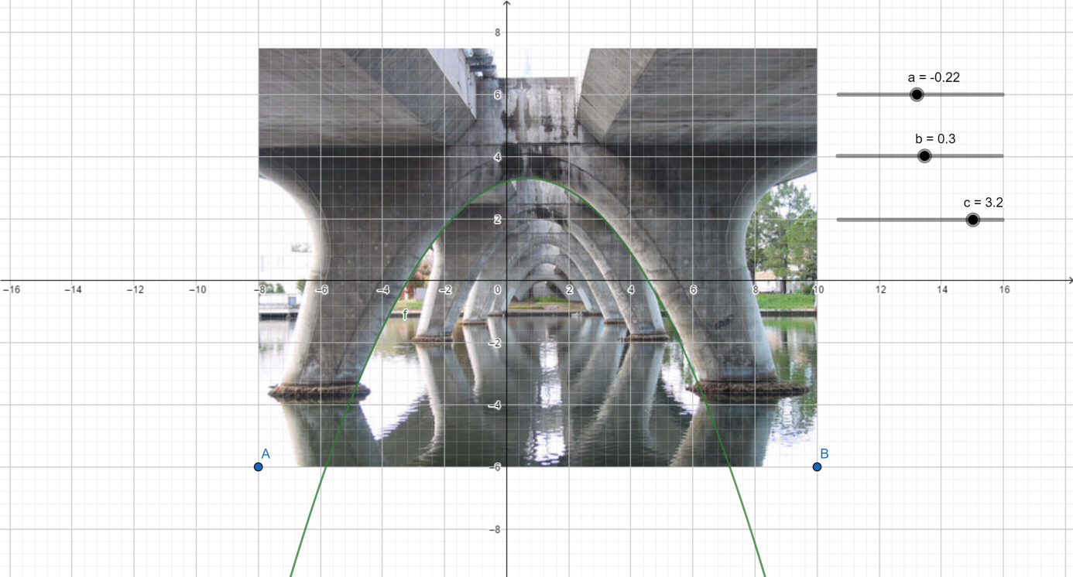
y= ax² + bx + c
y= -0.22x² + 0.3x + 3.2
The bridge has a shape of parabola.

