Hulme Arch Bridge Manchester, England

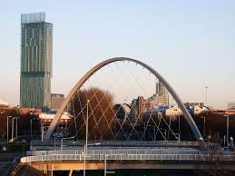

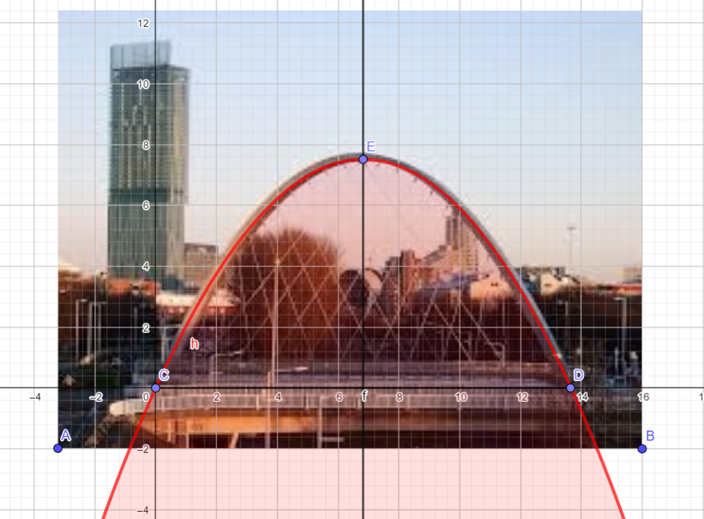

$$C(0;0) D(13,64;0) E(6,82;7,51) y=ax^{2}+bx+c$$

$$\left\{\begin{aligned}{13,64}^{2}a+13,64b=0 \\ {6,82}^{2}a+6,82b=7,51\end{aligned}\right.$$

$$c=0 , a=-0,161, b=2,2$$

$y=-0,161x^{2}+2,2x$ – Equation of Parabola

Daniel Klimkevich 10 Grade

