GORELE ANATOLIAN HIGH SCHOOL- BURÇİN BARUTCU 11A
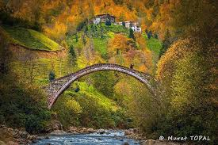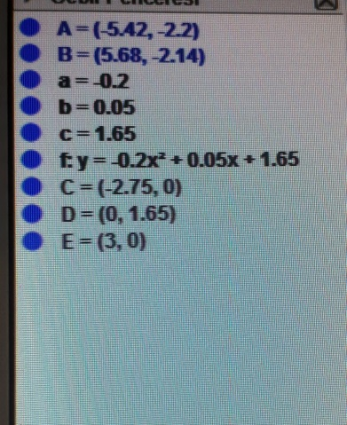
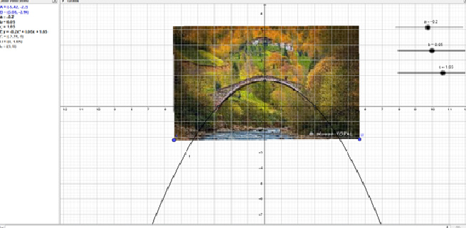
y= ax² + bx + c
y= -0.2x² + 0.05x + 1.65
The bridge has a shape of parabola.

