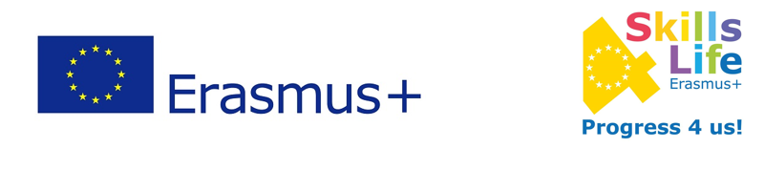
EVALUATION AFTER THE ACTIVITY
EUROPEAN HISTORY OF LEARNING

Work to do: create a digital timeline where there will be references on the history of learning and teaching in your country (different teaching methodologies, learning styles...)

1. Rate your knowledge about the history of teaching and learning in your country.
1 (insufficient) - 2 (sufficient) - 3 (good) - 4 (very good) - 5 (excellent)
2. Can you name any important events in the history of education in your country?
Yes / No
2.1 If the answer is Yes, could you please name them.
____________________________________________________________________________________________________________________________________________________________________
3. Can you name any important people who influenced development of education in your country?
Yes / No
3.1 If the answer is Yes, could you please name them.
____________________________________________________________________________________________________________________________________________________________________
4. Did you like working on this topic?
yes partially no
5. Did you find this topic interesting?
yes partially no

6. Did you use digital tools and social media to learn about this topic?
yes no
7. Do you think digital tools and social media are important to learn?
yes partially no
8. Do you think this activity helped you to improve your way of learning?
yes partially no
9. Do you think this activity developed your sense of initiative?
yes partially no
10. Do you think this activity developed your learning autonomy?
yes partially no

