POLAND
GENERAL INFORMATION  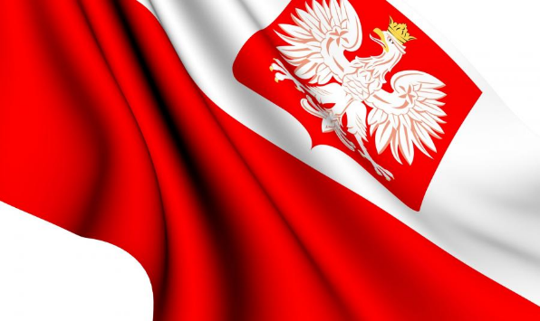  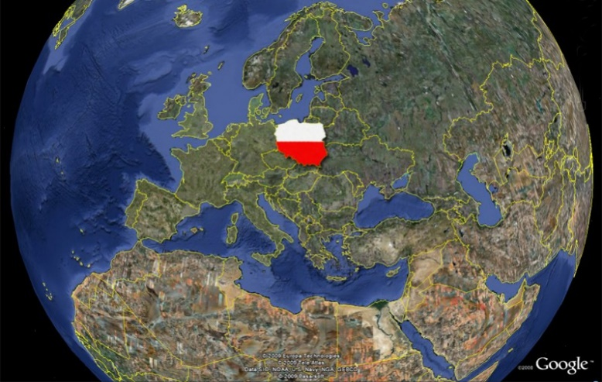 | Capital: Warsaw  Currency: Zloty  Population: about 38 300 000  Official Language: Polish  Country Size: 312 685 sq. km  Climate/Weather: temperate zone with four seasons  Official Government Website:  www.msz.gov.pl (Ministry for Foreign Affairs)  World Heritage Sites:  http://www.culture.pl/en/culture/  http://www.kobidz.pl/app/site.php5/Show/2.html  Poland is a beautiful and diverse country located in central Europe; although because of the historical structure it is said to be a part of Eastern Europe. Poland’s beautiful nature has much to offer – you can hike in high mountains in the South, you can swim in the Baltic Sea in the North and you can sail in many lakes which are located all over the country with a density in the central and eastern Poland. Poland also has also a rich culture and interesting history. It is a democratic country and it is a member of such international organizations like for example the European Union and the NATO.
GREETINGS  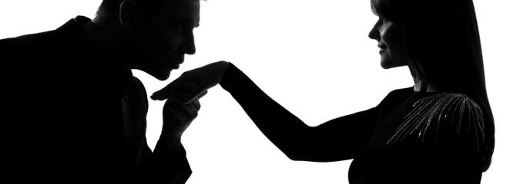 | Poles usually casually greet each other with a simple handshake as most other Europeans do. However, some of them would kiss you for hello. Poles kiss each other three times on the cheek like the French or the Belgians who would always give each other two kisses. What should be noticed is that both kisses and hugs are rather reserved for good friends. Moreover, the old-fashioned way of greeting a woman by a man was to kiss her hand. However, though used by some old-fashioned gentlemen, it is not too common today.  Robert Strybel, Warsaw Correspondent wrote:  Polish Americans visiting relatives in Poland for the first time are often surprised by the prevailing greeting custom. When embraced by a Polish relative who appears about to kiss them, the American often puckers his lips, but the Pole turns his/her head away from the Pol-Am’s mouth and plants three kisses on alternate cheeks one after the other. Kissing on the lips is reserved for lovers and married couples. There are many other forms of greetings and symbolic gestures that first-timers may find exotic, while others will ring a bell. These include:  Hand-kissing: Dashing Polish officers and even enlisted men stationed in Scotland during World War II swept the local lasses off their feet with the gallant custom of hand-kissing, and many mixed marriages ensued. This custom of greeting members of the weaker(?)sex by kissing their right hand has lasted on into the 21st century, although it probably won’t survive another generation or two. President Lech Kaczyñski greeted ladies the traditional way, but his prime minister didn’t.
DANCING  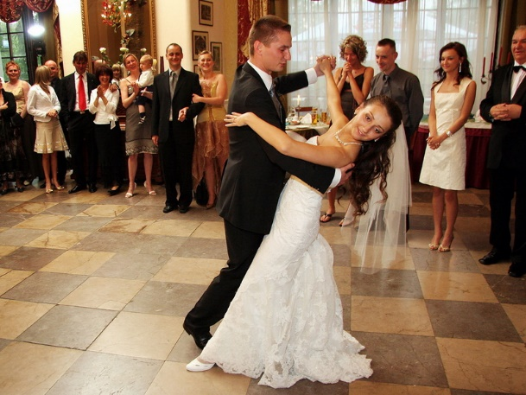  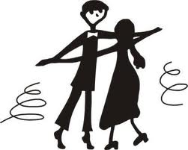 | Poles love dancing and there is no special place or music needed to get them start dancing. Poles are often called in Europe to be alike Spaniards who are rather spontaneous and open to party at any time and place. Nowadays, at discos and bars people dance rather in a group, however when dancing in couples, men should rather respect woman and keep a reasonable distance not keeping her too close to his body.  https://polandian.wordpress.com/2009/05/11/15-things-you-need-to-know-about-polish-weddings-the-survival-guide/  by Jamie Stokes  Proper dancing  Dancing is also a big deal a Polish weddings. It’s the women’s vodka. The first time I went to a Polish wedding my girlfriend said “You know there will be dancing, don’t you?” “Well yes” I said “that’s normal.” I had in mind the vague individual flailing around that every self-respecting Brit regards as dancing. Not so. Proper dancing is expected. In pairs, with feet and everything. Dancing schools make a killing in Poland=couple-dancing=Correct kind of dancing.

