Results of the questionnaire before the activity 1 European History of Learning
Portugal
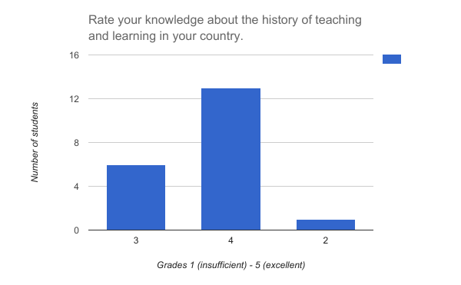
Average grade 3.60
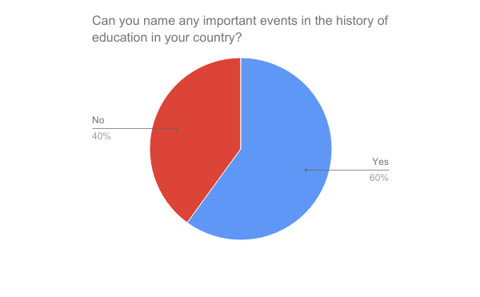

Half of the students could name one event, and the other half named several events. The following events were named:
The first university
University of Lisbon
The 25th april of 1974 was a great day to change the way that education works in our country.
University Of Lisbon
25th april 1974
The firts University of Lisbon in 1288, century XIII
The first university made in Lisbon in the year 1290,
The most important events that happened on April 25, the creation of the University of Coimbra in 1537, the creation of the Colleges of Arts in the sixteenth century. In the sixteenth to eighteenth century the influence of the Jesuits
University of Lisbon in 1289; Creation of Arts Colleges in XVI; Influence of the Jesuits in XV1 - XVIII; First High Schools for Woman's in 1888; Primary education reform and ritual in 1894; Mandatory primary education, End of Christian doctrine in schools, University of Lisbon and Porto, Creation of pre-primary education, Creation of high schools and technical schools and Private Schools in 1910; New State in 1924 - 1974; Propedeutic Education, Military Schools and Pre-primary and primary education in 1974; Professional Educatian in 1983.
the first university was made in Lisbon in 1288, them this university settled in Coimbra in 1537; on the Sec.XVI there were created the arts college, in 1888 was build the first women's high school; in 1894 was the reform of the primary and secundary education; in 1910 was implemented the obligation of the primary school, it was the ent of the Christian doctrine in the schools, it was the creation of the pre-primary school and it was the creation of the high school and tecnic schools.
in 1992 was create EPVL
First university was the one of lisboa in 1288 that later it moved to coimbra in 1537.
Creation of colleges of the arts in the XVI.
Influence of Jesuitas - company of Jesuitas in the XVI XVIII.
Marquês de Pombal ended up with the company of jesus, influenced the teaching in the universities.
First female high school in the 1888.
Reforms primary and secondary education in the 1894.
In 1910 compulsory primary education, the end of Christian doctrine, the creation of primary and secondary schools, as well as mixed schools.
In the 1992 Epvl was created.
Theo first university was the one of Lisboa on 1288 that lateral it moved to Coimbra in 1537.
Creation of colleges of the arts in the XVI.
Influence of Jesuitas - company of Jesuitas in the XVI - XVIII.
Marquês de Pombal ended up with the company of Jesus, influenced the teaching in the universities.
First female high school.
Reforms primary and secondary education in the 1894.
In 1910 compulsory primary education, end of Christian doctrine, the creation of primary and secondary schools, as Wellington as mixed schools.

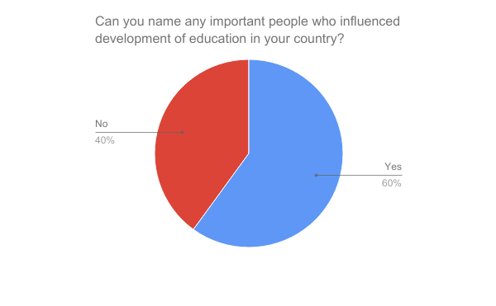

Those who answered positively named mostly more than one person. The following people were named:
João de Deus (8 students) Marques de Pombal (7 students)
D. Dinis (6 students) João de Barroso (5 students)
Veiga Simão (5 students) Gil Vicente (5 students)
Fernando Pessoa (5 students) António Damásio (5 students)
Bartolomeu de Gusmão (5 students) Garcia de Orta (5 students)
Sobrinho Simões (4 students) Nuno Peres (3 students)
Jerman Saraiva (3 students) Luis de Camões (3 students)
Fernando Lopes (2 students) Infante D. Henriques (2 students)
Mário Soares (1 student) Salazar (1 student)
Pedro Simoes (1 student) Pedro Nunes (1 student)

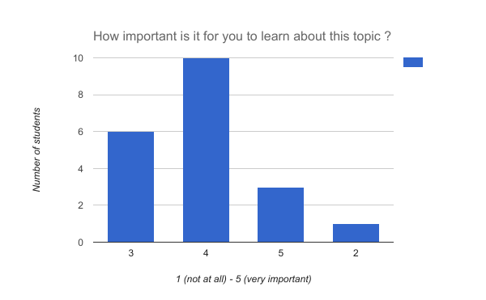
Average 3.75

