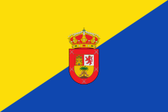  SPAIN  LOCAL COMPANIES VISITS : each partners visit local comBpanies in order to learn works’ rules & regulations  SPAIN  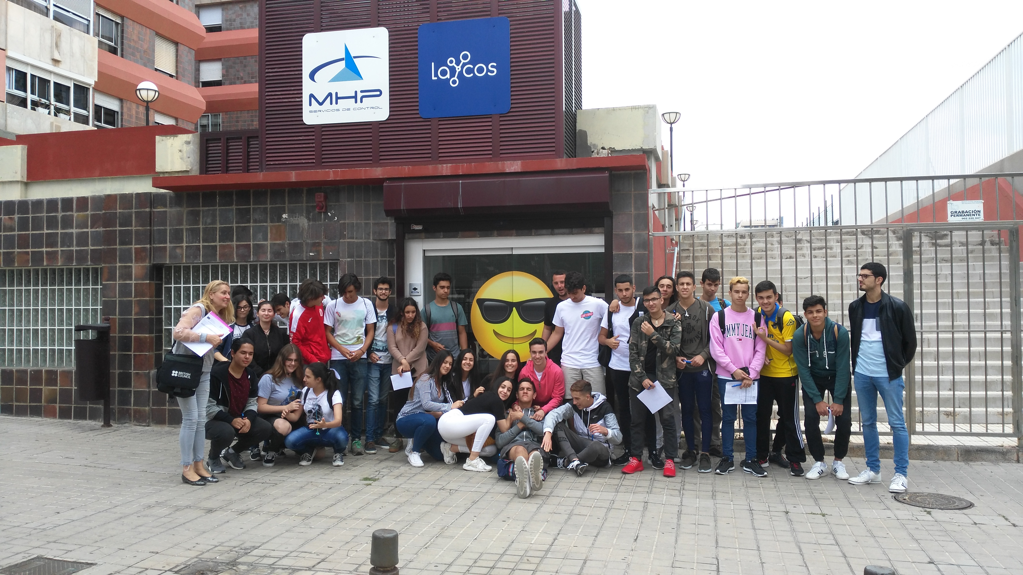  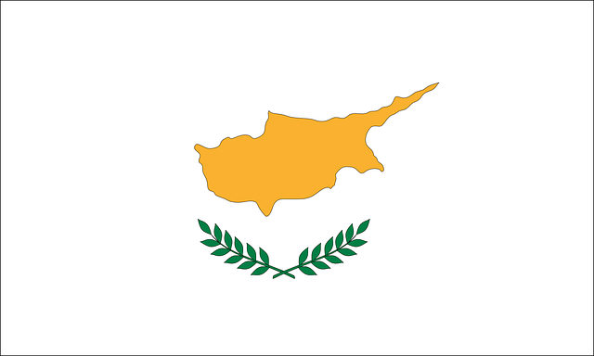  CYPRUS  BACK IN TIME : It’s about each partners traditions and useful informations learned from our ancestors.  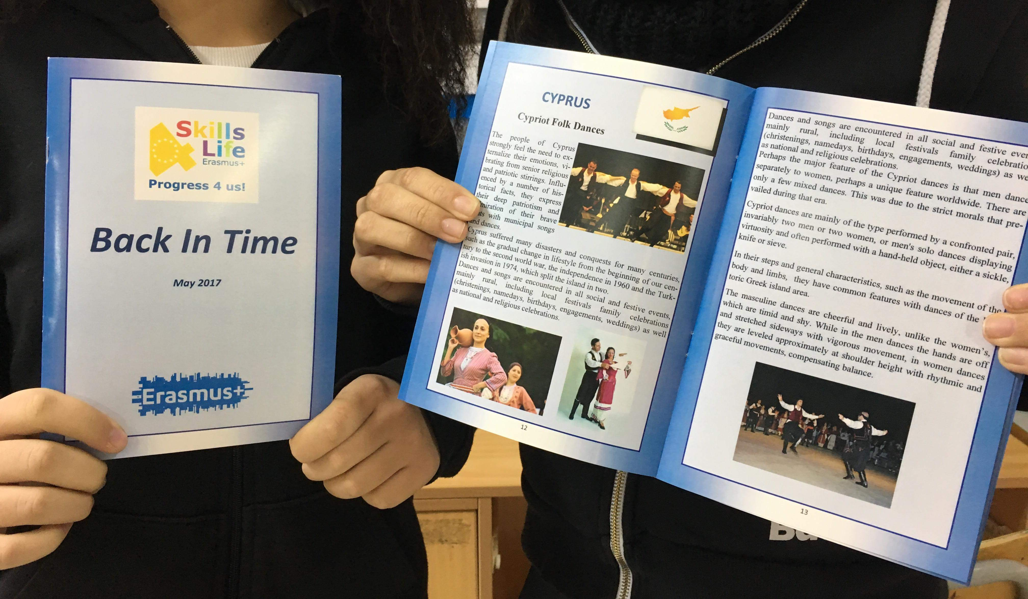  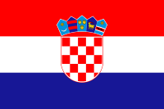  CROATIA  SURVEYS : After every activities our school prepared evaluations to assess its success. We created surveys and collected results from all our partners.  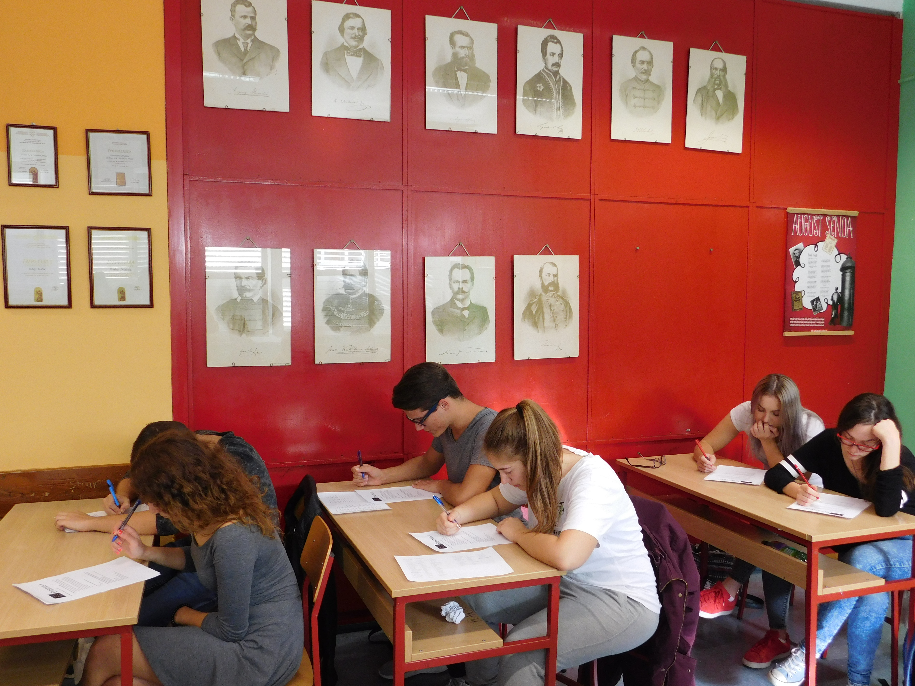  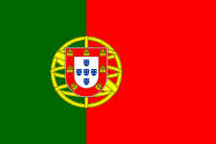  PORTUGAL : LIBRARY OF MOVIES Students are making the movie, using the videos from all the countries about culture shocks.  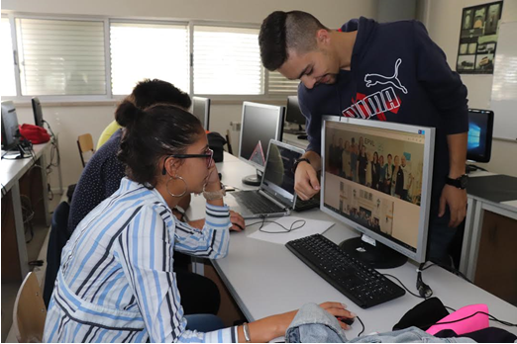 | 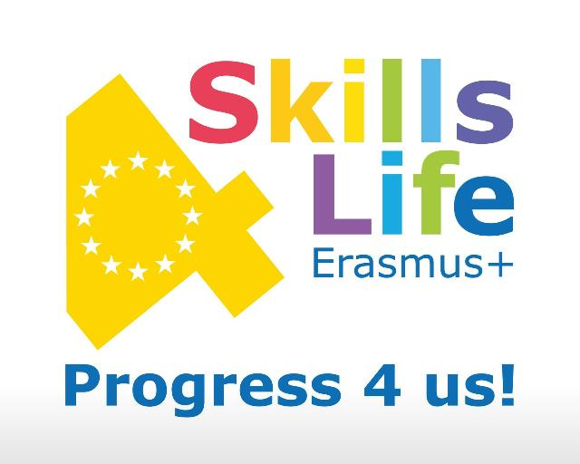  We are living in an era of accelerated change as concerns not only technological developments, but also society on the whole. As a consequence, the skills and competences needed for work and life in the 21st century are continuously evolving. It is generally accepted that transversal skills have a profound effect in employability.  At the international level, the free movement of workers within the EU has meant that borders between countries have been lessened which enables those, with the correct skills to find work in any country around Europe.  It is crucial that these skills will be identified and shared amongst our European students . The project will be undertaken on a broad labour field with the 7 partner countries providing a relevant array of data from the whole Europe.  Moreover, students will have the opportunity to participate in workshops and debates with other students of various countries and to be involved in face to face discussions about the present and the future of EU in context of employability.  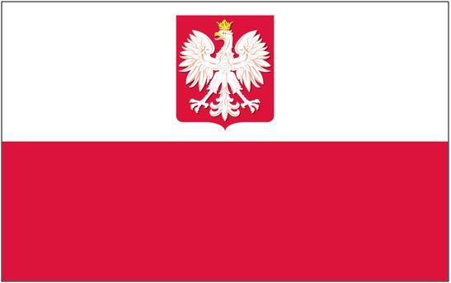  POLAND  ME & MY LEARNING : We prepared a questionnaire to identify our skills. Over 220 students from 7 countries answered this survey.  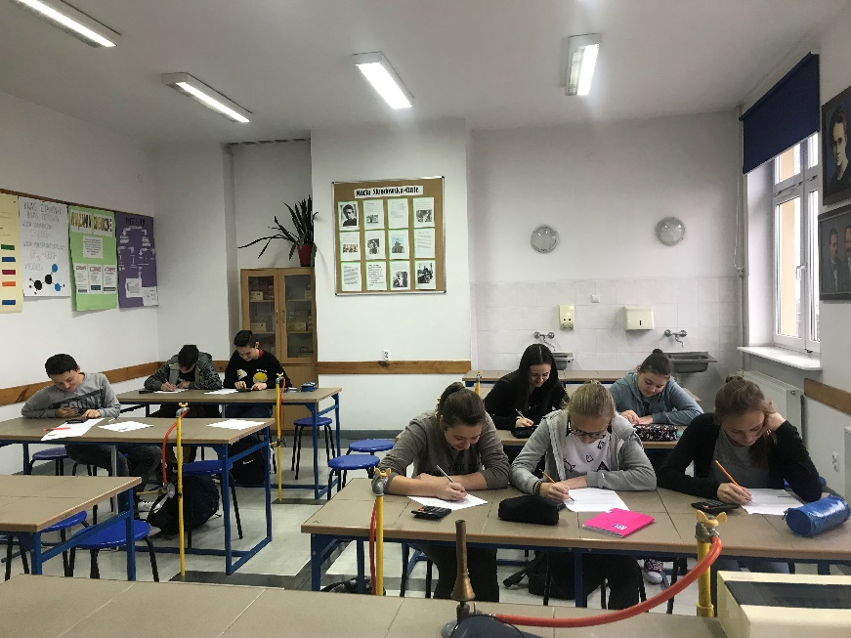  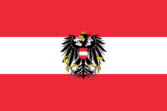  AUSTRIA  DIGITAL TIME LINE : The project of Austria was to create a digital timeline about the history of the different education system of every participating country.  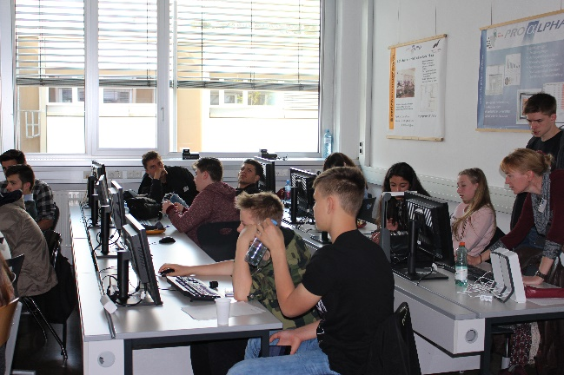 |   DISSEMINATION ACTIVITIES  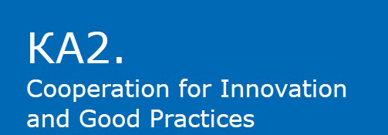  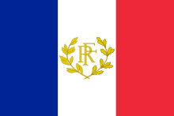  FRANCE  CHARITY EVENT : For the skills4life Project all the countries have taking part of a charity event, in order to know better about our duty as a european citizens.  

