Results of the questionnaire before the activity 1 European History of Learning
Poland
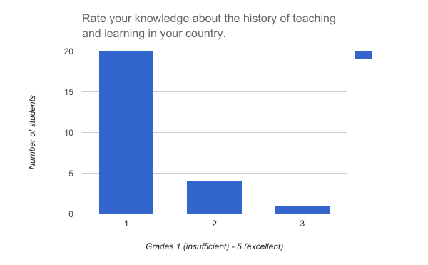
Average grade 1.24
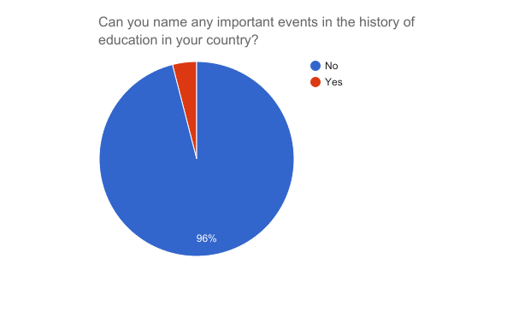

Those who answered positively named the following event:
Foundation of University in Cracow

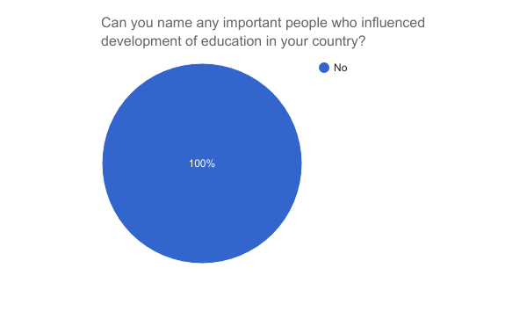

The students could not mention any person.
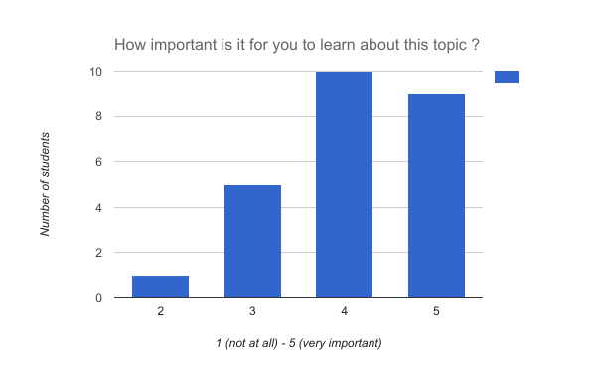
Average 4.08

