Results of the questionnaire before the activity 1 European History of Learning
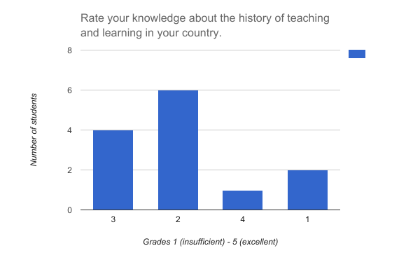
France

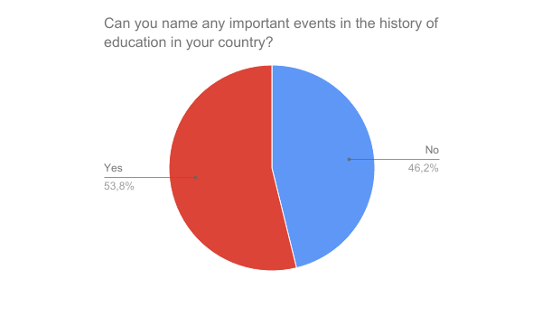
Average grade 2.31

Those who answered positively named mostly only one event. The following events were named:
La Bastille
l école laïque gratuite et obligatoire
Jules ferrie
Ecole gratuite et obligatoire
Ecole laïque et gratuite pour tous
jules ferri
charlemagne , napoleon

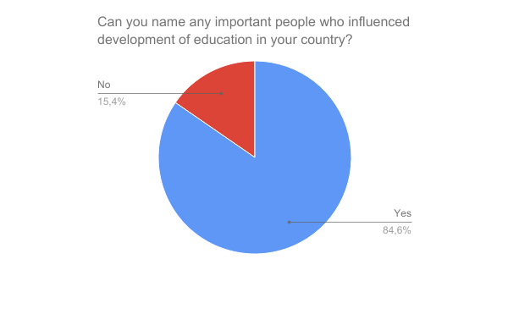
Those who answered positively named mostly only one person. The following people were named:
Charlemagne (7 students)
Jules Ferry (4 students)
Napoleon (1 student)

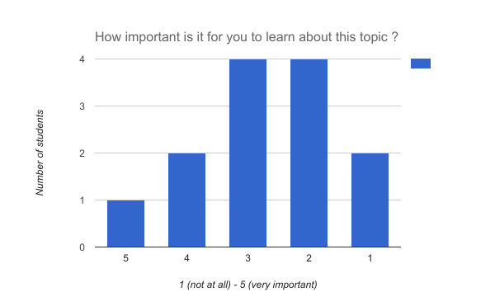
Average 2.69

