Results of the questionnaire before the activity 1 European History of Learning
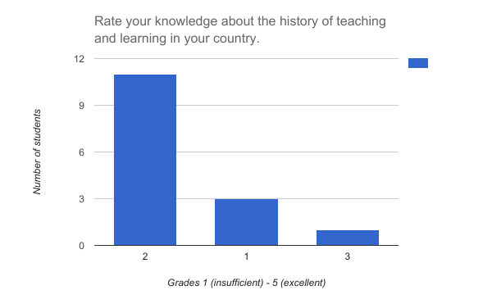
Cyprus
Average grade 1.87
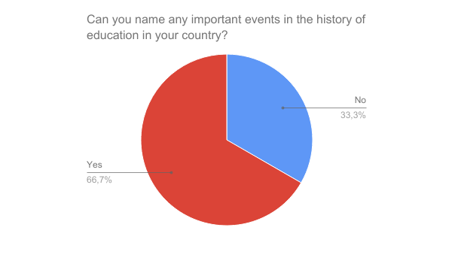

Those who answered positively named mostly only one event. The following events were named:
TURKISH INVASION
TURKISH INVASION, BRITISH COLONY
Foundation of the University of Cyprus 1991
Turkish invasion
being under occupation for many centuries
Turkish invasion
TURKISH INVASION, foundation of private universities in Cyprus
foundation of first gymnasium 1893 when the country was under British occupation
Turkish invasion, British Colony
Turkish invasion

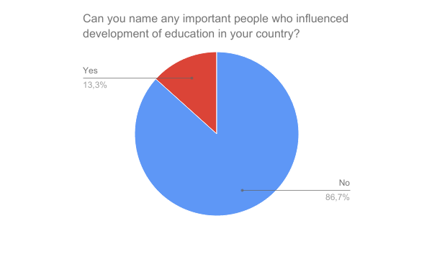

Those who answered positively named only one person. The following people were named:
Arch. Makarios (2 students)

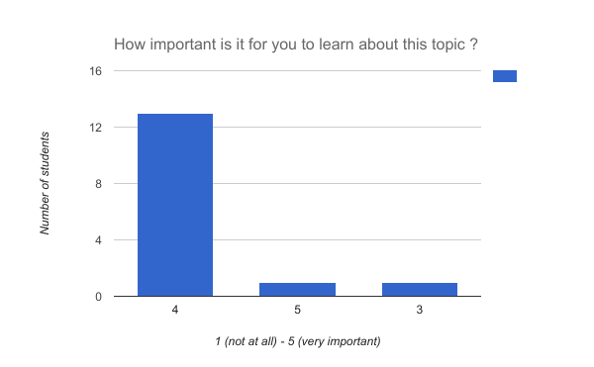
Average 4.00

