Results of the questionnaire before the activity 1 European History of Learning
Austria
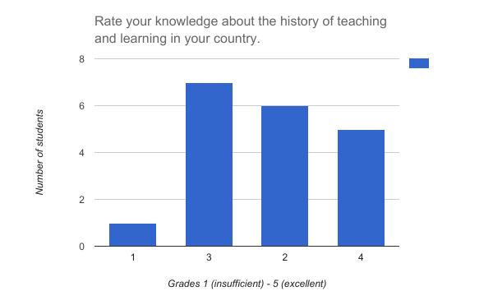
Average grade 2.84
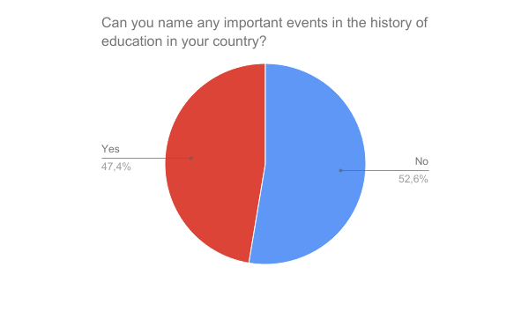

Those who answered positively named mostly only one event. The following events were named:
26.10 Nationalfeiertag
Maria Theresia führt die Allgemeine Schulpflicht ein
inception of the compulsory schooling
Maria Theresia
Arnold Schwarzenegger
Maria Theresia
Maria Theresia invented the school system.
Maria Theresia has introduced the compulsory education.
Compulsory schooling for students in Austria introduced by Maria Theresia.

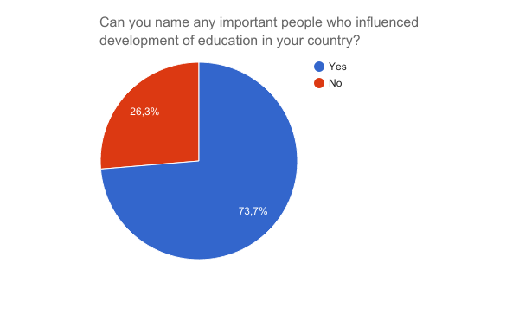

Those who answered positively named mostly only one person. The following people were named:
Maria Theresia (12 students)
Otto Glöckel (2 students)
Felix Baumgartner (1 student)

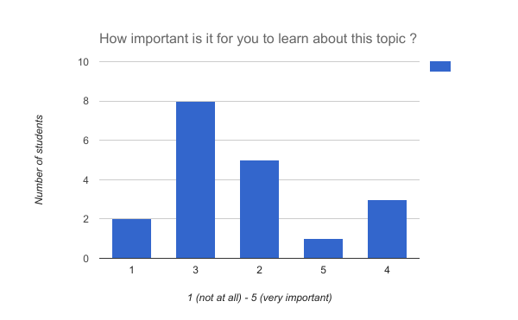
Average 2.79

