Results of the questionnaire before the activity 1 European History of Learning
Spain
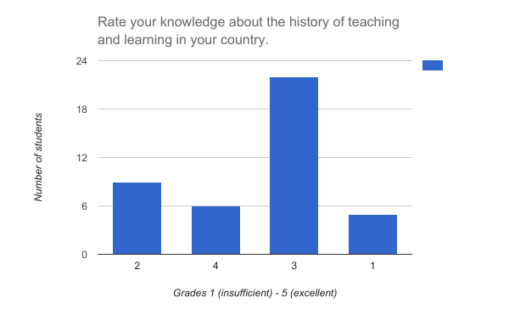
Average grade 2.69
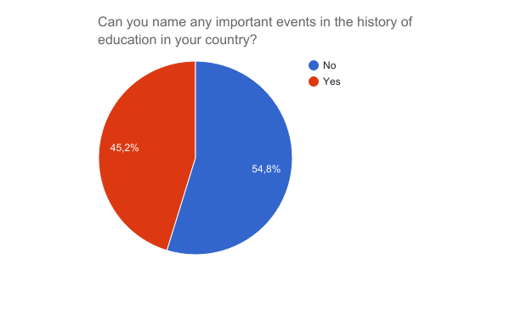

Those who answered positively named mostly only one event. The following events were named:
Th LOE in 2006 and the LOMCE in 2013
La primera guerra mundial
When Cristobal Colon arrived a Canary Islands or Perez Galdos was also important for the literary history in the Canary Islands.
In the second Spanish republic education was made obligatory and free.
La dictadura de Franco, la Guerra de la Independencia, ...
LOE and LOMCE
teacher´s day
LOMCE
Day of teacher and student
Public education is a unitary whole, composed of 3 levels : primary, secundary and higher or university degree.
creation of ILE (1876/1936), free learning institution (instituciÃ³n libre de enseÃ±anza), all types of ideologies could access to learning (Ortega y Gasset, RamÃ³n y Cajal, etc). Women could also study
The change of the education system in the year 1996/19967
During the spanish second republic education was made obligatory and free.
The Spanish Civil War, Spain's Empire in the Americas, the French occupation during the 19th century,...
la P.A.U
Civil War
Toledo Translation School
The diferents laws
The access of women to university studies
Change of education as LOMCE
LOMCE
the pass from education LOE law to the LOMCE law
HUELGA LOE
Organic law to improve de quality of education (LOMCE)
que las mujeres puedan estudiar
LOMCE, RevÃ¡lidas.

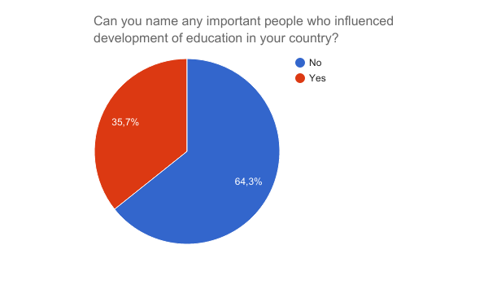

Those who answered positively named mostly only one person. The following people were named:
Miguel de Cervantes
Mariano Rajoy

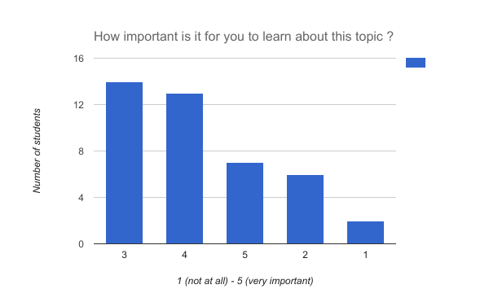
Average 3.40

