Results of the questionnaire before the activity 1 European History of Learning
Common results
(162 students)
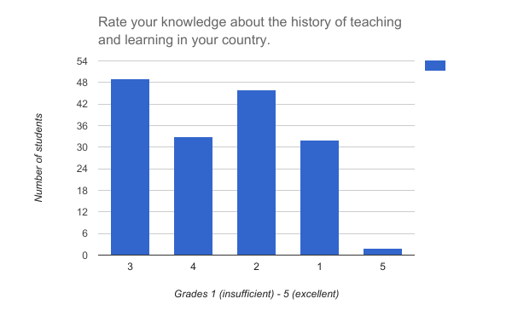
Average grade 2.55
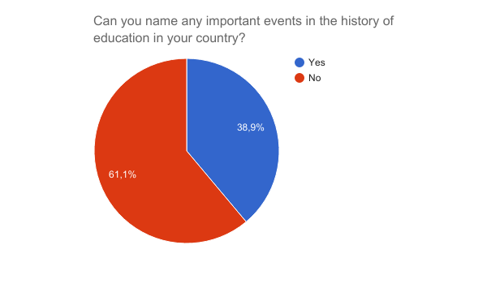
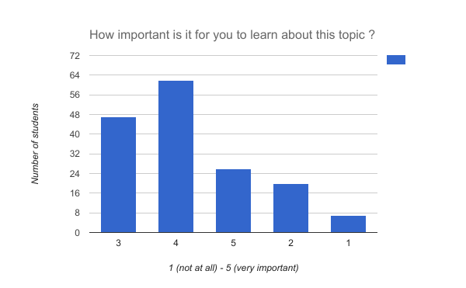
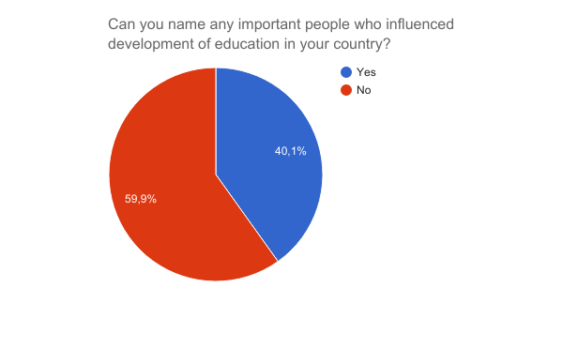

Average 3.49
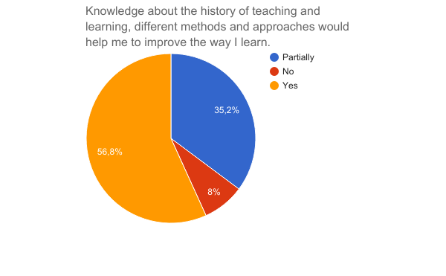

Conclusion:
The questionnaire was conducted among 162 students form the partner schools. The average grade of their own assessment on how much they know the subject is 2.55. About 40% of students can name some events or people that were important in the history of learning for their country. Most of them were able to name only one event or person. We can conclude that the students do not have a big knowledge about this topic. However, they express that they are interested in learning about it as the last question results show.

