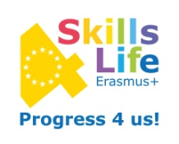

“LOCAL COMPANY VISIT DIARY” ERASMUS+ SKILLS4LIFE

Guidelines for the narration (including pictures):
- City and country
- Name and business sector of the company
- Date of the visit
- Number of students participating

Description of :

- Working conditions
- Marketing value – what , whom and how they sell their products
- Professional requirements – what skills are needed
- Qualification requirements – vocational / university degrees
- Successes and problems identified – do’s and don’t’s

