KNOWLEDGE AND ATTITUDE SURVEY – SCHOOL, FAMILY, COUNTRY AND REGION, HEROES AND MINORITIES
A) SCHOOL
1) Our school´s address is:
___________________________________________________________________
2) At what time we must be at school in the morning?
___________________________________________________________________
3) What´s our headmistress name?
___________________________________________________________________
4) What are your class assistants names?
___________________________________________________________________
5) What´s your class teacher´s name?
___________________________________________________________________
6) I feel welcome in our school, I belong
YES ①②③④⑤ NO
7) Our school is useful for me / I can gain something there
YES ①②③④⑤ NO

B) PLACE WE LIVE IN
1) What´s our region official name?
___________________________________________________________________
2) What´s our regional capital city name?
___________________________________________________________________
3) What´s our president´s name?
___________________________________________________________________
4) Draw our flag:

5) On which continent lies our country?
___________________________________________________________________
6) Are you proud of your country?
YES ①②③④⑤ NO
7) Is our region a good place to live?
YES ①②③④⑤ NO

C) MY FAMILY
1) Write your grandparents´ names and surnames.
___________________________________________________________________
2) Do you know what was your mom´s surname when she was your age?
___________________________________________________________________
3) Is your family important in your life?
YES ①②③④⑤ NO
4) Are you relatives interesting people?
YES ①②③④⑤ NO

D) HEROES IN OUR LIVES
1) Name a regional hero.
___________________________________________________________________
2) Name a national hero.
___________________________________________________________________
3) Is someone from your family a hero/role model for you?
YES ①②③④⑤ NO

4) Can having a role model help you in your life?
YES ①②③④⑤ NO

E) SENIORS
1) Where do your grandparents come from?
___________________________________________________________________
2) Do you talk with your grandparents about life in their childhood? ___________________________________________________________________
3) Have you ever talked with a person over 65 who is not a family member? ___________________________________________________________________
4) Are senior citizens „boring“?
YES ①②③④⑤ NO
5) Do you ressemble to any of your grandparents?
YES ①②③④⑤ NO

F) NATIONAL MINORITIES
1) Which significant minorities live in our country?
___________________________________________________________________
2) Which minorities live in our region?
___________________________________________________________________
3) Which minorities significantly influenced Ostrava in the past?
___________________________________________________________________
4) Would you befriend a classmate who speaks little Czech and uses another language with his parents?
YES ①②③④⑤ NO
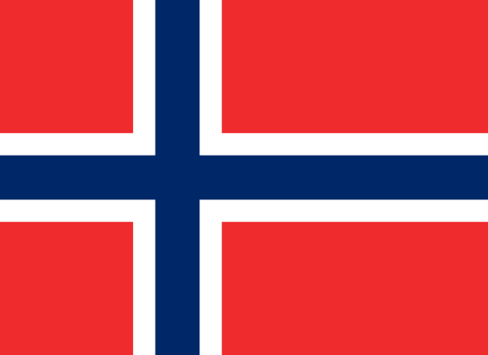
5) Link the country, the capital and the flag of our partner schools:
SWEDEN Bratislava
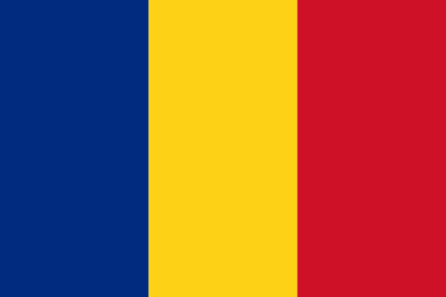
SLOVAKIA Bucarest
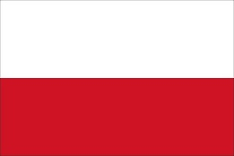
NORWAY Stockholm
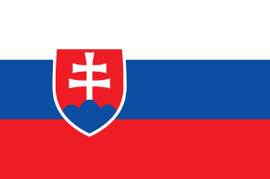
POLAND Oslo
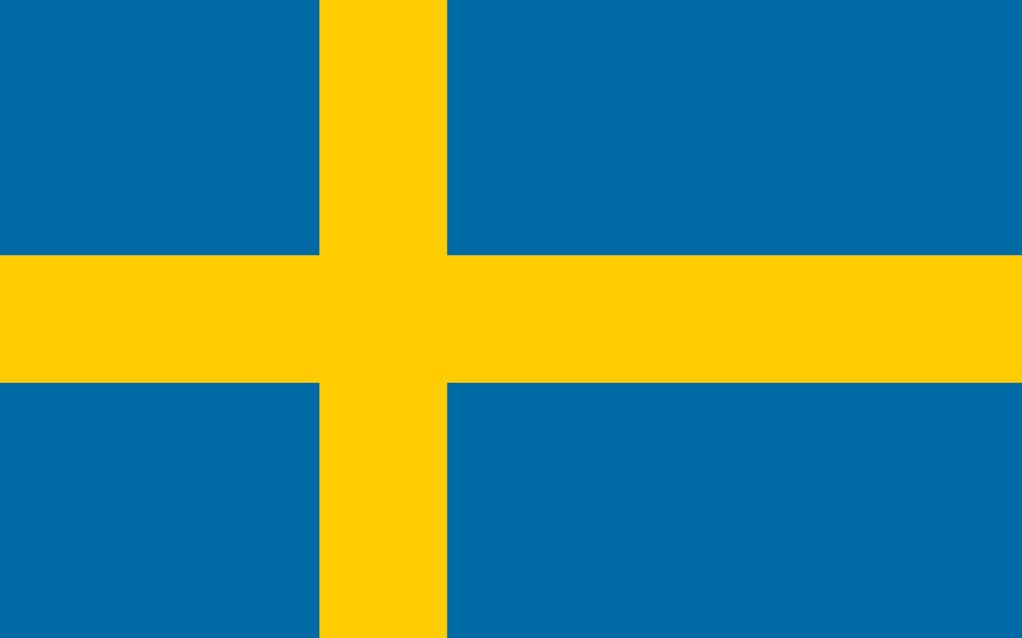
ROMANIA Warsaw

