ROMANIA- OUR COUNTRY, OUR HEROES

The activity ” Romania-our country, our heroes”, carried out within the ”Roots and Wings” Erasmus + project - 2019-1-CZ01-K229-061429_6, took place online due to coronavirus, on the G Suite Platform, with ten students, 5th and 8th grade.
The main objectives of this activity were:
- to understand and define the concept of heroes;
- to know representative figures of our history, considered heroes of our nation;
- to explain the importance of the heroic deeds of these people for our country;
Activities:
The first activity, carried out with the students on this topic, was to define the concept of hero. Using the brainstorming method, we were able to find out what our students understand by this concept.
The second activity - watching a short documentary film with the history of the Great Union, the significance of December 1 - the national day of Romania, the heroes who led to the realization of this union: Mihai Viteazul, Al. I. Cuza.

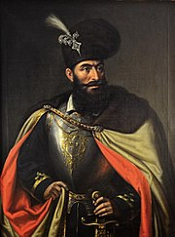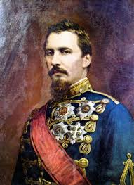
MihaiViteazul Al. I. Cuza
The link below:
https://www.youtube.com/watch?v=g-aDdZRsSWI
The third activity - a film about the life of Ecaterina Teodoroiu - the heroine from Jiu, the first female officer in the Romanian army and about her role in the World War I.

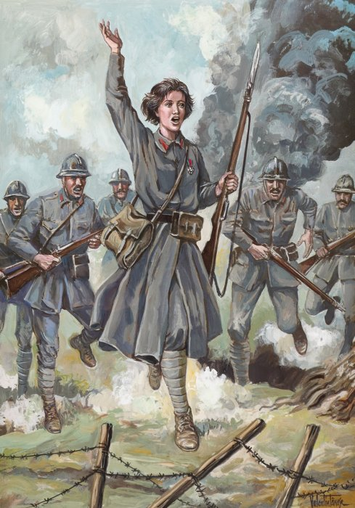
Ecaterina Teodoroiu

The link below:
https://www.youtube.com/watch?v=2uR870ZEhn8
At the end of the activity, each student chose a significant character from our history and colored the images that represent them, or various representative elements such as the country's flag or the map of united Romania.
