Our heroes:
The pupils have learned about what characterizes a hero and what qualities a hero person can have.
Words like doing something good for others, a person you can look up to and a person who can inspire others were something that the pupils thought characterizes a hero.

The pupils made pictures in WordArt about heroes.

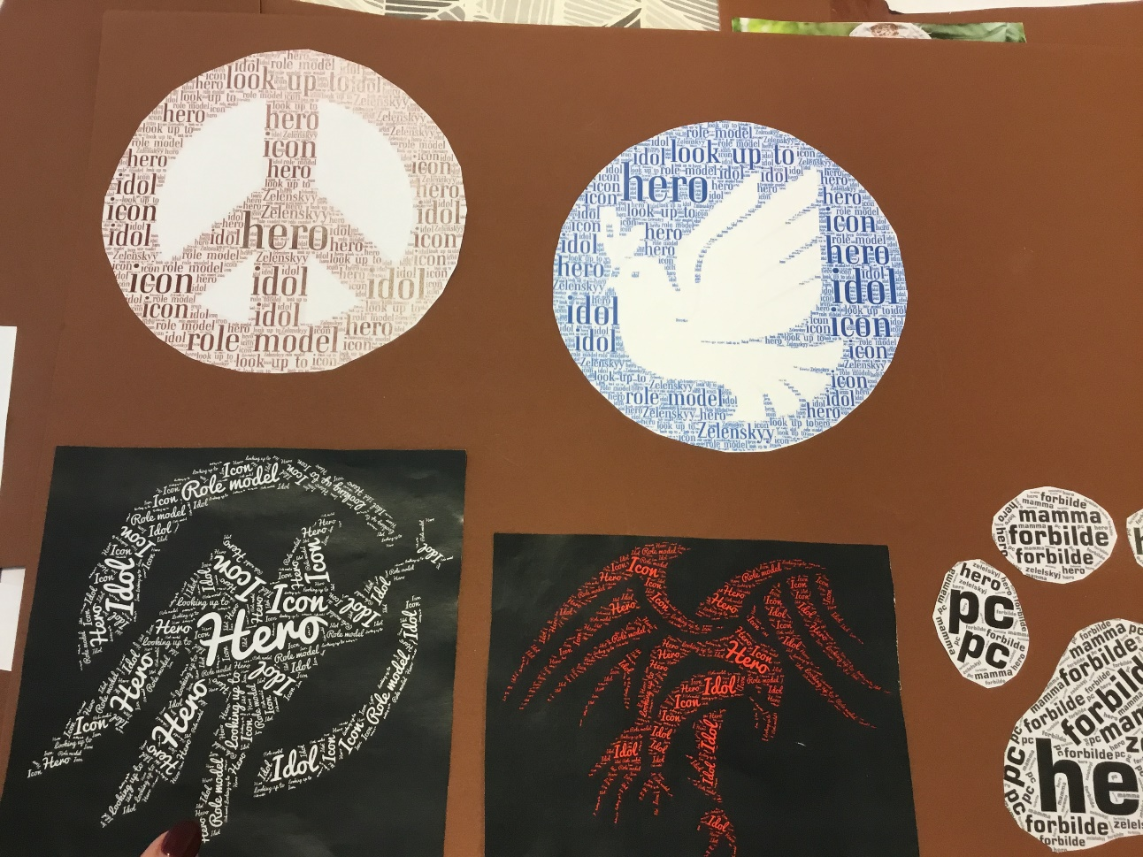

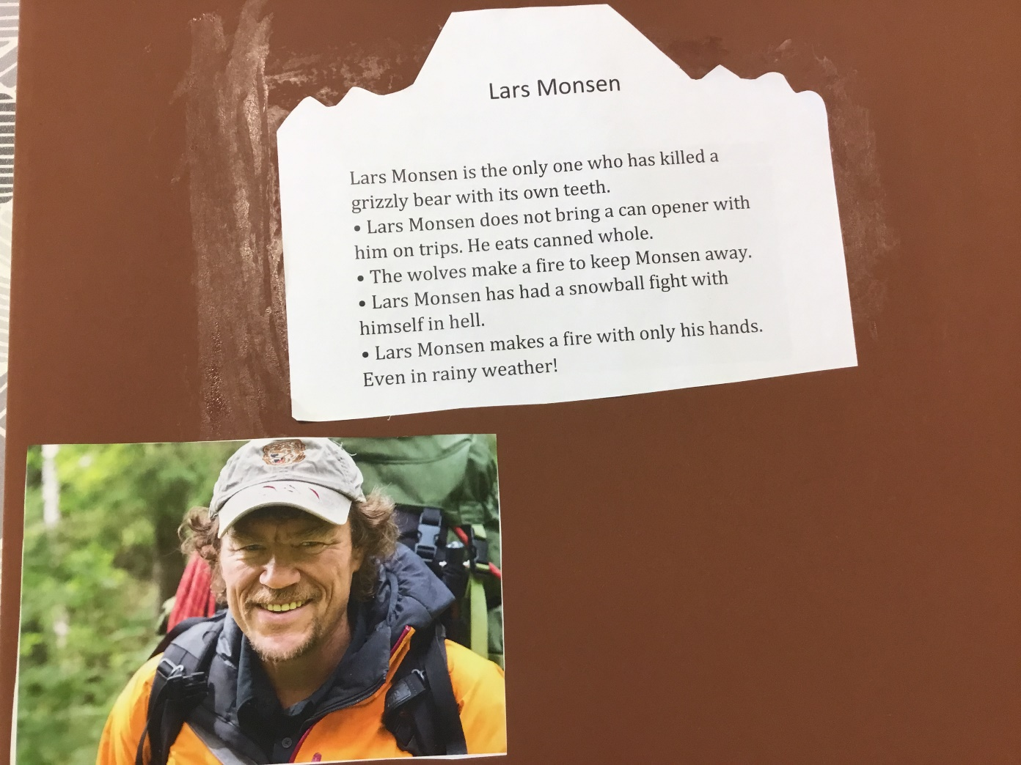

Lars Monsen is a national hero for many people in Norway. Also for some of the pupils in our school.
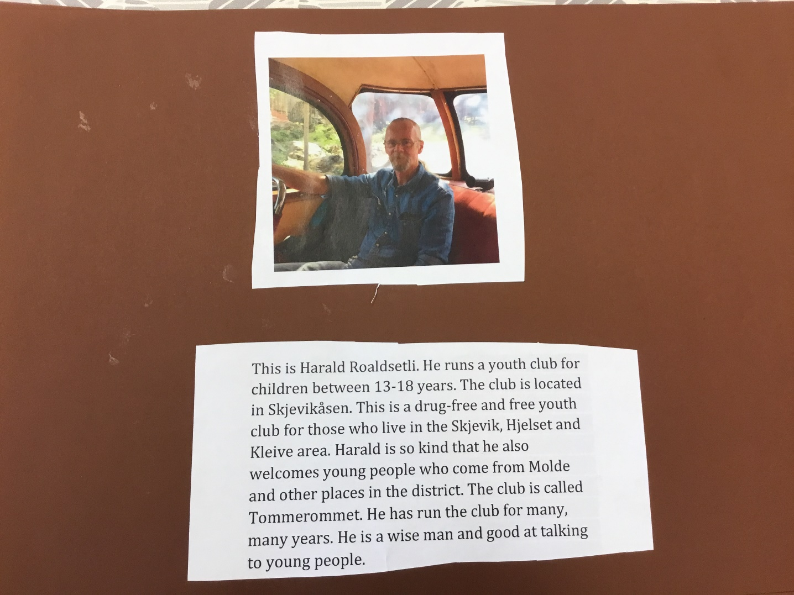

Harald Roaldsetli is a local hero for some of the pupils. This poster was presented to the other countries when Poland hosted the digital Erasmus Week. (week 11).
