Report of the 3rd LTT Meeting
Erasmus+ Project
“Read to Animate”
2018-1-PT01-KA229-047425

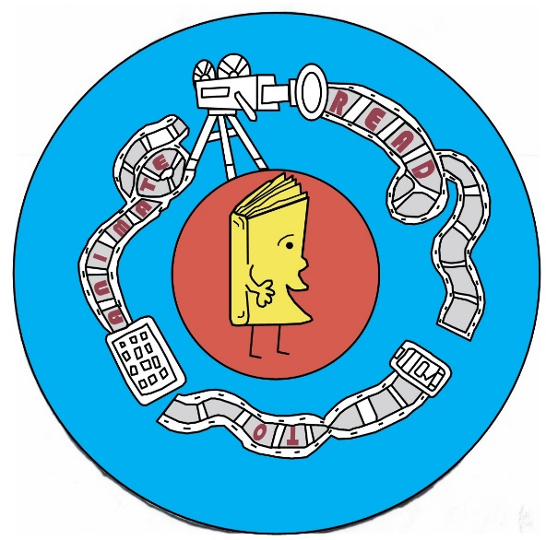

Tarvastu Gumnaasium
13th May to 18th May 2019

Introduction
1 – Attendance
2 – Welcome
3 – Activities
3.1 – ITC Students Activities
3.2 – Teachers Pedagogical Meetings
3.3 – Social activities
Conclusion

Introduction
This report concerns the development of the third international meeting held in Mustla, Viljandi county, Estonia from 13th May to 18th May 2019, hosted by the Estonian partner Tarvastu Gumnaasium. The partners from Bulgaria, Poland, Portugal, Italy and Greece attended the meeting.
The host partner provided support to visitor partners in the organization for accommodation, transport and daily life arrangements. They also prepared a complete program of cultural activities and free time, in order to favour visitors meeting the city and country hosts.
The following aims to analyse the whole planning of the meeting and its development, according to the general lines in order to guarantee standards of quality for activities and outcomes of the project.

1 – Attendance
Representing the “Szkola Podstawowa im. ks. S. Konarskiego w Wielkiej Wsi”, Poland:
- the teachers Renata Borkowska and Agnieszka Habina;
- the students Hojda Kacper, Hojda Paweł, Kołodziejczyk Łukasz, Marynko Julia, Terentjew Milena, Więckowska Konstancja.

Representing the school “Istituto Comprensivo 1 Taormina”, Italy:
- the teachers Giusy Trimarchi, Angela Foti;
- the students Jolanda Lo Giudice, Ignazio Salvatore Giovanni Lanzerotti, Giulia Mantineo, Miriam Matta, Cristina Spitaleri.

Representing the school “Agrupamento de Escolas António Correia de Oliveira”, Portugal:
- the teachers Lucilia Cardoso, Alice Pimenta, Rui Santos;
- the students Lia de Sá Hipólito, Anamar Gama de Sá, Ana Beatriz da Cruz Leitão, Maria Júlia Ferreira Silva, Matilde Duarte Marinho.

Representing the school “Zahary Stoyanov Primary School”, Bulgaria:
- the teachers Yuliya Vicheva Dobreva, Galina Parusheva Radeva;
- the students Daria Ivanona, Aleksandar Dimitrov, Nelina Pimpoireva, Todor Chalakov.

Representing the school “Experimental Intercultural Junior High School of Acharnes”, Greece:
- the teachers Taliadourou Eleni, Borbolis Athanasios;
- the students Gogou Anna, Kazaki Lydia, Gogos Stelios-Carlos, Mogourean Melina.

Representing the host school “Tarvastu Gumnaasium”, Estonia:
the teachers Marika Kovru and Küllike Bärengrub.

2 – Welcome
The international team partners met at the host school Tarvastu Gumnaasium. They were introduced to the support and guidance of the host school representatives, Estonian coordinator and Ms Ene Savi, the school headmaster. These introductions contributed to the development of a "Read to Animate" team spirit.
The partners visited the host school facilities. In the guided tour the students and the teachers presented their education system, explained the teaching concept, applied methods and examples of good practices in their own schools. Also, during the contact with the host school, a lot of educational ideas were exchanged in order to foster better educational responses for each student.
A local government representative organized a reception for the partner schools where the principles of our educational system was introduced. The Vice Municipality Mayor also gave an overview of all possibilities available for Estonian students to engage in free time activities in local area as well as environmental issues and cultural aspects, such as monuments and traditions and gastronomy. In his speech an emphasize was set on initiatives for human and cultural interaction development, our project being a great example for that.

3 – Activities
During the week several project-based activities were carried out. Some of them were planned only for teachers, others for students and of course the various ones in which the teams, students and teachers, worked together.
Joint activities for students and teachers were aimed at introduction of Estonian culture and were intertwined with animation knowledge as well as skills to be used in future learning, reading and teaching. The practices were planned to offer the participants possibilities to improve their thematic practical as well as social skills, enable them to practise the English language and learn from each other’s culture. The joint activities involved visits to Estonian National Museum, AHHAA science park and Estonian Film Museum.
In National Museum, besides learning about Estonian history and culture, both students and teachers had a workshop where they prepared hand-made puppets and props from natural materials for the upcoming puppetry animation workshop.
In the science park we visited an interactive exhibition where we learned how to detect and create visual illusions, which was very needful knowledge for the improvement of our future animation works as well as for stimulating one’s. mindset while reading books.
Film Museum offered a lot of possibilities to learn about Estonian filming history and development. The students and teachers participated also in several workshops involving precious tips for creating film clips and the possible handy equipment everyone could use to raise the quality of their film strips. We also gained knowledge about voicing the film, how to select suitable background music. Later students used the information in their workshops.
The central event for both students and teachers was a possibility for our Erasmus+project to participate in cooperation with MTÜ Tarvastu in the Animation Festival which was broadcast on the Internet all over the world and involved workshops instructed by Estonian professional animators and also included animation contest. One part of the festival was a contest for which each participant, among which were our partner schools, had prepared a short animation film. During the workshops every participant country needed to create also a new animation on spot, according to the instructions of the professionals. In the end a voting took place where the best of the best works were awarded. Our Bulgarian partner school won the first prize for their homework animation film.

3.1 - ITC Students Activities
The students were integrated in mixed groups, which allowed them to communicate and cooperate together as well as provided the opportunity to share their knowledge and understand the program contents that was being taught.
During these interaction days the students altogether improved their English language knowledge through intensive listening and speaking, teamwork with cooperation, decision-making through constant dialogues, problem solving according to the circumstances, they also practiced flexibility and tolerance in everyday performance despite the differences in cultures. The skills for which the students were motivated were performed with correction, interest and mutual involvement. As a result, cognitive and social skills were successfully developed.
The partners had the opportunity to use a wide range of tools trough animation and experience the guidance of professional animators during the International Animation Festival in which we had a great chance to participate.
In accordance to what was scheduled for this meeting and what was established in the original project, the students, in small groups, carried out animation workshops in order to learn basic principles of animation involving pre-production, production and post-production of an animated film. The teams explored different techniques, such as sand animation and puppetry animation based on an Estonian folk story, and instructions to use them in recreative reading during and after the project.
These workshops helped in the acquisition of knowledge and communication of their animation learning process. Thus implies more success since these activities develop their animation skills and enrich lessons, helping to improve students´s confidence and engagement. As a consequence there will be a dissemination of the acquired knowledge.

3.2 – Teachers’ Pedagogical Meetings
During the teachers pedagogical meetings, the objectives that have been structured in the program and the activities to be carried out by each partner were discussed and agreed on. The teachers’ team was working on planning the activities and products, according to what had been previously planned.
The teachers were encouraged to apply the animation works in the English and native language lessons, as well as all the other subject lessons, in order to improve and enliven education. We agreed that it also gives a solid platform for integration between various school subjects.
A workshop on ITC was performed, we were encouraged to use the e-Twinning environment and introduced to some Internet tools by the main coordinator, to work in classroom context, demonstrating the interdisciplinary potential.
Concerned to dissemination, each educational institution is responsible for communicating and dissolving the project in its own language, through newspapers, social networks and other means available in the partner localities. In addition the most valuable products of the project will be done and uploaded to the website and eTwinning platform.
An organization calendar was been reformulated. The next mobilities were discussed.

3.3 – Social activities
During the week, several social activities were developed to create cohesion among different partners countries. There were presentations of the partners about their country, culture and school for the entire educational community. The sessions were presented using the different presentation tools. Students had the opportunity to introduce themselves and communicate about their country in public.
The host school provided cultural activities to give all teams the opportunity to get acquainted with the Estonian culture. These activities were attended by parents, representatives of local government and the authority members of the directorship.
The teams had the opportunity to taste some of the gastronomic delicacies of the region and get involved in the daily food of the school canteen. Throughout the week the families had the kindness to prepare Estonian traditional food.
Finally there was a ceremony of award of participation diplomas. The authority members of the directorship of the schools group were responsible for this event. During this event, the students had the opportunity to show their culture through traditional dances and songs.

Conclusion
The achievement of our aims in Estonian meeting was performed with a project implementation plan with a concrete definition of objectives that will contribute to outline strategies and to continue our partnership evolution.
From the analysis of the activities program of the meeting, organization of the groups and workshops, works presentations, one can conclude that the third project LTT activity was a success.

20 June 2019

The School Coordinators

