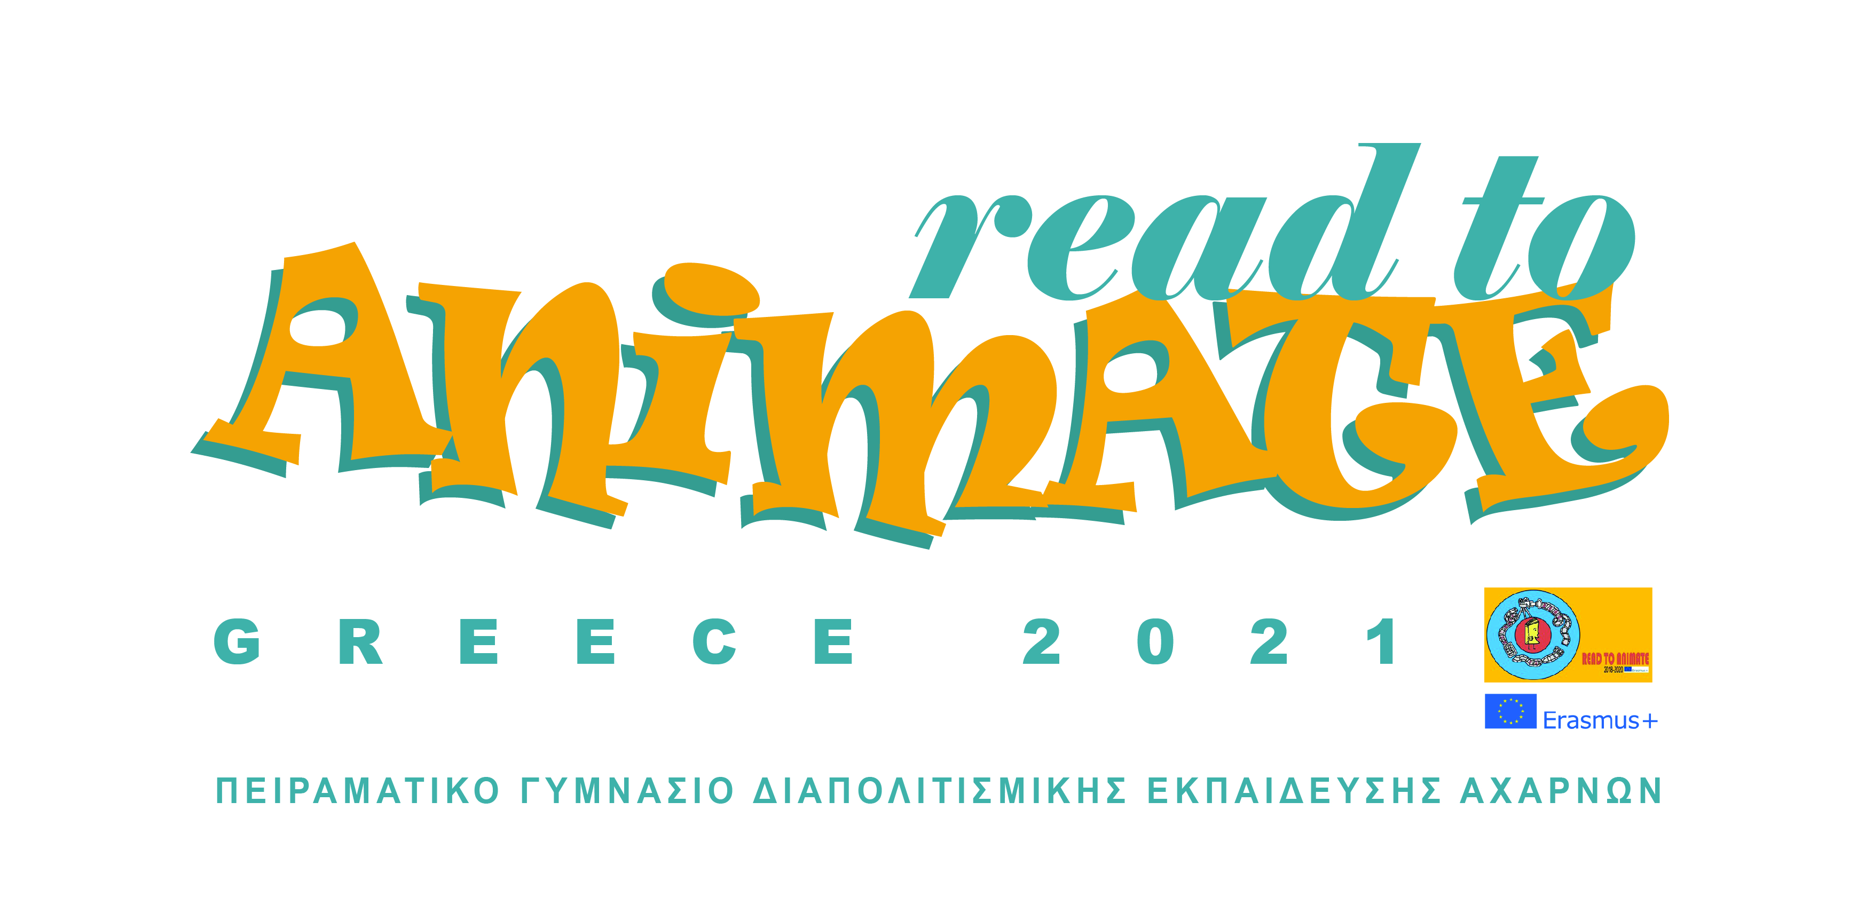
Monday | Tuesday | Wednesday | Thursday | Friday
10.30-11.30  Welcoming  Presentation of the municipality of Acharnes and our school. | 10.30-12.00  Stop motion drawing animation workshop by Karpos | 10.30-11.00  History of shadow theatre and Karagiozis’ art. | 10.30-11.45  - Book illustration presentation:  The animator Mr Panagiotis  Pantazis will present the way he illustrated the book: «The Secrets of the Swamp». | 10.30-11.30  Black-figure pottery painting workshop.
12.00-13.30  Pottery workshop by Mrs Alexandra Abati. | 12.30-13.00  Acropolis virtual tour. | 11.00-12.30  Karagiozis:  traditional shadow theater performance, and workshop by Mr Kostas Spiropoulos. | 12.00-13.00  Epidaurus’ ancient theater virtual tour +.  quiz | 11.45-12.45  Presentation of the workshops works.
13.00-13.30
“Tzatziki sauce” ….workshop (let’s cook).
Farewell

