Simar Nature Reserve
Simar Nature Reserve is an oasis amongst a valley of agricultural landscape. The reserve takes its name from the sharp rush (Is-Simar in Maltese) which is regenerating throughout the reserve. The wetlands provide a safe haven for both resident and migrating birds.
Made up of a mosaic of habitats including open pools, reedbed, and trees, Simar is teeming with wildlife. The pools are attractive to aquatic birds like herons, rails and kingfishers, but also provide a home for the rare and protected Mediterranean Killifish and species of rare tassel-weed. Simar is a fully protected bird sanctuary, a Ramsar site, and a Special Area of Conservation within the EU Natura.

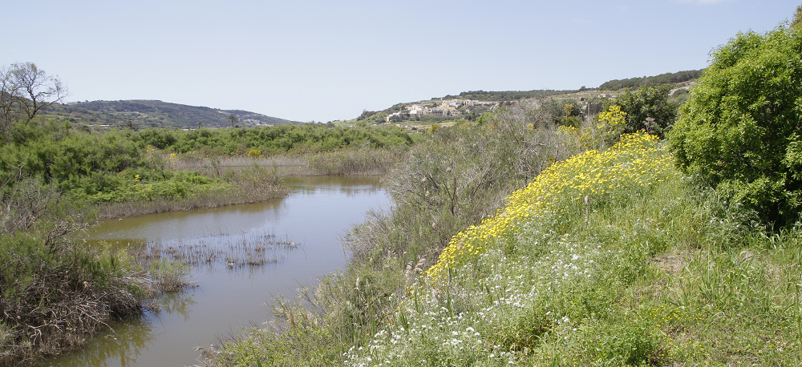

What To Spot
The reed beds offer a good hiding place for secretive species such as Water Rails, herons, egrets and shy
warbler species. As you walk around the trail, look out for Mediterranean Chameleon and geckos camouflaged on the branches, and listen for the distinct call of the Cetti’s Warbler.
During the spring, migrating Barn Swallows can be seen feeding on insects above the pools, where rare Mediterranean Killifish and various crustaceans dwell.
Simar is the only place on the Maltese islands where Coots and Little Grebes breed and for the first time in 2014, a pair of Black-winged Stilts successfully bred at this reserve
Salina Nature Reserve
Salina Nature Reserve lies in the Burmarrad valley mouth (limits of St Paul’s Bay in the north of Malta). Originally a harbour, the Salina site consists of 154,000 square metres of saline marshland and a number of salt pans built on a reclaimed island of clay surrounded by garrigue.
The site has recently been rehabilitated through a €7 million project partially financed with EU funds under the Agricultural Fund for Rural Development 2007-2013. The site’s potential to attract a number of species has been proven repeatedly by birds alighting in the salt pans to rest during migration, among which the most spectacular; the flamingo – a bird synonymous with salt pans, especially in the Mediterranean. Salina is a protected area forming part of the Natura 2000 network and also a Special Area of Conservation (SAC) because of the endemic flora and fauna which can be found in the area.
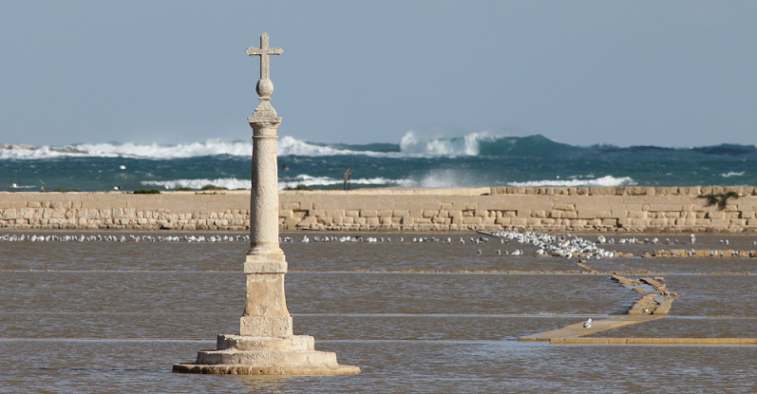
What To Spot
The salt pans at Salina regularly attract a number of species of gull – sometimes as much as 2,000 in a day! This includes species such as Black-headed, Mediterranean, and Audouin’s.
Sandwich Terns can be seen almost every day and occasionally rarer species of tern such Gull-billed and Caspian.
During the winter period, Common Sandpipers can be observed at the reserve whilst migration brings herons, egrets and very rarely a Greater Flamingo!
San Raphael Lake
Saint Raphael Lake (San Raflu) is a small rural area just outside the locality of Kerċem, at the south-west of the island of Gozo.
The area is situated on layers of Upper, Middle and Lower Globigerina limestone (Franka ta’ Fuq, tan-Nofs u ta’ Taħt), which make up the base of the whole San Raflu area. However, one also finds traces of Coralline limestone rock, which also makes up the Xlendi Cliffs. The high amount of limestone in the area also influences the soil, which is mainly xerorendzinas, a main characteristic of the Globigerina areas. In fact, this soil is a compound of the Globigerina limestone, the greensand, and several other organic material, and has very high levels of stone and chalk content, whilst keeping a very low level of humus.

